Name: Date:

**Student Exploration:** **Polynomials and Linear Factors**

**Vocabulary:** degree, linear factor, multiplicity, polynomial, zero (of a polynomial)

**Prior Knowledge Questions** (Do these BEFORE using the Gizmo.)

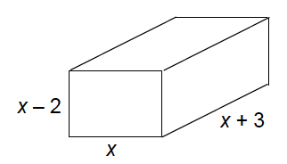

1. A rectangular box has a width of *x* meters, length of *x* + 3 meters, and a height of *x* – 2 meters. Write an expression for its volume.

1. Find the dimensions and volume of the box when *x* = 6.

Dimensions: Volume:

**Gizmo Warm-up**

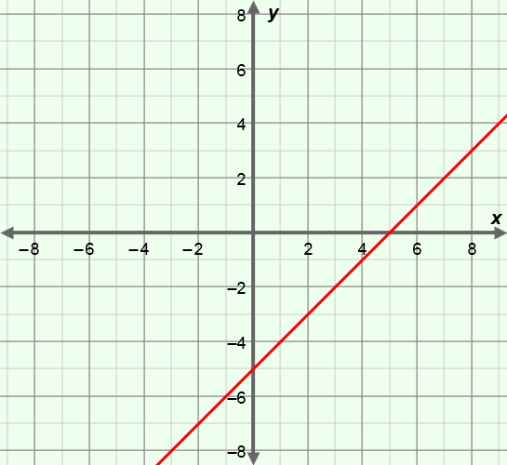A **polynomial** is a monomial or sum of monomials. In the *Polynomials and Linear Factors* Gizmo, you can create polynomials, written as products of linear factors.

1. Show *y* = *x* – 5 by moving the blue ***a*** slider to 5.
2. What is the *y*-intercept?
3. What is the value of *y* when *x* = 6?
4. A **zero** of a polynomial is an *x*-value for which the polynomial is equal to zero.

What is the zero of this polynomial? How can you tell?

1. Select the green ***b*** slider and set ***b*** = 2 (with ***a*** = 5).
2. Look at the polynomial in the pink box. How many linear factors does the polynomial have? What are they?
3. How many *x*-intercepts does the graph have? What are they?
4. What is the *y*-intercept? Click on the **TABLE** tab to check your answers.

|  |  |  |
| --- | --- | --- |
| **Activity A:**  **First- and second-degree polynomials** | Get the Gizmo ready:   * Select the **CONTROLS** tab. * Unselect all checkboxes. | 148SE2 |

1. Move the blue ***a*** slider to vary the value of *a* in *y* = *x* – *a*. As you do, observe the graph.
   1. What happens to the graph as you increase *a*?
   2. What happens to the graph as you decrease *a*?
   3. Drag the ***a*** slider to create the polynomial function *y* = *x* + 5. To create that function, what is the value of *a*?
   4. What is the zero of *y* = *x* + 5?
   5. What is the relationship between a linear factor and the zero of a function?

1. Select the ***b*** slider. Move the slider to vary *b* and observe what happens to the graph.
2. What happens to the *x*-intercepts of the graph as you increase *b*?

1. What happens as you decrease *b*?
2. In general, what shape is the graph of a polynomial with two linear factors?

1. In the Gizmo, graph *y* = (*x* – 3)(*x* – 7).
2. What are the linear factors of the polynomial?
3. What are the zeros of the polynomial?
4. If you multiply the linear factors, what polynomial do you get?

Turn on **Show unfactored form** to check your answer.

1. What is the **degree** (greatest exponent on *x*) of the polynomial in part C?
2. How does the degree relate to the number of linear factors?

**(Activity A continued on next page)**

**Activity A (continued from previous page)**

1. In the Gizmo, move the sliders to set ***a*** = –1 and ***b*** = –1.
2. How many linear factors does the polynomial have?

What are they?

1. How many *x*-intercepts does the graph have?
2. The **multiplicity** of a zero is the number of times its associated factor occurs in the polynomial. This polynomial function has a zero at *x* = –1 with multiplicity 2. Write the function in factored form below, using a squared term to represent the multiplicity.

1. The zeros of a second-degree polynomial are –4 and 7.
2. What are the linear factors of the polynomial?
3. Write the polynomial in factored form.
4. Write the polynomial in standard form.

Check your answers in the Gizmo.

1. 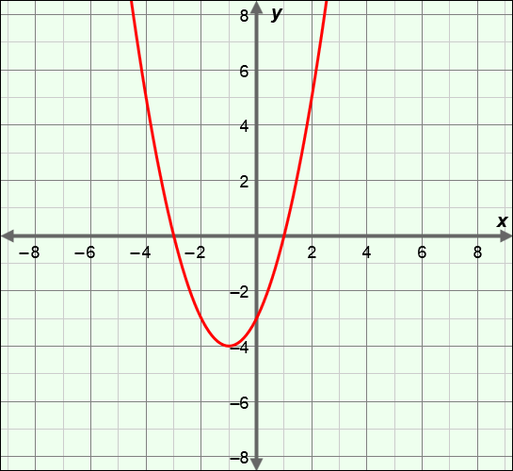The graph of a polynomial function is shown to the right.
2. What degree is the polynomial?

How do you know?

1. What are the *x*-intercepts?
2. What do you think its linear factors are?

1. In factored form, write the lowest-degree polynomial function that has those linear factors.

1. Graph your function in the Gizmo. Does your graph match the one above? If not, adjust your function until you match it.

|  |  |  |
| --- | --- | --- |
| **Activity B:**  **Third- and fourth-degree polynomials** | Get the Gizmo ready:   * Be sure the Gizmo shows the **CONTROLS** tab and that all boxes are unchecked. | 148SE4 |

1. In the Gizmo, select the ***b*** and ***c*** sliders. Set ***a*** = 0, ***b*** = –2, and ***c*** = 3.
   1. How many linear factors does this polynomial have?
   2. Look at the graph. How many *x*-intercepts are there?
2. Consider how the values of *a*, *b*, and *c* affect the number of zeros.
   1. Vary ***a***, ***b***, and ***c*** so that the graph has exactly two distinct *x*-intercepts. What do you notice about the linear factors and zeros?

* 1. Write the polynomial you created in factored form.
  2. Now rewrite it, using a squared factor.
  3. Can you vary ***a***, ***b***, and ***c*** so that the graph has exactly one *x*-intercept?

Explain.

1. Graph *y* = (*x* – 2)(*x* – 3)(*x* + 1)(*x* – 4) in the Gizmo. If you like, zoom out by clicking **–**.
   1. Describe the graph.
   2. How many distinct zeros does the polynomial have?
   3. What are the zeros?
   4. Can you vary ***a***, ***b***, ***c***, and ***d*** to form a polynomial with exactly 5 distinct zeros?

Explain.

1. Write a polynomial in factored form that satisfies each set of conditions below. Check your answers in the Gizmo.
2. Third-degree, with *x*-intercepts –2, 3, and 5
3. Third-degree, with one zero of multiplicity 3
4. Fourth-degree, with exactly two distinct roots