Name: Date:

**Student Exploration: Populations and Samples**

**Vocabulary:** frequency distribution, normal distribution, population, sample

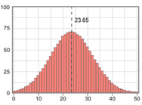

**Capitals named (no studying)**

**Frequency**

**Prior Knowledge Questions** (Do these BEFORE using the Gizmo.)

A **frequency distribution** indicates how many data points have each value or range of values. Suppose a large number of people were quizzed on how many U.S. state capitals they can name. The histogram to the right shows the frequency distribution of their results, with no studying.

1. How would you describe the shape of this distribution?

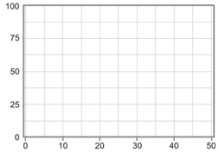

**Capitals named (after studying)**

**Frequency**

1. In the blank graph at right, sketch what you think this frequency distribution might look like if the same people could study for 10 minutes before taking the quiz.

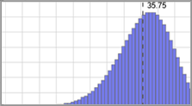

**Gizmo Warm-up**

In many cases, it is impractical to investigate every member of a **population**. Researchers often investigate a smaller **sample**, or subset, of the population. You can explore the accuracy of samples using the *Populations and Samples* Gizmo.

1. The red and blue histograms in the Gizmo are approximations of the frequency distributions described above, U.S. state capitals named, with no studying (red) and with studying (blue).

What is the mean of each distribution? Red mean: Blue mean:

1. PausePlayMove the **Simulation speed** slider all the way to the left. Click **Play** ( ) to start taking samples from each distribution. Click **Pause** ( ) when the sample size *n* is about 10.
2. What is the mean of each sample? Red mean: Blue mean:
3. How close are the sample means to the population means?

|  |  |  |
| --- | --- | --- |
| **Activity A:**  **Sampling frequency distributions** | Get the Gizmo ready:   * ResetClick **Reset** ( ). * Check that the original distributions are shown.   (If not, click **Refresh** or **Reload** on your browser.)   * Next to the bottom distribution, click **Clear**. | 508SE4 |

**Introduction:** Many population distributions approximate a bell-shaped **normal distribution**, with most data values lying near the mean, and a few farther out in the “tails” of the curve.

1. Suppose you wanted to know how many states American adults have visited. Suppose that the real population distribution is shown in the Gizmo, with a mean of 23.65.

Click **Play**, wait for the sample size to reach *n* = 5, and click **Pause**. Record the sample mean. Then take three more samples with sample sizes of approximately *n* = 20, *n* = 100, and *n* = 500. (Adjust the **Simulation speed** if necessary.) Record your results in the table.

|  |  |  |  |  |
| --- | --- | --- | --- | --- |
| **Sample size** | *n* = 5 | *n* = 20 | *n* = 100 | *n* = 500 |
| **Sample mean** |  |  |  |  |

1. How did the sample size affect the accuracy of the sample means?

1. How did the sample size affect the similarity of the sample distribution to the actual distribution?
2. 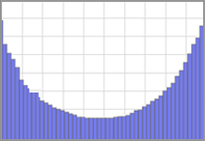Click **Reset**. Keeping the same frequency distribution for the red graph, click and drag in the blue graph to create a distribution that looks something like the graph to the right. Adjust this graph so its mean is very similar to that of the red graph. Record the mean of each distribution below.

Red mean: Blue mean:

Click **Play**. Pause the simulation when *n* = 10. Record the two sample means, under trial 1. Click **Reset**, and repeat four more times with *n* = 10, for a total of five trials.

|  |  |  |  |  |  |
| --- | --- | --- | --- | --- | --- |
|  | **Trial 1** | **Trial 2** | **Trial 3** | **Trial 4** | **Trial 5** |
| **Red sample mean** |  |  |  |  |  |
| **Blue sample mean** |  |  |  |  |  |

How does the shape of the original distribution affect the accuracy of the sample mean?

|  |  |  |
| --- | --- | --- |
| **Activity B:**  **Comparing samples** | Get the Gizmo ready:   * Select the **Predict** tab. * Check that **Show population(s)** is not selected. | 508SE6 |

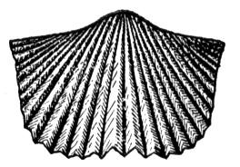

**Introduction:** A paleontologist collects fossil brachiopods from two locations. She is wondering if the brachiopods come from the same species or from different subspecies. To do this, she measures 5 brachiopods from each location, and finds the mean shell width at each location.

1. On the **PREDICT** tab, set the **Simulation speed** to its lowest value. Click **Play**, and then click **Pause** when *n* = 5. This represents the widths of brachiopods from the two locations.
2. What is the mean width of each sample? Red mean: Blue mean:
3. Do you think the samples were taken from two distinct populations, or from the same population?
4. To check, turn on **Show population(s)**. Were the samples taken from the same underlying population, or from two distinct populations?
5. Turn off **Show population(s)**, and click **New experiment**. Take one sample with *n* = 5, record the means, and then guess if the samples came from the same population or from two different populations. Check if you are right by turning on **Show populations(s)**. Repeat this process 4 times. Then, do the same experiment five times, with *n* = 50.

|  |  |  |  |  |  |
| --- | --- | --- | --- | --- | --- |
| **Experiments (*n* = 5)** | 1 | 2 | 3 | 4 | 5 |
| **Red sample mean** |  |  |  |  |  |
| **Blue sample mean** |  |  |  |  |  |
| **Same or different populations?** |  |  |  |  |  |
| **Actual – same or different?** |  |  |  |  |  |

|  |  |  |  |  |  |
| --- | --- | --- | --- | --- | --- |
| **Experiments (*n* = 50)** | 1 | 2 | 3 | 4 | 5 |
| **Red sample mean** |  |  |  |  |  |
| **Blue sample mean** |  |  |  |  |  |
| **Same or different populations?** |  |  |  |  |  |
| **Actual – same or different?** |  |  |  |  |  |

How did the sample size affect your ability to correctly predict if the samples were taken from two different populations or a single population?