Vocabulary: Prisms and Cylinders

dictionary2

**Vocabulary**

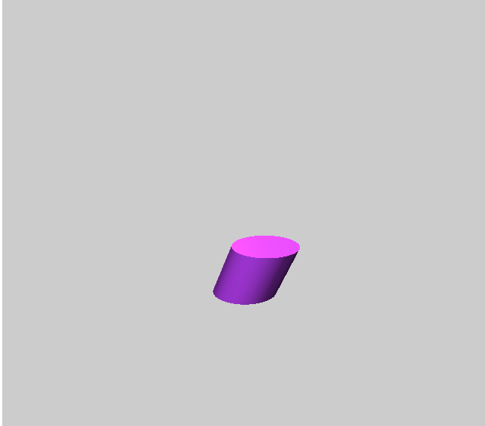

**Oblique cylinder**

**height**

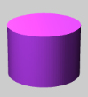

**Right cylinder**

**lateral surface**

**height**

**base**

* Cylinder – a three-dimensional figure with two congruent, circular bases in parallel planes and a curved lateral surface.
* The *lateral surface* connects the two bases.
* A cylinder that is straight up and down (the bases sit directly above one another) is *right*.
* A cylinder that is skewed (tilted to one side) is *oblique*.
* Height (of a cylinder or prism) – the perpendicular distance between the two planes in which the bases lie.
* Prism – a three-dimensional figure with two congruent, polygonal bases in parallel planes and other faces that are parallelograms.
* The bases of a prism determine its type.

**base**

**height**

**face**

**Right rectangular prism**

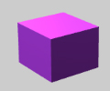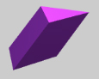

**Oblique triangular prism**

**height**

* For example, the figure to the right with rectangles for bases is a *rectangular prism*, and the one with triangles for bases is a *triangular prism*.
* A prism that is straight up and down (the bases sit directly above one another) is *right*.
* A prism that is skewed (tilted to one side) is *oblique*.
* A prism with six congruent square faces is a *cube*.
* Volume – the number of cubic units inside a three-dimensional figure.
* For example, the volume of the solid shown to the right is 18 cubic units.