Name: Date:

Student Exploration: Programmable Rover

Vocabulary: bug, call, code, code snippet, function, JavaScript, loop, optimize, program
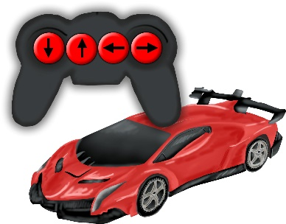

Prior Knowledge Questions (Do these BEFORE using the Gizmo.)

1. Describe how you would make the remote-controlled car on the right drive forward.

- How do you think the car knows what to do when a button is pressed?

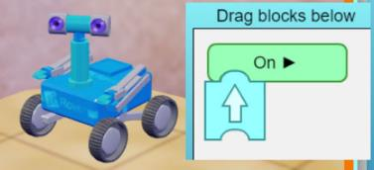
Gizmo Warm-up
In the Programmable Rover Gizmo, you are preparing to send a rover to Mars to explore and collect samples. During training, you will learn how to write a program. A program is a set of instructions that tell the rover what to do.

- To begin, make sure you are on the EXPLORE tab. Drag a Forward block (block with an up arrow) from the Block library to the green On play function button. Click Play ().

What does the rover do?

In programming, the forward block is an example of a function. When you click Play, this is calling the function.

- Click Reset (). Drag a Reverse block (block with a down arrow) to the bottom of the Forward block and let go. The two blocks should connect. Then, click Play.

Now what does the rover do?

- Click Next to move to another location. You now have two new blocks. What do you think they will tell the rover to do?
Activity A:  Block coding | Get the Gizmo ready:  - Switch to the TRAINING tab and make sure you are on Warm-up task 1. | 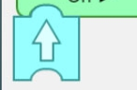

Introduction: A program is a series of instructions that control the operation of a machine. When the Gizmo is in Block mode, each block is an instruction or code snippet.

Question: How do you use block coding to instruct the rover to complete tasks?

- Program: You are on Earth in a training area that copies the Martian landscape you will explore during the mission. To complete each training task, you will instruct the rover to drive to the blue X using code blocks.

Complete warm-up tasks 1 and 2 by dragging blocks from the library to the On play button. Click Play to check your code. When you finish each task, open the Tools palette at upper left and click the Screenshot camera (). Copy and paste the image into a blank document to turn in with this worksheet.

- Explore: Switch to the EXPLORE tab. Click Next until you reach practice location 3.

- What does the Kangaroo block do?

- Click Next to go to practice location 4. What does the Hand block do?

- Switch to practice location 5. What does the Loop block do?

- Program: Switch back to the TRAINING tab. Make sure warm-up task 3 is selected.

- Write a code that uses a Kangaroo block to instruct the rover to jump over the rock and drive to the X. Take a screenshot when you have completed the task.

- What percent (%) battery is left after completing the task?

- Click Reset. Click Clear to delete your code. Write a new code that instructs the rover to drive around the rock to the X instead of using a Kagaroo block. Take a screenshot when you have completed the task.

- What percent (%) battery is left after completing the task?

- Which code uses less battery power?

Keep an eye on the battery when you practice other tasks. Your overall goal will be to complete the missions without running out of battery power.

Activity B:  Text coding | Get the Gizmo ready:  - On the TRAINING tab, select Warm-up task 1. | 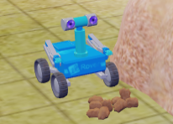

Introduction: Blocks are a simple way to start learning to code, but most programming languages use text-based code. In this Gizmo, all of the blocks have a matching text snippet. The text snippets can be edited to make the program more efficient. The text code is based on a computer language called JavaScript.

Question: How can you use text coding to optimize the rover’s programs?

- Observe: When Warm-up task 1 is selected, make sure that two Forward blocks are under the On play button. Click the Text radio button to switch to text mode.

- What does the green On play button change to?

- What does each forward block change to?

The green button turns into the function onStart() {}. A function is a group of instructions. When the function is called, all of the instructions inside of the {} brackets are executed.

- Optimize: You should see two translate(1); snippets in a row. Delete one of the translate(1); snippets. Then, in the other translate snippet change the 1 to a 2. Click Play.

What does changing the 1 to a 2 tell the rover to do?

- Debug: Click Reset. Delete the semicolon (;) after translate(2).

- What happens to the text?

The red squiggly line indicates that there is an error, or bug, in your code. A code with an error will not run. If you see a red squiggle again, check your code for errors.

- Add the semicolon back. Does the program work now?

- Analyze: Switch to Warm-up task 2. If you have not already done so, write a code in block mode that will solve the challenge. Click Play.

- What percent battery is left after completing the task?

- Click Reset. Switch to the text mode. What can you do to optimize this code, or make it shorter?

(Activity B continued on next page)
Activity B (continued from previous page)

- Optimize: Adjust your code like you described in question 4, then click Play.

- What percent battery is left now?

- Is the code optimized? Explain.

- Program: Complete warm-up tasks 3 and 4 using text code. Optimize your code to use the least battery power possible. When you finish each task, take a screenshot and add it to your document. As you go, write the matching text for the code blocks below.

- Program: Switch to the EXPLORE tab and to practice location 5. Select the Text function. Inside the onStart(){} function, type the loop code: for(var i = 0; i < 2; i++){}. Inside the brackets ({}) of the loop, type any code snippet you want. Click Play.

- How many times does the rover repeat your code snippet?

- Click Reset. Change the 2 of the loop code (in i < 2) to a 3. Click Play.

How many times does the rover repeat the code snippet?

- Now that you’ve seen these examples, describe what a loop does.

- Place your cursor to the right of the “}” bracket that closes the loop. Type enter (or return) to go to the next line. Type any code snippet you want. Click Play.

How many times is the new code snippet repeated?

- Explain why it is repeated that number of times.

Activity C:  Mission programs | Get the Gizmo ready:  - On the TRAINING tab, click Next until you get to Mission task 1. | 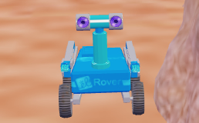

Introduction: Congratulations! You have finished training. Now, as a certified NASA programmer, you are ready to program the rover for its tasks on Mars. First, you will practice the missions here on Earth. Then, you will send the rover to Mars.

Question: Can you write more complex codes to prepare the rover for a Mars mission?

- Program: Write codes that will complete mission tasks 1-4. You can start in block mode and then switch to text mode to optimize your code, or write the code from scratch in text. After you complete each task, take a screenshot and add it to your document. Hand it in when you turn in this worksheet. Answer the following questions as you go.

- For mission task 2, how can you edit the loop text to complete the mission in the most efficient way?
- For mission task 3, try to get the rover to the X by jumping over the rock. How much battery power does this save?
- In mission task 4, how can you use a loop to conserve battery power?

- Challenge: Missions 5 and 6 are more complex. Use the Gizmo to solve these tasks, and then take a screenshot of each one. Add these screenshots to your document.

- In mission task 5, the barriers are too high to jump over. How can you get to the X?

- Optional: If you are up to the challenge, try finding two different ways to complete mission 6. Take a screenshot to record each method.

- Mission: Switch to the MISSION tab. The rover is now on a faraway planet. Once you press Transmit program, you cannot start a mission over again, so try to get to the X in one turn.

Click Transmit program to send your program to the rover. Do this for all 6 missions.

- Did the rover complete all the missions? If so, congratulations!

- What battery % do you have left? Compare your results to your classmates.

