Name: Date:

**Student Exploration:** **Proportions and Common Multipliers**

**Vocabulary:** common multiplier, proportion

**Prior Knowledge Questions** (Do these BEFORE using the Gizmo.)

1. A bakery sells packages of 6 cupcakes for $10. If the bakery starts selling the cupcakes in packages of 12, how much would you expect a package of 12 to cost?
2. Explain your reasoning.

**Gizmo Overview**

In the *Proportions and Common Multipliers* Gizmo, you will be given a proportion with an unknown value. A **proportion** is an equation that shows two ratios are equal. You will model the proportion with counters and use the model to find the unknown value, or solution.

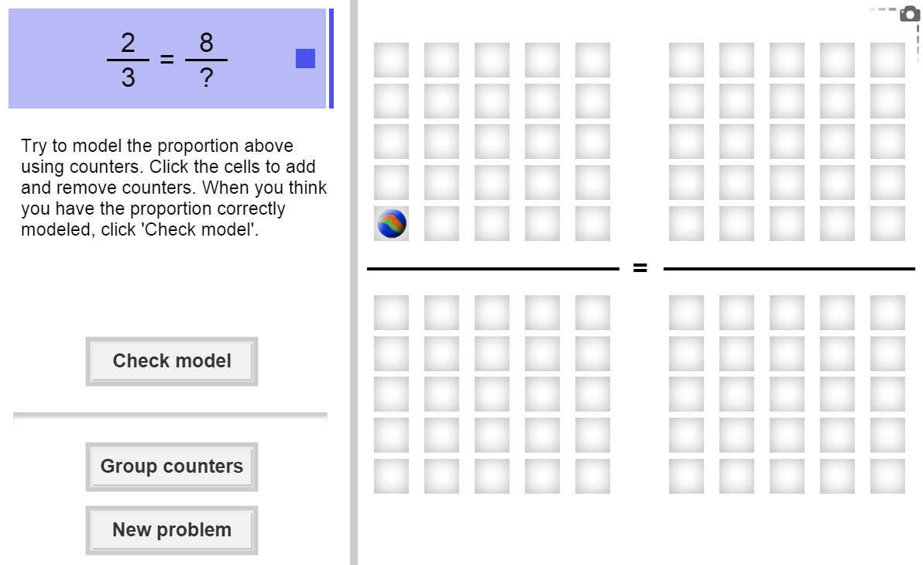Here’s how the Gizmo looks at first:

The proportion for you to solve is shown here.

The boxes give you space to model the proportion. To add or remove counters, click the boxes. (To add many counters quickly, you can click and drag the cursor over the boxes.)

To display your counters in groups, click **Group counters**.

To check your work, click **Check model**.

Once your model is correct, a **Your answer** box will appear. Type the missing value. Then click **Check answer**.

Click **New problem** for a new proportion to model and solve.

|  |  |  |
| --- | --- | --- |
| **Activity:**  **Solving a proportion** | Get the Gizmo ready:   * You should see the proportion  = . If not, click **Refresh** in your browser. | 268SE2 |

1. 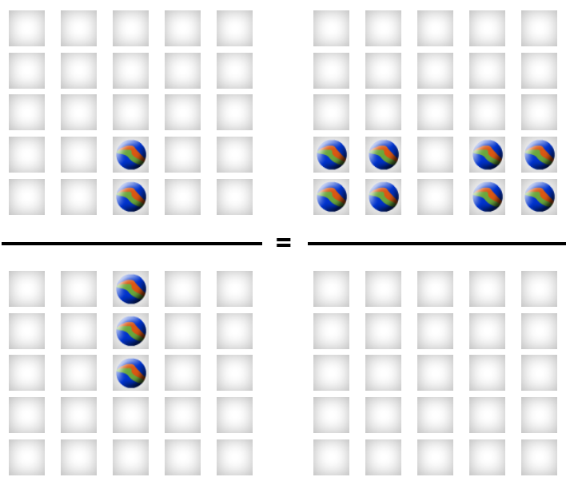To begin, model  = in the Gizmo, with counters. To model $\frac{12}{?}$, click 2 of the top-left boxes (the first numerator) and 3 of the bottom-left boxes (the first denominator). To model $\frac{3}{5}$, click 8 of the top-right boxes (the second numerator). Leave the bottom-right boxes blank for the unknown value.
2. Click **Group Counters**. The counters should now be organized in like groups. Then fill in the blanks below to describe how the counters are grouped to model  = .

 = 

1. What denominator would create equal ratios above? group(s) of counter(s)

1. In the Gizmo, click to place those counters. How many did you insert?

Click **Check Model** to see if your model is correct. (If not, keep trying.) If it is, type in that value and click **Check answer**. This is the solution of the proportion.

1. What is the solution of the proportion  = ?
2. Click **New problem**. You should now see the proportion  =  at the top of the Gizmo.
3. Use the Gizmo to model and solve the proportion. What is the solution?
4. Substitute your solution into the original proportion. What do both of these fractions equal, if written in simplest form (lowest terms)?
5. Explain what this shows about proportions.

**(Activity continued on next page)**

**Activity (continued from previous page)**

1. Proportions can be solved numerically too, of course, even without this Gizmo.
   1. Consider the proportion  = . In the numerators, what times 2 equals 8?
   2. In the denominators, what multiplied by 3 gives you 12?

This number is called the **common multiplier** in the proportion.

* 1. What is the common multiplier in the proportion  = ?
  2. In the proportion  = , what must the common multiplier be?
  3. What is the solution to the proportion above? Explain.

1. Click **New problem**. Work through several more problems in the Gizmo, using either visual patterns (counters) or common multipliers. Be sure to read the feedback along the way.
2. Solve each proportion below. Write all your steps in the space below each problem.
3.  = 
4.  = 
5.  = 
6.  = 