Name: Date:

**Student Exploration: Points in the Complex Plane**

**Vocabulary:** additive inverse, complex conjugate, complex number, complex plane,   
imaginary unit, imaginary axis, imaginary number, quadratic formula, real axis, real number

**Prior Knowledge Questions** (Do these BEFORE using the Gizmo.)

*x* = 

The **quadratic formula**, shown to the right, is used to find the solutions of a quadratic equation in the form *ax*2 + *bx* + *c* = 0.

1. Use the quadratic formula to find the solutions of *x*2 – 3*x* + 2.5 = 0. Show your work in the space to the right. Get as far as you can.
2. You should get *x* =  or *x* = 1.5 ± . What is the square root of –1?

Explain.

1. Negative numbers do not have real square roots, but they do have roots that are **imaginary numbers**. The **imaginary unit** *i*is defined as the square root of –1: *i* =  and *i*2 = –1.

Substituting *i* for , what are the roots of *x*2 – 3*x* + 2.5?

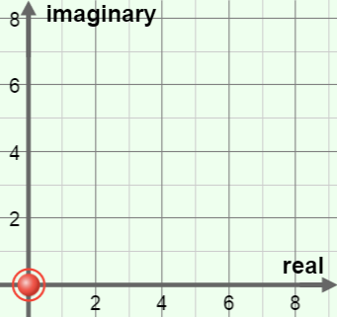**Gizmo Warm-up**

Although imaginary numbers may sound strange, they are useful in several branches of math and science. For example, the roots of some quadratics are **complex numbers** (*z*) that consist of a real part (*a*) and an imaginary part (*bi*): *z* = *a* + *bi* (*a* and *b* are **real numbers**).

The *Points in the Complex Plane* Gizmo allows you to plot complex numbers on a grid called the **complex plane**. Notice that the complex plane has a horizontal **real axis** and a vertical **imaginary axis**.

1. Drag the red point into the origin at the center of the grid. Move the ***a*** slider back and forth. What happens to the red point?
2. Return the point to the origin, and move the ***b*** slider back and forth. How does this affect the position of the red point?

|  |  |  |
| --- | --- | --- |
| **Activity A:**  **The complex plane** | Get the Gizmo ready:   * With the red point on the graph, set ***a*** and ***b*** to 0. (To quickly set a slider to a value, type the value into the text box to the right of the slider, and hit **Enter**.) | 147SE2 |

1. With the red point at the origin, move the ***a***slider back and forth. Look on the chart below   
   ***z* = *a* + *bi***. The value of the complex number ***z*** for each point is given on the chart.
2. Set ***a*** to 1. What is the value of *z*?
3. Set ***a*** to –5. What is the value of *z*now?

When *b* = 0, the number is an ordinary real number and is plotted on the real axis.

1. Set ***a*** to 0 and ***b*** to 2.
2. What is the value of *z*?
3. Set ***b*** to –8. What is the value of *z* now?

When *a* = 0 and *b* ≠ 0, the number is imaginary and lies on the imaginary axis.

1. Set ***a*** to 4 and ***b*** to 7. What is the value of ***z***?

When *a* ≠ 0 and *b* ≠ 0, the number is a complex number of the form *z* = *a* + *bi*.

1. 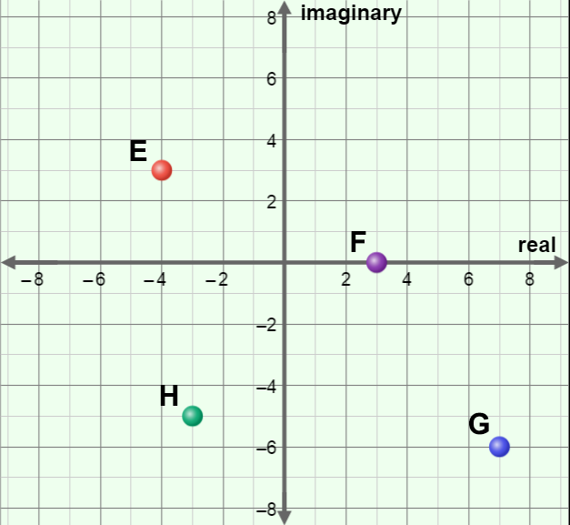Plot the points A–D on the grid to the right. Then write the coordinates of points E–H below, using the *a* + *bi* notation. Use the Gizmo to check your answers.
2. 8 + 4*i*
3. –5 – 2*i*
4. –2 + 7*i*
5. –3*i*

|  |  |  |
| --- | --- | --- |
| **Activity B:**  **Complex arithmetic** | Get the Gizmo ready:   * Remove all points from the grid. Drag the red point to 3 + *i* and the blue point to 4 + 5*i*. | 147SE4 |

1. To add complex numbers, just add the real parts and then add the imaginary parts. For example, the sum of 2 + 3*i* and 4 + 5*i* is (2 + 4) + (3 + 5)*i*, or 6 + 8*i*.

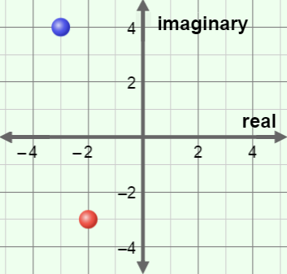

1. What is the sum of (3 + *i*) and (4 + 5*i*)?
2. Find the sum of –4 + 6*i* and 5 – 3*i*.
3. What is the sum of the two complex numbers graphed to the right? Show your work below.

+ =

1. The **additive inverse** of a complex number *z*1 is a complex number *z*2 where *z*1 + *z*2 = 0.
2. In the Gizmo, drag the red point to 4 + 5*i* and a second point to its additive inverse.

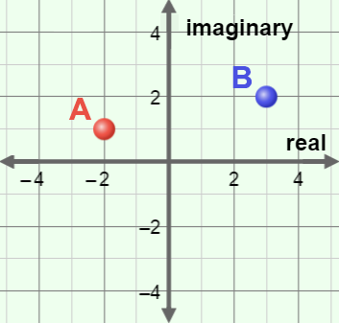What is the additive inverse of 4 + 5*i*?

1. On the grid to the right, plot the additive inverses of points A and B. Label the additive inverses A’ and B’. How is the position of each additive inverse related to the position of the original point?

1. In general, how do you find the additive inverse of a complex number?

1. Remove all points but the red point, and place the red point at 3 + 5*i*. Turn on **Show complex conjugates**. The **complex conjugate** () of a complex number has the same real part and the opposite imaginary part. For example, the conjugate of *a* + *bi* is *a* – *bi*.
2. What is the complex conjugate of 3 + 5*i*? =
3. Move the red point to –3 – 4*i*. What is the complex conjugate of –3 – 4*i*?
4. Drag the red point around. Where is the complex conjugate located, relative to the original point?

**(Activity B continued on next page)**

**Activity B (continued from previous page)**

1. Multiplying two complex numbers is similar to multiplying binomials. For example, the product of (2 + 3*i*) and (1 + 4*i*) is:

(2 + 3*i*)(1 + 4*i*) = (2 • 1) + (2 • 4*i*) + (3*i* • 1) + (3*i* • 4*i*)

= 2 + 8*i* + 3*i* + 12*i* 2

= 2 + 11*i* + 12(–1) (Recall that *i* 2 = –1)

= 2 + 11*i* – 12

= –10 + 11*i*

Find the following products. Show your work.

(2 + 5*i*)(3 + *i*) = (4 – *i*)(5 + 2*i*) =

1. An interesting thing happens when you multiply a complex number by its conjugate. Try the following problems. Show your work.

(4 + 2*i*)(4 – 2*i*) = (–1 + 6*i*)(–1 – 6*i*) =

What is true about the product of a complex number and its conjugate?

1. Extension: Complex conjugates can help when dividing one complex number by another. For example, consider (14 + 5*i*) ÷ (1 + 4*i*). First, write it as a fraction. Then, simplify by multiplying the numerator and the denominator by the conjugate of the denominator, (1 – 4*i*).

Complete the calculation to find the quotient. See if you can simplify the answer to a single complex number.

 •  =