Vocabulary: Quadratics in Factored Form

Vocabulary

      - Factored form of a quadratic function – a function of the form y = a(x – r₁)(x – r₂), where a ≠ 0 and r₁ and r₂ are the roots of the related equation.

- Linear factor – a first-degree factor of a polynomial.
  - For example, the polynomial x² – 2x – 8 = (x + 2)(x – 4), so the linear factors of
x² – 2x – 8 are (x + 2) and (x – 4).

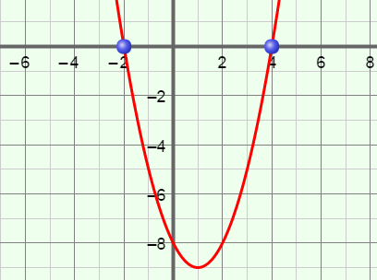
- Parabola – the graph of a quadratic function.
x-intercepts
vertex
- For example, the graph of y = (x + 2)(x – 4) shown to the right is a parabola.

- Polynomial – a monomial or sum of monomials.
  - Each monomial is called a term of the polynomial.
- For example, x² – 2x – 8 is a polynomial with three terms.

- Quadratic function – a function in which y depends on the square of x.
- The polynomial form of a quadratic function is y = ax² + bx + c and the factored form is y = a(x – r₁)(x – r₂), where a ≠ 0.
- The graph of a quadratic function is always a parabola.

- Root of an equation – a quantity that makes the related function equal to 0.

- Vertex of a parabola – the point that is the maximum or minimum of a parabola.
- The vertex is the minimum when the parabola opens up, and it is the maximum when the parabola opens down.
- For example, the vertex of the parabola shown above is a minimum.

- x-intercept – the x-coordinate where a graph intersects the x-axis.
- For example, the x-intercepts of the graph above are –2 and 4.

