Name: Date:

Student Exploration: Quadratics in Vertex Form

Vocabulary: axis of symmetry, parabola, quadratic function, vertex form of a quadratic function, vertex of a parabola, x-intercept, y-intercept

Prior Knowledge Questions (Do these BEFORE using the Gizmo.)
The graph of the function y = |x| is shown to the right.

- What can you do to y = |x| to move the graph up 1 unit?

- What can you do to y = |x| to move the graph 2 units left?

- What can you do to y = |x| to make the graph open down?

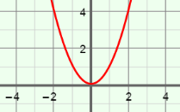
Gizmo Warm-up
A quadratic function is any function in which y depends on the square of x. A quadratic function can be written in polynomial form,
y = ax² + bx + c, or in vertex form, y = a(x – h)² + k. You will explore the vertex form in the Quadratics in Vertex Form Gizmo.

- To begin, graph y = x² by setting a to 1.0, h to 0.0, and k to 0.0. (Change the values by dragging the sliders, or by clicking in the text field, typing in a value, and hitting Enter.) Notice that this graph is the parabola shown above.

- Drag the k slider back and forth. How does this affect the graph?

- Set k back to 0.0. Drag the h slider back and forth. How does this affect the graph?

- Set h back to 0.0. Drag the a slider back and forth.

- What happens as a increases?

- What happens when a is less than zero?

Activity A:  The vertex | Get the Gizmo ready:  - Set a to 1.0, h to 0.0, and k to 0.0. | 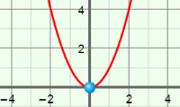

- The vertex of a parabola is either the maximum or minimum point. Vary the value of a.

- How does the sign of a determine if the vertex is a maximum or a minimum point?

- How does the value of a affect the width and steepness of the parabola?

- Turn on Show vertex and intercept(s). Set the value of a to 1.0. Vary the values of h and k. Watch the coordinates of the vertex as you do.

How do the values of h and k relate to the coordinates of the vertex?

- Turn off Show vertex and intercept(s), and turn on Show axis of symmetry. The axis of symmetry is a line that divides a parabola into two halves that are mirror images.

- Graph y = x². Vary the value of h. What do you notice about the number in the equation of the axis of symmetry and the value of h?
- What is the general equation of the axis of symmetry for the graph of a quadratic function given in vertex form? x =
- Vary the value of k for a variety of functions. As k is varied, what do you notice about the location of the vertex?
- The equation of the axis of symmetry of the graph of a quadratic function in polynomial form, y = ax² + bx + c, is x = .

Is it easier to find the equation of the axis of symmetry for a quadratic function in polynomial or vertex form?

Activity B:  The intercepts | Get the Gizmo ready:  - Set a to 1.0, h to 1.0, and k to –4.0.  - Turn on Show vertex and intercept(s).  - Turn off Show axis of symmetry. | 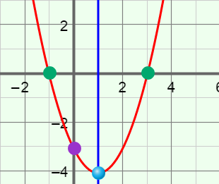

- The function graphed in the Gizmo should be y = (x – 1)² – 4.

  - The y-intercept of the graph is the value of y when x is zero. Write an equation for the y-intercept of this graph. Then simplify the equation in the space to the right. Check your answer by comparing it to the
y-intercept given in the Gizmo.

  - Now simplify the right side of the equation y = a(0 – h)² + k. What is the general equation of the y-intercept? y = Experiment with a variety of quadratic functions to check that this equation always works.

- Graph the function y = (x – 1)² – 4 again.

- The x-intercepts of the graph are the values of x when y is zero. Substitute zero for y in y = (x – 1)² – 4 and solve for x. Show your work in the space to the right. Check your answer by comparing it to the
x-intercepts given in the Gizmo.

- Turn on Show axis of symmetry to see the axis of symmetry. How do the locations of the x-intercepts of this graph relate to the axis of symmetry?

Vary the value of k to check that this relationship always exists.

- Solve the equation 0 = a(x – h)² + k for x to find the general equation of the x-intercepts. Show your work in the space to the right. (Remember that square roots can be positive or negative.)

- How does the general equation prove that the x-intercepts are equidistant from the axis of symmetry? (Hint: Recall that the equation for the axis of symmetry is x = h).

(Activity B continued on next page)
Activity B (continued from previous page)

- In the Gizmo, graph y = –(x – 2) + 1. Select the TABLE tab.

- How can you use the table to find the x- and y-intercepts?

- What are the intercepts? x-intercepts: y-intercept:

Select the CONTROLS tab to check your answer.

- Tell whether the graph of each of the following functions opens up or down, and find the vertex, line of symmetry, and intercepts. Show your work for the intercepts. Then graph each function in the Gizmo to check your answers. Sketch each graph on the coordinate plane to the right of each function.

- y = 2(x – 5)² – 2
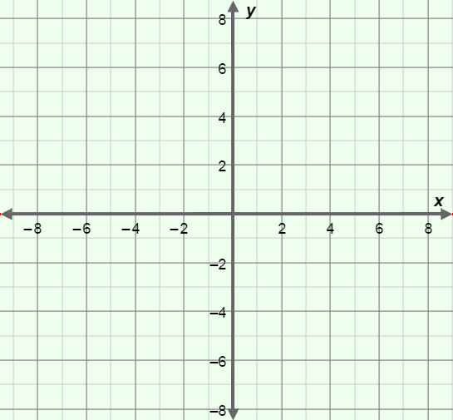
Opens:

Vertex: ( , )

Axis of symmetry: x =

y-intercept:

x-intercepts:

- y = –3(x + 4)² + 3
Opens:

Vertex: ( , )

Axis of symmetry: x =

y-intercept:

x-intercepts:

