Name: Date:

Student Exploration: Quilting Bee

Vocabulary: line of symmetry, line symmetry, quilt, reflection, rotational symmetry, symmetry

Prior Knowledge Questions (Do these BEFORE using the Gizmo.)
A quilt is a bedcover made from pieces of fabric sewn together. Many quilts exhibit symmetry, which means that different parts of the quilt match up with one another. Look at the quilts below.

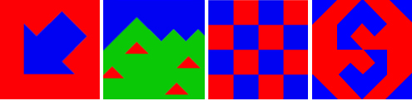
A
B
C
D

- Which quilt or quilts do you think show symmetry? _________________________________

Explain. __________________________________________________________________

- Which quilt or quilts do you think do not show symmetry? ___________________________

Explain. __________________________________________________________________

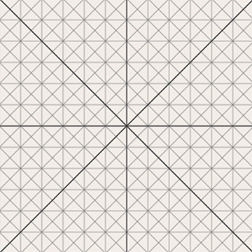
Gizmo Warm-up
Traditionally, quilts were made in quilting bees. At the start of spring, women would gather together to sew and prepare food while the men worked in the fields. The Quilting Bee Gizmo allows you to explore symmetry by creating, folding, and rotating quilts.

- Click Clear, and turn on Show grid. Below Fabric color, select a color to start with. Click inside the quilting area to add fabric to the quilt. Make a simple quilt and then sketch what you did in the space at right.

- Fold and unfold your quilt by clicking the and buttons along the sides of the quilt.

Can you fold the quilt so that both halves match up perfectly? ________________________

Explain: __________________________________________________________________

Activity A:  Line symmetry | Get the Gizmo ready:  - Click Clear. Turn off Show grid.  - Under Symmetry type, click the button.

You have just been hired to work at Quackenbush Quality Quilts, a store specializing in symmetrical quilts. On your first day on the job, you meet a customer who only likes quilts with line symmetry. A quilt has line symmetry if two sides are reflections or mirror images.
- From the Quilt gallery, select quilt 6. Click the button above the quilt to fold it across a vertical (up and down) line. Do the two sides match up? ___________
If the two sides are mirror images, the vertical line is called a line of symmetry.
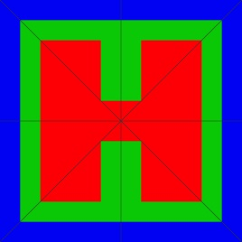

- Select quilt 7. On the image at right, draw as many lines of symmetry as you can. Check your answers by folding the quilt along these lines.

How many lines of symmetry did you find? __________

- Select quilt 2, the one with the green rectangle. Click the and buttons.

Is either the vertical or horizontal line a line of symmetry? ___________________________

- Move the fold lines by dragging the icons. Can you find lines of symmetry now? _____

Which ones did you find? ____________________________________________________

- Look through the other quilts in the Quilt gallery. (Remember that you can drag the vertical and horizontal fold lines around to help find lines of symmetry!)

  - List 2 quilts that have a vertical ( | ) line of symmetry: ________________

  - List 2 quilts that have a horizontal (—) line of symmetry: ________________

  - List 2 quilts that have a diagonal ( ⁄ ) line of symmetry: ________________

- Click Clear, and turn on Show grid. The Symmetry type buttons allow you to automatically create a symmetric quilt. Choose one of these buttons and create a quilt of your own design.

When you have finished, click the camera in the upper right corner. Open a blank word-processing document, and select Paste to paste in your quilt. If you like, challenge your classmates to identify the lines of symmetry in your quilt.

Activity B:  Rotational symmetry | Get the Gizmo ready:  - Click Clear.  - Under Symmetry type, click the button. | 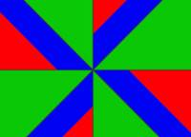

Another client of Quackenbush Quality Quilts only likes quilts that have rotational symmetry. A quilt has rotational symmetry if it looks exactly the same after being turned.

- From the Quilt gallery, select quilt 13.
  - Do you think this quilt might look the same after it has been rotated? ________
  - Click the button to turn the quilt 90°. Does it look the same as before? ________
  - Click the button once more to turn the quilt a total of 180°. Does the quilt look the same as it did before it was turned? ________
For this quilt, there are two positions that look the same: The original position is one, and turned 180° is the second. Because of this, the quilt has twofold rotational symmetry.

- Now select quilt 8 from the Quilt gallery.
  - Do you think this quilt might look the same after it has been rotated? ________
  - Click the button to turn the quilt 90°. Does it look the same as before? ________
  - Click the button three more times to get back to the original position. Does the quilt ever change? ________
There are four positions where this quilt looks the same: the original position, rotated 90°, rotated 180°, and rotated 270°. Therefore, the quilt has fourfold rotational symmetry.

- Besides quilts 8 and 13, there are 5 other quilts in the gallery that have rotational symmetry. List these quilts and state whether they have twofold or fourfold rotational symmetry.

Quilt | Symmetry

Quilt | Symmetry

- Click Clear. Create your own quilts with rotational symmetry. Make one quilt that has twofold rotational symmetry and one quilt that has fourfold rotational symmetry. When each quilt is complete, click the camera icon. Paste the images into a word-processing document.

Activity C:  Custom quilts | Get the Gizmo ready:  - Click Clear.  - Turn on Show grid. | 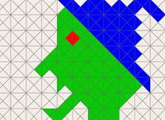

Other clients of Quackenbush Quality Quilts want to buy original, custom quilts.
- Design a quilt based on each special order.
- When you have completed the design, click the camera icon at upper right.
- Paste the image of quilt in a word-processing document.
- Name each quilt and list the kinds of symmetry it has.

- The first order is for a quilt that shows a picture of a face. The quilt should have a vertical line of symmetry.

- The second order is for a quilt with an interesting pattern. The quilt should have four lines of symmetry: horizontal, vertical, and both diagonals.

- The third order is for a quilt that has twofold rotational symmetry but no line symmetry.

- The fourth order is for a quilt with no symmetry at all.

- The fifth order is for a quilt that has a vertical line of symmetry, but not through the middle of the quilt (the line is moved over a bit). The quilt also has a horizontal line of symmetry, but not through the middle of the quilt.

- The last order is just for a beautiful and creative quilt. Have fun!

