Name: ______________________________________ Date: ________________________

Student Exploration: RNA and Protein Synthesis

Vocabulary: amino acid, anticodon, codon, gene, messenger RNA, nitrogenous base, nucleotide, ribosome, RNA, RNA polymerase, transcription, transfer RNA, translation

Prior Knowledge Questions (Do these BEFORE using the Gizmo.)

- Suppose you want to design and build a house. How would you communicate your design plans with the construction crew that would work on the house?

_________________________________________________________________________

_________________________________________________________________________

- Cells build large, complicated molecules such as proteins. What do you think cells use as their “design plans” for proteins?

_________________________________________________________________________

_________________________________________________________________________

Gizmo Warm-up
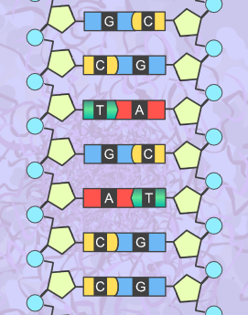
Just as a construction crew uses blueprints to build a house, a cell uses DNA as plans for building proteins. In addition to DNA, another nucleic acid, called RNA, is involved in making proteins. In the RNA and Protein Synthesis Gizmo, you will use both DNA and RNA to construct a protein out of amino acids.

- DNA is composed of the nitrogenous bases adenine (A), cytosine (C), guanine (G), and thymine (T). RNA is composed of adenine, cytosine, guanine, and uracil (U).

Look at the SIMULATION pane. Is the displayed segment a part of a DNA or RNA molecule? How do you know?

________________________________________________

- RNA polymerase is a type of enzyme. Enzymes help chemical processes occur quickly. Drag the yellow RNA polymerase molecule onto the DNA strand. Describe what happens.

_________________________________________________________________________

Activity A:  Transcription | Get the Gizmo ready:  - If necessary, drag the RNA polymerase molecule onto the DNA strand. | 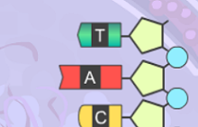

Introduction: The first stage of building a protein involves a process known as transcription. In transcription, a segment of DNA serves as a template to produce a complementary strand of RNA. This complementary strand is called messenger RNA, or mRNA.

Question: What occurs during transcription?

- Experiment: Like DNA, RNA follows base-pairing rules. Experiment to find which RNA nucleotide on the right side of the Gizmo will successfully pair with the thymine at the top of the template strand of DNA. (NOTE: The DNA on the right side is the template strand.)

Which RNA base bonded with the thymine? ______________________________________

- Experiment: The next three bases on the DNA template strand are adenine, cytosine, and guanine. Use the Gizmo to answer the following questions:

    - Which RNA base bonds with adenine? ____________________________________

    - Which RNA base bonds with cytosine? ____________________________________

    - Which RNA base bonds with guanine? ____________________________________

- Observe: In molecules of RNA, uracil takes the place of the DNA base ________________.

- Build: Continue building the strand of mRNA until you have used all of the RNA nucleotides. What is the nucleotide sequence of the mRNA strand you built?

_________________________________________________________________________

- Apply: Suppose a template strand of DNA had the following sequence:

T A C G G A T A A C T A C C G G G T A T T C A A

What would be the complementary strand of mRNA?

__ __ __ __ __ __ __ __ __ __ __ __ __ __ __ __ __ __ __ __ __ __ __ __

- Predict: How would a change to the sequence of nucleotides in a DNA segment affect the mRNA transcribed from the DNA? _____________________________________________
_________________________________________________________________________
Activity B:  Translation | Get the Gizmo ready:  - Once the mRNA strand has been built, click Continue. | 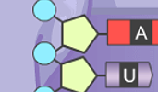

Introduction: After a strand of mRNA has been built, the strand exits the cell’s nucleus. The second stage of protein synthesis, called translation, occurs next. During translation, the strand of mRNA is used to build a chain of amino acids.

Question: What occurs during translation?

- Observe: Examine the strand of mRNA. Each group of three bases of mRNA is called a codon.

Codon | mRNA bases
1
2
3

While the mRNA strand may be longer, translation begins at the universal start codon, which has the bases AUG. In the table at right, list the nitrogenous bases in the first three codons. (Hint: Start from the top of the strand and read down.)

- Predict: Translation starts when a ribosome (the purple structure on the SIMULATION pane) binds to a strand of mRNA. Transfer RNA, or tRNA, begins bringing amino acids into the ribosome. Each tRNA molecule carries only one kind of amino acid. This amino acid is determined by the tRNA’s anticodon, a set of three unpaired bases.

Which anticodon do you think would attach to the mRNA’s start codon? ________________

Place this tRNA molecule next to the start codon.

- Observe: Place the next two tRNA molecules on the mRNA strand. What happens?

_________________________________________________________________________

_________________________________________________________________________

As each tRNA molecule binds to the mRNA, the ribosome joins the amino acid carried by the tRNA to the growing amino acid chain.

- Describe: UAG (as well as UAA and UGA) is an example of a stop codon. Molecules called release factors bind to stop codons. Place the release factor on the mRNA molecule.

What happens? ____________________________________________________________

_________________________________________________________________________

Click Continue. Your protein is now complete. Most actual proteins consist of sequences of hundreds of amino acids.

(Activity B continued on next page)
Activity B (continued from previous page)

- Infer: Why do you think stop and start codon signals are necessary for protein synthesis?

_________________________________________________________________________

_________________________________________________________________________

_________________________________________________________________________

- Summarize: Describe the processes of transcription and translation in your own words, based on what you have observed in the Gizmo.

Transcription: ______________________________________________________________

_________________________________________________________________________

_________________________________________________________________________

_________________________________________________________________________

_________________________________________________________________________

_________________________________________________________________________

Translation: _______________________________________________________________

_________________________________________________________________________

_________________________________________________________________________

_________________________________________________________________________

_________________________________________________________________________

_________________________________________________________________________

Extension:  Genes and traits | Get the Gizmo ready:  - You will not need to use the Gizmo for this activity. | 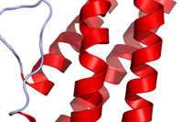

Introduction: Inside a ribosome, amino acids are linked together to form a protein molecule. As the chain of amino acids grows, it folds and coils to form a three-dimensional shape. The complex shape that results determines the properties of the protein. Proteins have a wide variety of structures and perform many essential functions in living things.

A sequence of DNA that codes for a specific protein is called a gene. By coding for proteins, genes determine an organism’s inherited traits.

Question: How do genes code for specific proteins and traits?

- Translate: Each codon codes for one of 20 amino acids. This code is universal among all living things. For example, the mRNA codon GGU codes for the amino acid glycine in every living thing, from a bacteria to an elephant.

Examine the codon chart below. The amino acid coded for by a specific mRNA codon can be determined by finding the first base of the codon along the left side of the table, the second base along the top of the table, and the third base along the right side of the table.
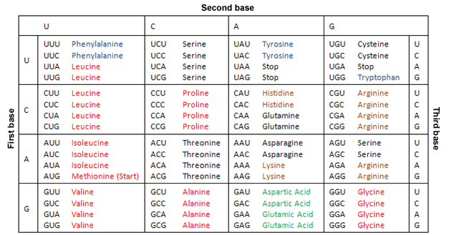

_________________________________________________________________________

What amino acids do the following codons code for?

AUG: _____________ CUG: _____________ ACC: _____________ UAG: _____________

(Extension continued on next page)
Extension (continued from previous page)

- Apply: Suppose you wanted a protein that consists of the amino acid sequence methionine, asparagine, valine, and histidine. Give an mRNA sequence that would code for this protein.

___ ___ ___ ___ ___ ___ ___ ___ ___ ___ ___ ___

- Summarize: How do genes determine the traits of an organism? Explain in detail.

_________________________________________________________________________

_________________________________________________________________________

_________________________________________________________________________

_________________________________________________________________________

_________________________________________________________________________

- Extend your thinking: Sometimes errors occur during transcription or translation. Examine the codon chart on the previous page. Notice that each amino acid is coded for by several different codons. For example, alanine is coded for by GCU, GCC, GCA, and GCG.

How might this offset transcription or translation errors? ____________________________

_________________________________________________________________________

_________________________________________________________________________

- Think and discuss: Consider the two following statements:
- The theory of evolution states that all living things had a single common ancestor.
- The translation between mRNA and amino acids is the same for all living things. (For example, the mRNA codon CAG codes for glutamine in all living things.)

Does the second statement support the theory of evolution? Explain why or why not. If possible, discuss your answer with your teacher and classmates.

_________________________________________________________________________

_________________________________________________________________________

_________________________________________________________________________

_________________________________________________________________________

_________________________________________________________________________

