Name: ______________________________________ Date: ________________________

Student Exploration: Rainfall and Bird Beaks

Vocabulary: adaptation, beak depth, directional selection, drought, evolution, natural selection, range, stabilizing selection

Prior Knowledge Questions (Do these BEFORE using the Gizmo.)
During the voyage of the HMS Beagle (1831–1836), the young Charles Darwin collected several species of finches from the Galápagos Islands. Two of Darwin’s finches are shown below.
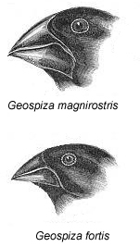
- Which species do you think is best adapted to a diet of small, delicate seeds? Explain why you think so.

_______________________________________________________

_______________________________________________________

- Which species do you think is best adapted to a diet of large, tough-to-crack seeds? Explain.
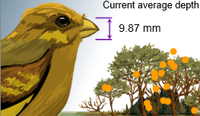

_______________________________________________________

_______________________________________________________

Gizmo Warm-up
Darwin’s finches are one of many types of animals on the Galápagos Islands that have unique adaptations, or traits that help an organism survive in its environment. The Rainfall and Bird Beaks Gizmo allows you to explore how rainfall influences the range of beak shapes found in a single finch species.

- The beak depth of a finch is the distance from the top of the beak to the bottom, as shown.

  - What is the current average beak depth in the Gizmo? ________________________

  - Select the HISTOGRAM tab. Do all the finches have the same beak depth? _______

- Click Play () and let the simulation play for five years with average rainfall (25 cm/yr). Select the GRAPH tab and view the Finches vs time and Beak depth vs time graphs.

  - How does the finch population change? __________________________________

  - Does the beak depth change significantly? ________________________________

Activity A:  Normal years | Get the Gizmo ready:  - Click Reset (). | 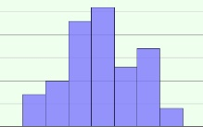

Introduction: The Galápagos Islands are very dry, with an average rainfall on some islands of only 12 centimeters per year. The amount of rainfall has a large impact on the abundance and types of seeds that are available to be eaten by finches. In the process of natural selection, only the finches that are best adapted to the available seed types survive and have offspring.

Question: How is the finch population affected by a period of average rainfall?

- Observe: With the Rain sliders set to 25 cm, click Play, and then Pause () after one year has passed. Select the TABLE tab and look at the Month and Finches columns.

- How did the finch population change over the course of one year? ______________

___________________________________________________________________

- The finches have their young during the rainy season. Based on the table, which part of the year do you think is the rainy season? _______________________________

- Analyze: Click Reset, and choose the HISTOGRAM. The bars represent the numbers of finches that have different beak depths. The range of beak depths is equal to the difference between the largest and smallest beaks.

  - What is the average beak depth of the current finch population? ________________

  - What is the range in beak depths in the population? __________________________

  - Do most of the finches have beak depths near the lower extreme, the middle, or the higher extreme of the range? ____________________________________________

- Experiment: Click Play, and observe the histogram as the simulation plays for five years.

  - What is the average beak depth now? ____________________________________

  - What is the current range of beak depths? _________________________________
  - Based on what you have seen, are finches with very small, medium, or very large beaks most likely to survive in times of normal rainfall? Justify your answer.

___________________________________________________________________

___________________________________________________________________

___________________________________________________________________

Activity B:  Drought | Get the Gizmo ready:  - Click Reset. | 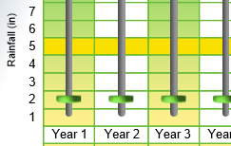

Introduction: In years of extreme drought, Galápagos plants don’t produce new seeds. The small, delicate seeds get eaten up quickly, leaving behind only the largest, toughest seeds.

Question: How does drought affect the finch population and average beak depth?

- Form hypothesis: What type of beak do you think will be best for finding food in a drought?
_________________________________________________________________________

- Predict: Select the HISTOGRAM tab. On the left side below, sketch the current histogram and list the average beak depth and range of beak depths. On the right side, sketch what you think the histogram will look like after five years of drought. Explain your prediction.

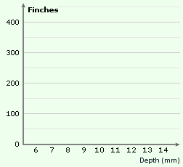
Initial beak depths Beak depths after 5 years (predicted)

Initial number of finches: ___________ Explanation: ________________________

Initial average depth: _________ ___________________________________

Initial range of beak depths: _________ ___________________________________

- Experiment: Use the sliders to set the Rain to 5 centimeters for each of the five years in the simulation. Click Play, and wait for five years. Observe the beak of the finch.

    - How does the beak depth change over time? _______________________________

    - What is the final average beak depth? ____________________________________

    - What is the final range of beak depths? ___________________________________

(Activity B continued on next page)
Activity B (continued from previous page)

- Describe: Compare the final histogram to the initial histogram. How have the finches been affected by drought? Describe at least two changes that you notice.

_________________________________________________________________________

_________________________________________________________________________

- Analyze: Was the increase in the average beak depth caused by an increase in large-beaked finches or a decline in small-beaked finches? Explain your answer.

_________________________________________________________________________

_________________________________________________________________________

_________________________________________________________________________

- Draw conclusions: What do you think caused the changes in the finch population and average beak size during the drought?

_________________________________________________________________________

_________________________________________________________________________

_________________________________________________________________________

- Interpret: Directional selection occurs when individuals at one end of a range are more likely to survive than intermediate individuals or individuals at the opposite end of the range. Stabilizing selection occurs when intermediate individuals are the most likely to survive.

Is directional selection, stabilizing selection, or both operating in this example? Explain.

_________________________________________________________________________

_________________________________________________________________________

_________________________________________________________________________

- Think and discuss: Evolution is the process by which populations of organisms can change over time. How is directional selection related to evolution?

_________________________________________________________________________

_________________________________________________________________________

_________________________________________________________________________

Activity C:  Rainy days | Get the Gizmo ready:  - Click Reset. | 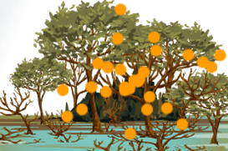

Introduction: In years of abundant rainfall, there can be 50 centimeters or more of rain. In these years, plants produce an enormous number and variety of seeds.

Question: How does plentiful rainfall affect the finch population and average beak depth?

- Form hypothesis: What beak shape do you think will be best for finding food in a period of abundant rainfall? __________________________________________________________

- Predict: Select the HISTOGRAM tab. On the left side, sketch the current histogram and list the average beak depth and range of beak depths. On the right side, sketch what you think the histogram will look like after five years of abundant rain. Explain your prediction.

Initial beak depths Beak depths after 5 years (predicted)

Initial number of finches: ___________ Explanation: ________________________

Initial average depth: _________ ___________________________________

Initial range of beak depths: _________ ___________________________________

- Experiment: Click Reset. Use the sliders to set the Rain to 50 cm for each of the five years in the simulation. Click Play, and wait for five years. Observe the beak of the finch.

    - How does the beak depth change over time? _______________________________

    - What is the final average beak depth? ____________________________________

    - What is the final range of beak depths? ___________________________________

(Activity C continued on next page)
Activity C (continued from previous page)

- Describe: Compare the final histogram to the initial histogram. How have the finches been affected by abundant rain? Describe at least two changes that you notice.

_________________________________________________________________________

_________________________________________________________________________

- Analyze: Was the decrease in the average beak depth caused by an increase in small-beaked finches or a decline in large-beaked finches? Explain your answer.

_________________________________________________________________________

_________________________________________________________________________

_________________________________________________________________________

- Draw conclusions: What do you think caused the changes in finch population and average beak size during the period of abundant rain?

_________________________________________________________________________

_________________________________________________________________________

_________________________________________________________________________

- Extend your thinking: Most scientists think that a small group of finches colonized the Galápagos Islands thousands of years ago. They would have been the only seed-eating birds on the islands. Suppose one island was very dry and another had plentiful rainfall.

    - How would the finch populations on these islands change over time? ____________

___________________________________________________________________

___________________________________________________________________

___________________________________________________________________

    - What might happen to the finch populations after millions of years? ______________

___________________________________________________________________

___________________________________________________________________

___________________________________________________________________

