Vocabulary: Rational Functions

dictionary2

**Vocabulary**

* 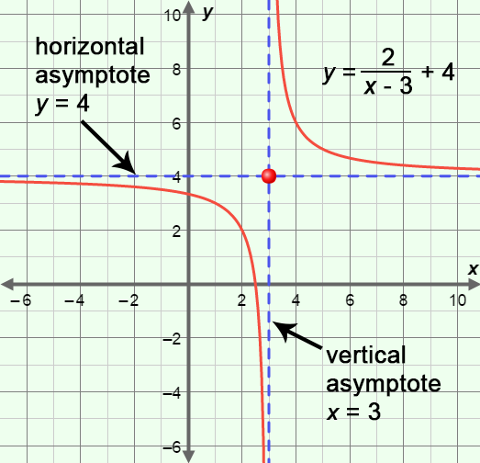Asymptote – a line that a graph approaches more and more closely.
  + Asymptotes are most commonly shown as dashed lines to represent that they are not a part of the graph itself.
  + A *horizontal asymptote* is a horizontal line that a graph approaches as the value of *x* goes to positive or negative infinity.
    - For example, the graph of the rational function *y* =  + 4, shown to the right, has a horizontal asymptote of   
      *y* = 4.
  + A *vertical asymptote* is a vertical line that a graph approaches.
    - For example, the graph of the rational function *y* =  + 4, shown above has a vertical asymptote of *x* = 3.
    - Vertical asymptotes occur at an *x*-value for which the function is undefined, usually due to division by zero.
* Hyperbola – a type of graph whose shape results from graphing a rational function.
  + The graph of a hyperbola has two disconnected and symmetrical parts, called *branches*.
* Rational function – a function of the form *y* = , where the denominator cannot be zero.
  + For example, *y* =  and *y* =  are both rational functions.
* Translation – a *transformation* that shifts every point of a figure in the same distance and same direction.
  + A translation can shift a graph horizontally, vertically, or both.