Name: ______________________________________ Date: ________________________

**Student Exploration:** **Ray Tracing (Lenses)**

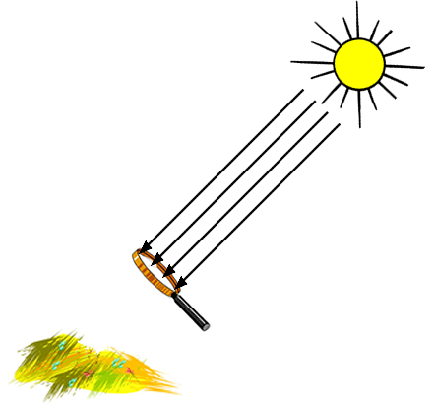

**Vocabulary:** concave lens, convex lens, focal point, image, magnification, real image, refraction, virtual image

**Prior Knowledge Questions** (Do these BEFORE using the Gizmo.)

Agnes is trapped on a desert island with nothing but a magnifying glass. She wants to use the glass to focus sunlight and start a fire. She holds the glass above some dry grass as shown at right.

1. On the diagram, draw the path the Sun rays will likely take from the magnifying glass to the grass.
2. A magnifying glass is an example of a **convex lens**—a lens that curves outward on both sides.

Why is a convex lens useful for starting fires? ____________________________________

_________________________________________________________________________

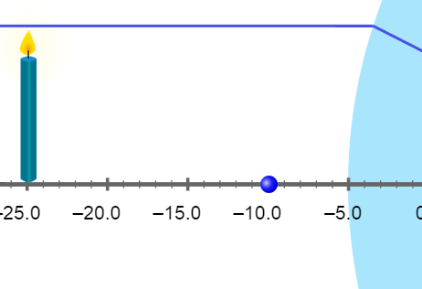

**Gizmo Warm-up**

The *Ray Tracing (Lenses)* Gizmo shows light rays passing through a lens. The light rays are bent by **refraction** as they pass through the lens and form a focused **image** to the right of the lens.

To begin, turn on the **Colorize lines** checkbox. Under **Show lines**, turn off the **Central line** and the **Line through focal point** so that only the **Parallel line** is showing.

1. The blue dots in front of and behind the lens are the **focal points** of the lens. Move the candle on the left back and forth and up and down.

What is always true about the light ray that emerges from the right side of the lens?

_________________________________________________________________________

1. Turn off the **Parallel line** and turn on the **Line through focal point**. Move the candle.

What do you notice about this line? _____________________________________________

_________________________________________________________________________

|  |  |  |
| --- | --- | --- |
| **Activity A:**  **Real and virtual images** | Get the Gizmo ready:   * Turn on the **Parallel line**, **Central line**, and **Line through focal point**. * Move the candle to -24 on the central axis, with the focal point at -12. | 588SE2 |

**Introduction:** A convex lens is called a “converging lens” because it focuses light rays into a point. A **real image** is formed where the light rays emitted from a point converge on the other side of the lens. If you placed a sheet of paper at the image, a focused image would be projected onto the paper.

**Question: How do lenses create images?**

1. Observe: In its current configuration, the distance from the candle to the focal point is 12 units and the distance from the focal point to the lens is also 12 units.
2. What do you notice about the orientation of the candle’s image on the right side of the lens? ___________________________________________________________
3. What do you notice about the size of the image? ____________________________

___________________________________________________________________

1. Investigate: Complete each action listed in the table below, and describe how that action affects the image to the right of the lens. Return the candle and focal point to their original positions (-24 for the candle, -12 for the focal point) after each action.

|  |  |
| --- | --- |
| **Action** | **Effect on image** |
| Move the candle to the left. |  |
| Move the candle to the right. |  |
| Move the left focal point to the left. |  |
| Move the left focal point to the right. |  |

1. Analyze: How is the image size related to the distance between the candle and the focal point? ____________________________________________________________________

_________________________________________________________________________

**(Activity A continued on next page)Activity A (continued from previous page)**

1. Explore: Move the candle to -12 and the focal point to -24. Shorten the candle to see the whole image. What do you notice when the candle is between the focal point and the lens?

_________________________________________________________________________

_________________________________________________________________________

The image you see is called a **virtual image** because no actual light rays are focused there. The dotted lines represent locations from which light appears to be coming to an observer located left of the lens. An observer would perceive a magnified virtual image of the candle. This is what happens when you look at an object through a magnifying glass.

1. Investigate: Return the candle to -24 and the left focal point to -12. Under **Show specific line segments**, turn off **Apparent light lines**. On the menu at lower right, select **Concave lens**. A **concave lens** curves inward on both sides.
2. What do you notice about the three lines after they pass through the concave lens?

___________________________________________________________________

Because a concave lens causes light rays to spread apart, it is also called a “diverging lens.”

1. Turn on **Apparent light lines**. Is the image of the candle a real image or a virtual image? Explain. (Hint: Recall that a real image forms where light rays are focused.)

___________________________________________________________________

___________________________________________________________________

1. Move the candle back and forth. No matter where the candle is placed, what is true about the image? ____________________________________________________

___________________________________________________________________

1. What would an observer see if she looked at the candle through the concave lens?

___________________________________________________________________

1. Summarize: What are the differences between the images formed by convex and concave lenses? __________________________________________________________________

_________________________________________________________________________

_________________________________________________________________________

|  |  |  |
| --- | --- | --- |
| **Activity B:**  **Thin-lens equation** | Get the Gizmo ready:   * Select the **Convex lens**. * Move the candle to -15 and the focal point to -10. * Turn off all line segments, and turn on **Show ruler**. | 588SE3 |

**Question: How is the position of the image related to the position of the object and the focal length of the lens?**

1. Measure: In this activity, you will measure the relationships between several values:

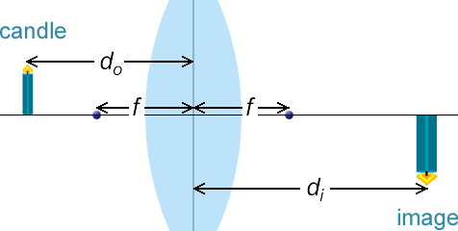

*do*: Distance between object and lens

*f*: Distance between focal points and lens

*di*: Distance between image and lens

What are the current values of these variables?

(Note: If you like, use the ruler to measure *di*.)

*do* = _____________ *f* = _____________ *di* = _____________

1. Gather data: Use the ruler to measure *di* for each of the following values of *do* and *f*. For the last three rows of the table, use your own values of *do* and *f*.

|  |  |  |  |  |  |
| --- | --- | --- | --- | --- | --- |
| ***do*** | ***f*** | ***di*** |  |  |  |
| 15 | 10 |  |  |  |  |
| 25 | 10 |  |  |  |  |
|  |  |  |  |  |  |
|  |  |  |  |  |  |
|  |  |  |  |  |  |

1. Calculate: Find the reciprocal of each value and fill in the last three columns of the table.
2. Analyze: For each row of the table, find the sum of  and .

__________ __________ __________ __________ __________

What do you notice? ________________________________________________________

**(Activity B continued on next page)Activity B (continued from previous page)**

1. Make a rule: Express the relationship between , , and  as an equation.

=

This equation is called the *thin lens equation* because it assumes a very thin lens. Errors are introduced when a thicker lens is used.

1. Practice: A candle is placed 6 cm in front of a convex lens. The image of the candle is focused on a sheet of paper that is exactly 12 cm behind the lens.

What is the focal length of the lens? _______________

Show your work:

1. Practice: A candle is placed in front of a convex lens with a focal length of 5 cm. The image of the candle is focused on a sheet of paper that is exactly 15 cm behind the lens.

What is the distance from the candle to the lens? _______________

Show your work:

1. On your own: Use the Gizmo to determine if the thin-lens equation applies to a concave lens. Report the results of your investigation below. (Hint: If the image is virtual, *di* and *f* are negative.)

_________________________________________________________________________

_________________________________________________________________________

_________________________________________________________________________

_________________________________________________________________________

|  |  |  |
| --- | --- | --- |
| **Activity C:**  **Magnification** | Get the Gizmo ready:   * Select the **Convex lens** and turn on **Show ruler**. * Move the candle to -15 and the focal point to -10. * Adjust the height of the candle to 5.0 units. | 588SE4 |

**Question: What determines the magnification of an image?**

1. Measure: What are the current values of these variables?

*do* = ___________ *f* = ___________ *di* = ___________

1. Measure: In addition to the variables you explored in the previous activity, you will now investigate several others. Measure each of these variables and list their values below.

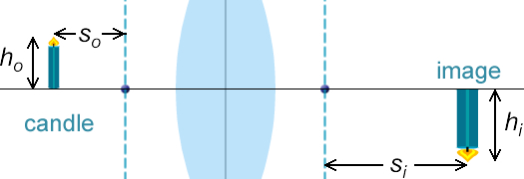

*ho*: Object height

*hi*: Image height

*so*: Object-focal point distance

*si*: Image-focal point distance

*ho* = __________ *hi* = __________ *so* = __________ *si* = __________

1. Gather data: Use the values above to fill in the first row of the table. Then run your own experiments to fill in the last three rows:

|  |  |  |  |  |  |  |  |  |  |  |
| --- | --- | --- | --- | --- | --- | --- | --- | --- | --- | --- |
| ***do*** | ***f*** | ***di*** | ***ho*** | ***hi*** | ***so*** | ***si*** |  |  |  |  |
| 15 | 10 |  |  |  |  |  |  |  |  |  |
|  |  |  |  |  |  |  |  |  |  |  |
|  |  |  |  |  |  |  |  |  |  |  |
|  |  |  |  |  |  |  |  |  |  |  |

1. Calculate: Calculate the given ratios to fill in the last four columns of the table.
2. Analyze: What do you notice about the four ratios? ________________________________

_________________________________________________________________________

_________________________________________________________________________

**(Activity C continued on next page)Activity C (continued from previous page)**

1. Make a rule: The magnificationof an image is equal to the ratio of the image height to the object height. Using the ratios from the table on the previous page, write three equations that could be used to calculate magnification:

= = =

1. Practice: A candle is placed 4 cm in front of a convex lens. The image of the candle is focused on a sheet of paper that is exactly 10 cm behind the lens.

What is the magnification of the image? _______________

Show your work:

1. Practice: A 29-cm pencil is placed 35 cm in front of a convex lens and illuminated by a spotlight. The focal point of the lens is 28 cm from the lens.
2. What is the height of the pencil’s image? _______________
3. How far from the lens will the image of the pencil be focused? _______________

Show your work:

1. Challenge: When the object is between the focal point and the lens, *so* is negative. What other values must be negative for your equations to still work? Explain. (Hint: The distance between the focal point and lens (*f*) is never negative unless the lens is concave.)

_________________________________________________________________________

_________________________________________________________________________

_________________________________________________________________________

_________________________________________________________________________