Vocabulary: Reading Topographic Maps

Vocabulary

- Contour interval – the change in elevation between adjacent contour lines.

- Contour line – a line connecting points of equal elevation on a map.
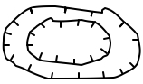

Depression contours
- Depression contour – a contour line with hachure marks to indicate a depression or hollow.
  - Depression contours form closed curves.
  - The hachure marks distinguish depression contours from contour lines that indicate a hill or mountain.

- Elevation – the height of a location above a fixed reference point, usually sea level.

- Gradient – the slope of a surface or line.
  - To calculate the gradient of a surface between two points, divide the change in elevation by the horizontal distance between the points.
  - Gradient can be estimated and compared using contour lines.

- Index contour – a contour line that includes an elevation label.

- Relief – the difference in elevation between the highest and lowest points in a landscape.

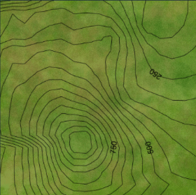
- Topographic map – a map that uses contour lines to depict variations in elevation across a landscape.
  - Contours that form closed curves usually indicate hills or mountains but can also indicate depressions.
  - Contours that are close together indicate steep slopes, while contour lines that are far apart indicate flatter terrain.
  - Contour lines in a river valley or stream are often V-shaped, with the point of the V pointing uphill.
Topographic map

