Name: ______________________________________ Date: ________________________

Student Exploration: Refraction

Vocabulary: angle of incidence, angle of refraction, frequency, index of refraction, medium, refraction, Snell’s law, total internal reflection, wave front, wavelength, wave speed

Prior Knowledge Questions (Do these BEFORE using the Gizmo.)
Two runners ran side by side, each holding one end of a horizontal pole.

- What would most likely happen if one of the runners began jogging in knee-deep water?

_________________________________________________________________________

- How would this affect the direction of the runners? Explain. _________________________

_________________________________________________________________________

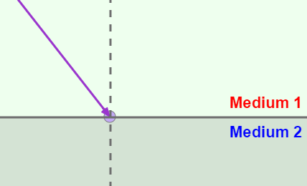
Gizmo Warm-up
Light can travel through many materials, or media. As with a runner on pavement or sand, the speed of light can change when it moves into a different medium. The Refraction Gizmo allows you to observe what happens to a beam of light as it travels from one medium to another.

Turn off View wave fronts. Set Index of refraction 2 to 3.0.

- Click Play (). Observe the ray of light as it passes from Medium 1 to Medium 2.

    - What happens to the speed of the light wave? ______________________________

___________________________________________________________________

    - What happens to the direction of the light wave? ____________________________

The bending of the light ray you see is called refraction.

- Click Reset () and turn on View wave fronts. A wave front is an imaginary line that connects the crests or troughs of a wave. The wavelength of a wave is the distance between wave fronts.

Click Play. What happens to the wavelength of the wave as it passes into Medium 2?

_________________________________________________________________________

Activity A:  Angle of refraction | Get the Gizmo ready:  - Click Reset. Turn off View wave fronts.  - Make sure View normal is selected.  - Make sure Index of refraction 1 is 1.0 and Angle of incidence is 45°.  - Set Index of refraction 2 to 2.0. | 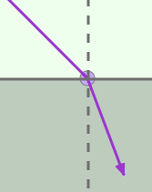

Introduction: The normal is an imaginary line perpendicular to the boundary between two media. The angle of incidence is the angle between the light ray in medium 1 and the normal. The angle of refraction is the angle between the ray in medium 2 and the normal.
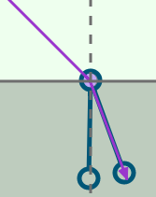
Question: What affects how much light waves refract?

- Measure: Click Play. To measure the angle of refraction, turn on Click to measure angles. Drag the protractor’s vertex to the intersection of the ray and the normal. Align the protractor’s legs to the ray and the normal in Medium 2.

What is the angle of refraction? ______________

- Gather data: For each angle of incidence listed in the table below, use the Gizmo to find the angle of refraction. Then, fill in the “Change of direction” column by subtracting the angle of refraction from the angle of incidence.

Angle of incidence | Angle of refraction | Change in direction
20°
40°
60°
80°

- Analyze: What patterns do you notice? __________________________________________

_________________________________________________________________________

_________________________________________________________________________

- Explain: Do you think refraction would occur if the angle of incidence is 0°? Explain.

_________________________________________________________________________

_________________________________________________________________________

(Activity A continued on next page)
Activity A (continued from previous page)

- Predict: The index of refraction indicates how fast light can travel through a medium. The higher the index is for a medium, the slower light will travel through that medium. How do you think increasing a medium’s index of refraction might affect the angle of refraction?

_________________________________________________________________________

- Gather data: Keep the Index of refraction 1 set to 1.0. Set the Angle of incidence to 60°. For each Index of refraction 2 listed in the table below, use the Gizmo to find the angle of refraction and the change in direction.

Index of refraction 2 | Angle of refraction | Change in direction
1.0
2.0
3.0

- Analyze: What patterns do you notice? __________________________________________

_________________________________________________________________________

- Explain: Why does no refraction occur when the media have the same index of refraction? _________________________________________________________________________

- Explore: Set the Index of refraction 2 to 1.0. Set the Angle of incidence to 25°. Collect data for each Index of refraction 1 listed in the table below.

Index of refraction 1 | Angle of refraction | Change in direction
1.5
2.0
3.0

- Analyze: What did you notice about the change in direction in the first two trials? _________________________________________________________________________
What happened in the third trial? _______________________________________________

When the angle of refraction is greater than 90°, the beam of light will reflect off of the surface instead of refracting through the surface. This is called total internal reflection.

Activity B:  Snell’s law | Get the Gizmo ready:  - Click Reset.  - You will need a scientific calculator for this activity. | 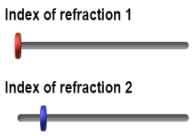

Introduction: In the mid 1600s, the Dutch scientist Willebrord Snell experimented with how light refracts. During his experiments, he determined the relationship between the angle of incidence, the angle of refraction, and the indices of refraction of two media.

Question: How can you determine the angle of refraction?

- Gather data: Use the Gizmo to set up three different scenarios. For each scenario, change the Index of refraction 1, Index of refraction 2, and Angle of incidence. Record the values you choose in the first three columns of the table below. Then, use the protractor tool to measure and record the angle of refraction. Leave the last two columns blank for now.

Index of refraction 1 (n₁) | Index of refraction 2 (n₂) | Angle of incidence (θ_{i}) | Angle of refraction (θ_{r}) | n₁(sin θ_{i}) | n₂(sin θ_{r})

- Calculate: Use a calculator to multiply the index of refraction of the first medium (n₁) by the sine (sin) of the angle of incidence (θ_{i}). Use this value to fill in the fifth column of the table.

Next, multiply the index of refraction of the second medium (n₂) by the sine (sin) of the angle of refraction (θ_{r}). Use this value to fill in the last column of the table.

- Analyze: Study the last two columns of your table.

  - What do you notice about the two values? _________________________________

  - Write an equation showing the relationship between the two values:
____________ = ____________
This equation is known as Snell’s law. Snell’s law can be used to determine the index of refraction of a medium, the angle of incidence, or the angle of refraction.

- Apply: A light beam with a 70° angle of incidence travels through a medium with an index of refraction of 1.8. The light enters a second medium and has an angle of refraction of 37°.

What is the index of refraction of the second medium? ______________________________

Use the Gizmo to check your answer.

Activity C:  Wave speed | Get the Gizmo ready:  - Click Reset and turn off the Protractor.  - Turn on Click to measure lengths. | 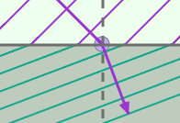

Introduction: A wave can be described by its wavelength and its frequency, or the number of waves produced in a given period of time. The wave speed is equal to the product of wavelength and frequency. Wavelength and frequency are the keys to understanding why refraction happens.

Question: Why does light bend when it enters a different medium?

- Measure: You will now use the Gizmo to measure the light ray’s wave speed in different media. Set the index of refraction of each medium to the same value, 1.0. Click Play and then click Pause () after the ray moves into Medium 2.

Use the Ruler to measure how far the light ray has traveled. (Note: No units are used by this Gizmo, so you do not need to record units in the table.)

The time is given at the bottom of the SIMULATION pane. Record this time in the third column. Then, repeat the measurement for indices of 2.0 and 3.0. (In each case, use the same index of refraction for each medium.)

Index of refraction | Distance (d) | Time (t) | Wave speed (d/t) | Wave speed ratio
1.0
2.0
3.0

- Calculate: Calculate the wave speed by dividing the distance by the time. Record this value in the fourth column of the table.

- Calculate: Calculate the wave speed ratio by dividing the wave speed in a medium with an index of refraction of 1.0 (the first wave speed you measured) by the wave speed recorded in each row. (Hint: You will divide the first wave speed recorded by itself.) Record this value in the last column of the table.

- Compare: What is the relationship between the index of refraction and wave speed ratio?

_________________________________________________________________________

- Analyze: How does the speed of a wave change as the index of refraction increases?

_________________________________________________________________________

(Activity C continued on next page)
Activity C (continued from previous page)

- Measure: Now you will measure the frequency of a light ray. Turn off the Ruler and turn on View wave fronts. Click Reset, and move the Simulation speed slider all the way to the left. Set each medium’s index of refraction to 1.0 and the Angle of incidence to 1°.

Click Play, and then click Pause after 5 units of time have passed. Record the number of wave fronts on the SIMULATION screen in the table below. Then, repeat the experiment with each medium’s index of refraction set and 2.0 and then 3.0.

Index of refraction: | 1.0 | 2.0 | 3.0
Number of wave fronts:

- Analyze: How does the index of refraction affect frequency? _________________________

- Draw conclusions: As a wave moves into a medium with a higher index of refraction, it slows down. What causes the wave to slow: a change in the wave’s wavelength or a change in its frequency?

_________________________________________________________________________

- Make a diagram: In the image below, try to draw a scenario in which the wave fronts become more closely spaced as the light beam enters Medium 2 and slows down, but the light beam and wave fronts do NOT change direction. (Remember, the wave fronts must remain connected as they cross the boundary.)
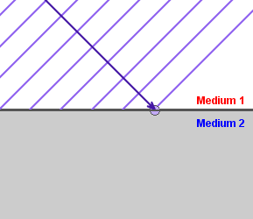
Did you encounter any difficulties making your drawing? Explain.

__________________________________________

__________________________________________

__________________________________________

__________________________________________

- Draw conclusions: Use what you have learned about wave speed and your diagram to explain why waves bend when they enter a different medium.

_________________________________________________________________________

_________________________________________________________________________

_________________________________________________________________________

