Vocabulary: River Erosion

Vocabulary

- Cutbank – a steep or overhanging riverbank on the outside of a meander.
  - Water flows more quickly on the outside of a meander, causing erosion to occur along the cutbank.
  - Cutbanks (or cut banks) are also known as river cliffs.

- Discharge – the volume of water that flows past a point in a given period of time.
  - Discharge is usually measured in cubic meters (m³) per second.
  - For example, a discharge of 155 m³/s means that 155 cubic meters of water flow past a given point each second.

- Erosion – a surface process in which soil, rocks, and other materials are removed and transported to another place.
  - Erosion can be caused by gravity, water, ice, or wind.

- Flood – an unusually high discharge in a river.
  - During a flood, parts of the land surrounding the river that are usually dry are covered by water.

- Floodplain – a flat area surrounding a meandering river.
  - The floodplain consists of sediments deposited by the river.
  - The floodplain becomes covered by water during a flood. This water deposits new sediments on the floodplain.
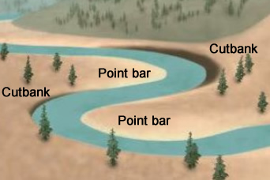
Two meanders
- Meander – a wide curve in a river.
  - Water flows more quickly along the outside of the meander, near the cutbank, than on the inside of the meander near the point bar.
  - Over time, a meander will grow wider as the cutbank erodes and sediments are deposited on the point bar.

- Meandering river – a river that forms many wide curves across a floodplain.
  - Meandering rivers tend to have very gentle channel slopes and erode side to side rather than downward.
  - Common features of meandering rivers include cutbanks, point bars, oxbow lakes, and floodplains.
  - Natural levees are raised deposits of sediment that form along the banks of meandering rivers. These sediments are deposited during floods.

- Oxbow lake – a horseshoe-shaped body of water formed when a river breaks through the neck of a meander.
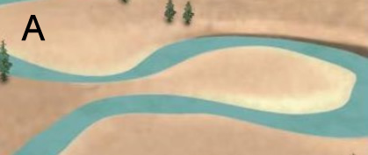
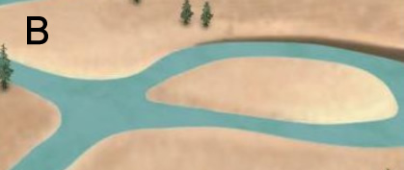
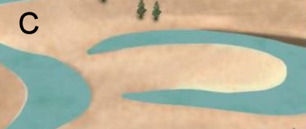
Formation of an oxbow lake
  - As a meander widens, part of the land separating the two sides of the meander will become very narrow. (Image A)
  - When the river erodes through this neck, water will no longer flow through the rest of the meander. A new bank forms that separates the river from the cut-off meander. The old meander is now an oxbow lake. (Images B and C)

- Point bar – a gently sloping deposit of sediments on the inside of a meander curve.
  - Water flows more slowly on the inside of curves, allowing sediments to be deposited there.

- River speed – a measure of how fast water is flowing through a river channel.

- Riverbank – the side of a river channel.

- Riverbed – the bottom of a river channel.

- Sediments – rock fragments that have been transported to a different location.
  - Sediments are classified by their grain size:
Sediment type | Grain size range (mm)
Clay | Less than 0.004 mm
Silt | 0.004 – 0.06 mm
Sand | 0.06 mm – 4 mm
Pebble | 4 – 64 mm (0.4 – 6.4 cm)
Cobble | 64 – 256 mm (6.4 – 25.6 cm)
Boulder | Greater than 256 mm (25.6 cm)

- Slope – the steepness of a line or surface.
  - The channel slope of a river is defined by how many meters the river channel drops over one horizontal kilometer. For example, a channel slope of 22 m/km means that the channel drops 22 meters every kilometer.
  - Slope is also called gradient.

- Tributary – a smaller stream or river that flows into a larger stream or river.

- Weathering – a process in which rocks at Earth’s surface are gradually broken down into smaller pieces and eventually into soil.

