Name: Date:

Student Exploration: Road Trip

Vocabulary: budget, gas mileage, odometer, range

Prior Knowledge Questions (Do these BEFORE using the Gizmo.)
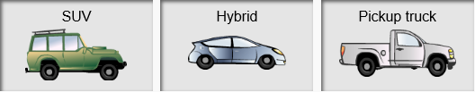
- Which of the vehicles at right do you think will go farthest on a tank of gas?

__________________________________

- Why do you think so? _______________________________________________________

_________________________________________________________________________

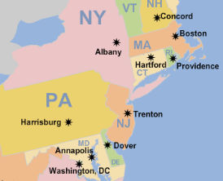
Gizmo Warm-up
The Road Trip Gizmo allows you to plan a road trip to visit United States capital cities. To get started, check that the Choose start tab is selected (shown in white).

- Click New, and select a vehicle. Click Back to map.

Which vehicle did you pick? ___________________

- Click a city on the map as your starting point. (Note: You can drag the map around if you like.)

Which starting city did you pick? _______________________________________________

- Select the Go on trip tab. Click Get gas. Set the gas price using the Price per gallon slider. Click Start to put gas in the tank. It will continue until the tank is full.

  - What price of gas did you choose? ___________________

  - How much gas did it take to fill the tank? ___________________

- Click Back to map. Click a city that connects to your starting city. As you drive, watch the Trip odometer in the lower left to see how far you have driven. Get more gas as needed.

Which city did you drive to? ___________________ How far was it? ________________

Activity A:  Gas mileage | Get the Gizmo ready:  - Select the Choose start tab.  - Click on Phoenix, AZ. (Drag the map if needed.)  - Click New and pick Sedan. Click Back to map. | 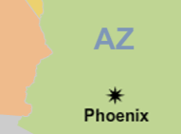

You are a traveling encyclopedia salesman based in Phoenix, Arizona. You drive a sedan because it’s comfortable, but you wonder if it uses too much gas.

- Select the Go on trip tab. The gas tank is empty, so click Get gas to go to the gas station. Click +1 gal. to add exactly one gallon to the gas tank. Click Back to map.

- Click on Denver, CO, to travel there. Look at the Trip odometer.

How far did the car travel on a gallon of gas? ____________

This is the car’s gas mileage (in miles per gallon, or mpg). Gas mileage is a measure of how far the car goes on each gallon of gas.

- Next to the odometer, click Reset. Click Get gas. Add 10 gallons to the tank by clicking the +10 gal. button. How far do you think the car will travel on 10 gallons of gas? ____________

- Click Back to map. Drive until you run out of gas.

  - How far did the car go on 10 gallons of gas? ____________

  - In general, how are gas mileage, gallons of gas, and distance related to each other? ___________________________________________________________________

- Reset the trip odometer. Click Get gas, and this time fill the tank all the way up.

  - How many gallons filled the tank of the sedan? ____________

  - How far do you think the car will go before it runs out of gas? ____________

- Click Back to map. Drive until you run out of gas.

  - How far did you go on this tank? ____________This distance is the range of the car.

  - Divide the range by the amount of gas you used. What do you get? _____________

  - What do you notice about this number? Explain. ____________________________

___________________________________________________________________

Activity B:  Comparing cars | Get the Gizmo ready:  - Select the Choose start tab.  - Click on Phoenix, AZ, as your starting city. | 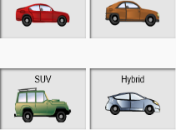

As a traveling encyclopedia salesman, it’s important that you choose the best vehicle for the job.

- Click New and select the Small car. Then click Back to map.

Do you think this car will have better gas mileage than the sedan, or worse? ____________

- Select Go on trip. Click Get gas and click Quick fill-up. How big is your tank? __________

- Click Back to map. Click a city to travel to, and drive until you run out of gas.

      - How far did you travel? _____________ (Reminder: This is the range of the car.)

      - What is your gas mileage? _____________ (Divide distance by gallons of gas used.)

- Fill in the first line of the table. Then find the range and gas mileage of all other vehicles.

Vehicle | Range | Tank size | Gas mileage
Small car
Sports car
SUV
Hybrid

Vehicle | Range | Tank size | Gas mileage
Pickup
Van
Motor-cycle
School bus

- Which vehicle would you pick if you wanted to travel as cheaply as possible? ____________

Explain: __________________________________________________________________

- Which would you pick if you wanted to go as far as possible on a tank of gas? ___________

Explain: __________________________________________________________________

- Considering all factors, including your job, which vehicle would you pick? _______________

Explain your choice: ________________________________________________________

_________________________________________________________________________

Activity C:  Cross-country trip! | Get the Gizmo ready:  - Select the Choose start tab.  - Click on Phoenix, AZ, as your starting city. | 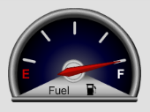

For summer vacation, you decide to take your family on a road trip to Boston, MA. But how much will it cost? To find out, you must plan a budget for the trip.

- First pick a vehicle. Then, on the Go on trip tab, click Get gas, set the gas price, and fill up.

- Which vehicle did you choose? _____________

- What price of gas did you set? _____________

- Click Back to map. Click cities between Phoenix and Boston, and keep driving until you arrive in Boston. Get gas as needed. When you are done, click the Trip log.

  - Which cities did you drive through? _______________________________________

___________________________________________________________________

  - What was the total distance of your trip? _____________

  - How much money did you spend on gas? _____________

  - Look at the total miles and total gallons of gas you used. What was the gas mileage of your vehicle? (Hint: Is there any gas left in the tank?) _____________

- Do the same trip, from Phoenix to Boston, with the Pickup truck and the Motorcycle.

  - How much money did you spend on gas for the pickup truck? _____________

  - How much money did you spend on gas for the motorcycle? _____________

  - How much would you save by driving the motorcycle? _____________

- Try a variety of different routes and vehicles for this trip.

  - What is the shortest driving distance between Phoenix and Boston? _____________

  - What is the least amount of money you could spend on gas for the trip? __________

On your own: Using the Gizmo for help, plan a cross-country trip from one city to another. In a report, list your vehicle, the cities you will visit, the total distance, and the cost of gas. Estimate other expenses such as food, hotels, and souvenirs. Present your plan to your class.

