Vocabulary: Roots of a Quadratic

dictionary2

**Vocabulary**

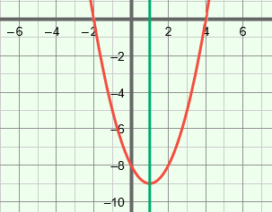

**axis of symmetry**

**vertex**

* Axis of symmetry – a line that divides a shape into two parts that are mirror images of each other.
* The axis of symmetry of a parabola goes through the *vertex* of the parabola.
* The equation of the axis of symmetry of the graph of *y* = *ax*2 + *bx* + *c*, where *a* ≠ 0, is *x* = .
* Complex number – a number written as *a* + *bi*, where *a* and *b* are real numbers and *i* is the square root of –1.
* The value *a* is the real part of a complex number, and *bi* is the imaginary part.
* For example, the real part of 2 + 3*i* is 2, and the imaginary part is 3*i*.
* Conjugates – a pair of binomials with the same first term and opposite second terms.
* For example, 2 + 3*i* and 2 – 3*i* are conjugates.
* Discriminant – the part of the quadratic formula that is under the radical, *b*2 – 4*ac*.
* Imaginary number – any number that can be written in the form *bi*, where *b* is a real number not equal to zero and *i* is the square root of –1.
* For example,  =  •  = 4*i*.
* Parabola – the graph of a quadratic function.
* For example, the graph of *y* = *x*2 – 2*x* – 8 (shown above) is a parabola.
* Quadratic equation – an equation of the form *ax*2 + *bx* + *c* = 0, where *a* ≠ 0.
* Quadratic formula – a formula that can be used to find the roots of a quadratic equation of the form *ax*2 + *bx* + *c* = 0.
  + The quadratic formula is *x* = .
* Quadratic function – a function of the form *y* = *ax*2 + *bx* + *c*, where *a* ≠ 0.
* The “*a*” cannot be 0 because, if *a* = 0, the function becomes linear: *y* = *bx* + *c*.
* The graph of a quadratic function is always a parabola.
* Root of an equation – a quantity that makes the related function equal to 0.