Vocabulary: Rotations, Reflections, and Translations

Vocabulary

- Image – a figure that has been transformed, compared to the original figure (the preimage).

- Preimage – the original figure, before being transformed.
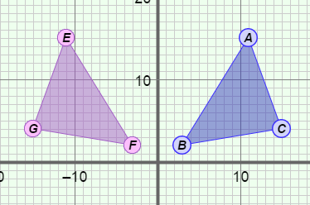
- Reflection – a mirror image.
  - In the figure shown to the right, ΔEFG is the reflection of ΔABC over the y-axis, so ΔEFG is a mirror image of ΔABC.
  - The y-axis is called the line of reflection.

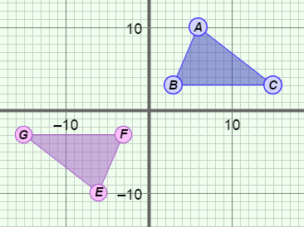
- Rotation – a turn of a figure about a point.
- In the figure shown to the right, the preimage, ΔABC, has been rotated 180° about the origin to get the image, ΔEFG.

- Transformation – a change in the size, shape, direction, or position of a figure.
- Transformations that don’t change the size or shape of images are isometric, and include reflections, rotations, and translations.
- Other transformations such as dilating (resizing) are not isometric.

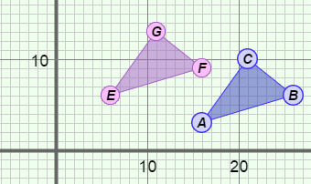
- Translation – a movement of a figure from one place to another.
  - In the figure shown to the right, the preimage, ΔABC, has been translated 10 units to the left and 3 units up to get the image, ΔJKL.

