Name: Date:

Student Exploration: Trends in Scatter Plots

Vocabulary: correlation, scatter plot, slope, trend line, y-intercept

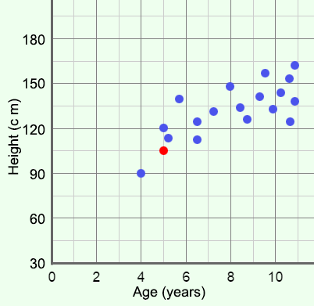
Prior Knowledge Questions (Do these BEFORE using the Gizmo.)
A school nurse records the age and height of each student she sees in a week. Then she makes a scatter plot showing the ages of students (in years) on the x-axis and their heights (in centimeters) on the y-axis.

- The red dot has the coordinates (5, 105). What do you know about the student represented by this point?

- Based on the graph, how do you think age and height are related?

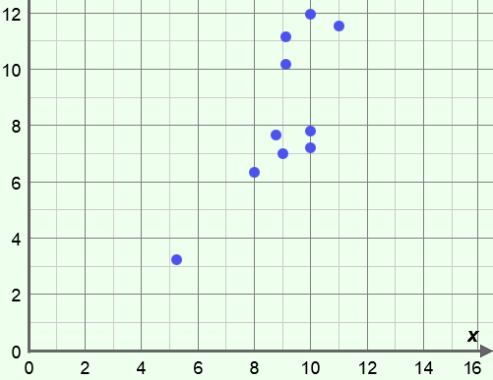
Gizmo Warm-up
Because we grow as we get older, a scatter plot of height vs. age will show that older children are generally taller than younger children. When two variables are related, like age and height, they are said to be correlated.

The Trends in Scatter Plots Gizmo explores different types of correlation. To begin, check that the slider is close to the Positive trend side.

- When there is a positive trend (or positive correlation), do the y-values of the points on the scatter plot tend to increase or decrease as the x-values increase?

- Move the slider to the Negative trend side. When there is a negative trend (or negative correlation), how to the y-values change as the x-values increase?

- Move the slider to the middle, under No trend. What does the scatter plot look like now?

Activity A:  Trend lines | Get the Gizmo ready:  - Click the Positive trend button. | 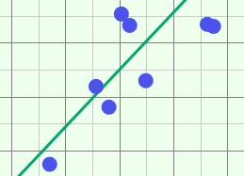

- Click Positive trend several times. What do these scatter plots have in common?

- When data has a strong positive or negative trend, the points often approximate a line. A trend line is a line that best fits the data and gives an estimate of how one variable is correlated to the other. Select Show actual trend line.

- In the current scatter plot, how many points are above the trend line?

- In the scatter plot, how many points are below the trend line?

- Drag the slider all the way to the right. What do you notice?

- Drag the slider to the left. What happens as you approach the No trend setting?

- Drag the slider all the way to the left, under Negative trend. What happens now?

- The slope of a line describes its steepness. Click Positive trend several times, observing the slope of the trend line each time.

- What do all of these trend lines have in common?

- Do the trend lines for these scatter plots all have the same slope?

- Click the Negative trend button several times.

- How would you describe the points in these scatter plots?

- What do all of these trend lines have in common?

- Do the trend lines for these scatter plots all have the same slope?

(Activity A continued on next page)
Activity A (continued from previous page)

- Move the slider to the No trend setting. Observe the graph and the slope of the trend line. Then, click Positive trend to generate a new data set, and move the slider back to No trend. Repeat this process to observe several data sets with no trend.

- How would you describe the points in these scatter plots?

- What do all of these trend lines have in common?

- Do the trend lines for these scatter plots all have the same slope?

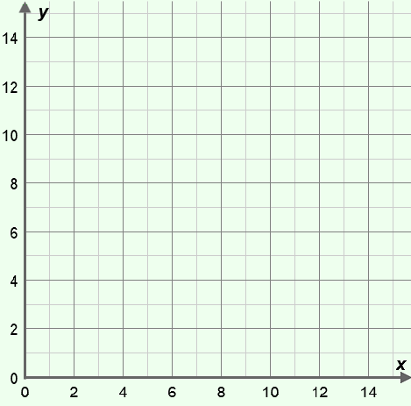
- You can try fitting your own line to a data set. To do this, turn off Show actual trend line, click the Positive trend button, and then select Fit a line.

- Use the m slider to change the slope and the b slider to change the y-intercept of your estimated trend line. When you are done, sketch the data set and your estimated trend line in the blank grid.

- What is the equation of your estimated trend line?
- Turn on Show actual trend line. What is its equation?

- Turn off Show actual trend line, and click Negative trend. Use the same procedure to estimate the trend line for this data set.

- What is the equation of your trend line?

- Turn on Show actual trend line. What is its equation?

- Hans looks up the latitude and average January temperature (in degrees Celsius) of a variety of cities in the northern hemisphere. He then creates a scatter plot showing each city’s latitude on the x-axis and temperature on the y-axis.

- Do you think this graph will have a positive, a negative, or no trend?

Explain.

- Would you expect the trend line have a positive or negative slope?

Activity B:  Predicting trends | Get the Gizmo ready:  - Turn off Fit a line.  - Select Show actual trend line.  - Click Positive trend. | 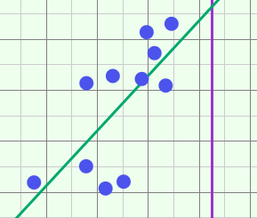

- A trend line is useful for showing the general “shape” of a data set. In addition, the equation of a trend line can be used to estimate the positions of new points in the data set.

- What is the equation of the current trend line in the Gizmo?

- Turn on Show probe. Drag the probe to x = 0. What is the value of y?

- What part of the trend line equation is equal to this value?

This is the y-intercept of the trend line. It is the value of y when x equals zero.

- Carefully drag the probe to x = 1. What is the value of y?

- How much did the value of y increase from x = 0 to x = 1?

- What part of the equation is equal to this value?
This is the slope of the line, or the amount that y changes for each unit increase of x.

- Click Positive trend. You can use the equation of the trend line to predict the value of y for a given value of x.

- What is the equation of the current trend line?

- Suppose you wanted to estimate the y-value of a point with an x-value of 5. Using the trend line equation, solve for y when x is equal to 5. y =
- Drag the probe to x = 5. What is the value of y?

- Click Negative trend.

- What is the equation of the trend line?

- What is the predicted value of y if x = 14? Check this with the Gizmo probe.

- Hans made a scatter plot of average January temperature in °C (y) vs. latitude (x) for some northern hemisphere cities. The equation for the trend line of this graph is y = –0.6x + 30.

Estimate the average January temperature in Oslo, Norway (latitude 60° N). °C

