Vocabulary: Trends in Scatter Plots

dictionary2

**Vocabulary**

* Correlation – a measure of the relationship between two variables.
* If the variables vary together (as one goes up, the other tends to go up), they are *positively correlated*.
* If the variables vary in opposite directions (as one goes up, the other tends to go down), they are *negatively correlated*.
* If the variables are unrelated, they have *no correlation*.
* Scatter plot – a graph of (*x*, *y*) points that shows the general relationship between two variables, *x* and *y*.
  + Generally, the variable on the horizontal (*x*) axis is the *independent variable*, and the variable on the vertical (*y*) axis is the *dependent variable*.
* Slope – a measure of the steepness of a line.
  + 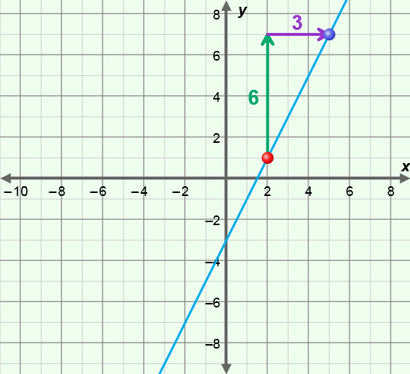For two points on a line, (*x*1, *y*1) and (*x*2, *y*2), slope is defined as:

slope =  =  = .

* + For example, the slope of the line through the points (2, 1) and (5, 7) as shown to the right is:

 =  = 2.

* Trend line – a line that fits the points in a scatter plot well.

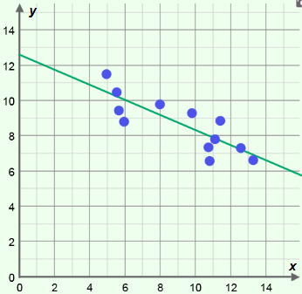

**trend line**

* The slope of the trend line indicates the type of correlation the variables have.
* A positive slope indicates a positive correlation, a negative slope indicates a negative correlation, and a slope of zero indicates no correlation.
* For example, the trend line shown to the right suggests a negative correlation between the variables.
* *y*-intercept – the *y*-coordinate where a graph intersects the *y*-axis.
  + In the equation *y* = *mx* + *b*, *b* is the *y*-intercept.