Name: ______________________________________ Date: ________________________

**Student Exploration: Seasons: Earth, Moon, and Sun**

**Vocabulary:** altitude, axis, azimuth, equinox, horizon, latitude, revolution, rotation, solstice

**Prior Knowledge Questions** (Do these BEFORE using the Gizmo.)

1. Suppose you were stranded on a desert island without a calendar or clock. How would you know when a day, a month, or a year had passed? ________________________________

_________________________________________________________________________

1. How could you tell what time of year it was? ______________________________________

_________________________________________________________________________

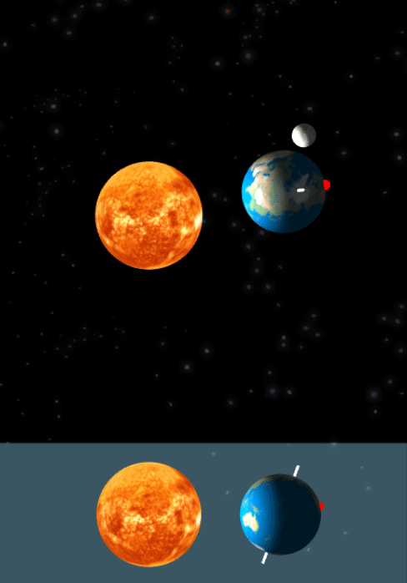

**Gizmo Warm-up**

Thousands of years ago, people told time by looking at the sky. You may not think about it, but you probably do this as well. For example, you know a day has passed when the Sun rises, it grows light outside, and then Sun sets again.

In the *Seasons: Earth, Moon, and Sun* Gizmo, you will learn how you can relate the passage of time to different astronomical events.

Drag the **Sim. speed** slider all the way to the left. Click **Play** (Play) and observe the SIMULATION pane.

1. What happens?_____________________________

_________________________________________

1. Click on the 2D VIEW tab. What do you see? _______________________________

______________________________________________________________________

1. Click on the DAY GRAPH tab. What do you see? ____________________________

______________________________________________________________________

1. Click on the SHADOWS tab. What do you see? _____________________________

______________________________________________________________________

|  |  |  |
| --- | --- | --- |
| **Activity A:**  **Days, months, and years** | Get the Gizmo ready:   * Click **Reset** (Reset). * Select the 2D VIEW tab. | 468SE2 |

**Question: What astronomical events coincide with the passage of a day, month, or year?**

1. Observe: Click **Play**. Observe how the position of the red dot in the SIMULATION pane relates to the cycle of night and day on the 2D VIEW tab.

What astronomical event causes day and night? __________________________________

_________________________________________________________________________

Every time Earth finishes one **rotation** on its **axis**, a complete cycle of day and night occurs. In the SIMULATION pane, Earth’s axis is represented by the white line that goes through the center of the planet.

1. Describe: Months are another unit of time based on an astronomical event. Click **Reset**, and move the **Sim. speed** slider to the right a quarter of the way. Click **Play**, and observe the movements of Earth and the Moon for one month. (Note: You can use the calendar in the upper right corner of the 2D VIEW tab to determine when a month has passed.)
2. Describe the movements of Earth and the Moon over the course of a month.

___________________________________________________________________

1. What astronomical event corresponds to the passage of one month?

___________________________________________________________________

It takes approximately 28 days for the Moon to revolve around Earth. **Revolution** is the elliptical motion of a body traveling around another body in space.

1. Diagram: Click **Reset**. Set the **Sim. speed** to maximum. Click **Play**, and observe the movement of Earth over the course of one year. In the diagram below, draw how the position of Earth changes.
   * 1. What astronomical event corresponds to the passage of 1 year? _______________



_________________________________

_________________________________

* + 1. How long does it take Earth to revolve around the Sun? ____________________

|  |  |  |
| --- | --- | --- |
| **Activity B:**  **Sun’s path** | Get the Gizmo ready:   * Click **Reset**. * Set the **Sim. speed** to minimum. | 468SE4 |

**Question: What causes the Sun to appear to move in a path across the sky?**

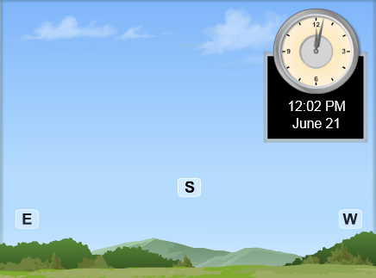

1. Observe: Select the 2D VIEW tab. Click **Play**, and watch the apparent motion of the Sun across the sky. In the diagram at right, draw an arrow to show the Sun’s direction and path.

Mark the highest **altitude** the Sun reaches with an *X.* Altitude is the distance an object appears to be above the **horizon**. The horizon is the line along which the sky and the Earth appear to meet.

1. Make a rule: On the 2D VIEW tab, *E* stands for *east* and *W* stands for *west.* Knowing this, you can conclude that the Sun rises in the __________ and sets in the __________.

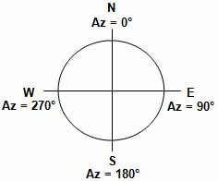

1. Analyze: The Sun’s **azimuth** is the direction of the Sun in the sky. Azimuth is measured in degrees. Look at the diagram.
2. What is the Sun’s approximate azimuth when it rises? ____________________________________
3. What is the Sun’s approximate azimuth when it sets? _________________________________________
4. Summarize: Select the SHADOWS tab. Click **Play**, and observe the **Azimuth**.How does the Sun’s azimuth change over the course of the day?

_________________________________________________________________________

_________________________________________________________________________

1. Describe: Click **Reset**. Select the 2D VIEW tab. On the SIMULATION pane, the red dot on Earth represents where the observer who is seeing the scene on the 2D VIEW tab is standing. Describe the position of the red dot in the SIMULATION pane at midnight.

_________________________________________________________________________

**(Activity B continued on next page)Activity B (continued from previous page)**

1. Observe: Click **Play**. When the Sun begins to rise on the 2D VIEW, click **Pause** (Pause). How has the position of the red dot changed? ________________________________________

_________________________________________________________________________

1. Observe: Click **Play** again. When the Sun begins to set on the 2D VIEW, click **Pause**. How has the position of the red dot changed? ________________________________________

_________________________________________________________________________

1. Draw conclusions: What causes the apparent motion of the Sun across the sky: the movement of Earth or the movement of the Sun? Explain. ___________________________

_________________________________________________________________________

1. Predict: A shadow is caused when an object blocks sunlight. For example, when your body blocks sunlight, you may see a shadow of yourself on the ground. How do you think the shadow of an object, such as a flagpole, would change over the course of the day as the Sun appears to move across the sky?

_________________________________________________________________________

_________________________________________________________________________

1. Observe: Click **Reset**. Select the SHADOWS tab, and click **Play**. Observe the **Overhead** and **Projection** view of the **Shadow of a stick**.

What do you notice? ________________________________________________________

_________________________________________________________________________

1. Compare: As you watch the shadow move, observe how its length changes in comparison to the **Altitude** of the Sun.
2. Describe the length of the shadow when the Sun is at its highest altitude.

___________________________________________________________________

1. Why does the Sun’s altitude affect shadow length? __________________________

___________________________________________________________________

|  |  |  |
| --- | --- | --- |
| **Activity C:**  **Sunrise and sunset times** | Get the Gizmo ready:   * Click **Reset**. Select the DESCRIPTION tab. * Set the **Simulation speed** to minimum. | 468SE6 |

**Question: What factors affect sunrise and sunset times?**

1. On your own: **Latitude** is a location’s distance north or south of the equator. You can use Google™ or another search engine to look up your town’s latitude.

What is the latitude of your town? _____________________________________________

Use the **Latitude** slider on the DESCRIPTION tab to set the Gizmo to your town’s latitude.

1. Collect data: Select the GRAPH tab and check that **Day graph** is selected. Click **Play**,and observe. The solar intensity curve goes up at sunrise and goes down at sunset.

Click **Reset**. Use the red date slider at lower right to set the date to March 21. Click **Play**, and then click **Pause** after the sun sets. Use the **Day graph** to record the approximate sunrise and sunset times in the table below. (*Note:* The Gizmo does not take Daylight Saving Time into account.)

|  |  |  |  |
| --- | --- | --- | --- |
| **Date** | **Sunrise Time** | **Sunset Time** | **Hours of Daylight** |
| March 21 |  |  |  |
| June 21 |  |  |  |
| September 23 |  |  |  |
| December 21 |  |  |  |

Click **Reset**, and repeat the activity above for the other dates listed in the table. Then calculate the hours of daylight for each of the four dates.

1. Compare: How do sunrise times, sunset times, and hours of daylight change over the course of the year? _________________________________________________________

_________________________________________________________________________

1. Analyze: **Equinoxes** are dates on which the daytime lasts as long as the nighttime. **Solstices** are the dates of the longest and shortest daytimes of the year.

* 1. Which two dates are equinoxes? ______________________________________
  2. How does the amount of daylight during the summer solstice (June 21) compare to that on the winter solstice (December 21)? _________________________________

**(Activity C continued on next page)Activity C (continued from previous page)**



1. Diagram: Click **Reset**. Move the date slider to each of the equinox and solstice dates. Examine how moving the date slider makes the position of Earth on the SIMULATION pane change.

In the diagram at right, mark Earth’s position and the position of Earth’s axis on each date. Shade in the part of Earth not lit by the Sun.

**June 21 December 21**

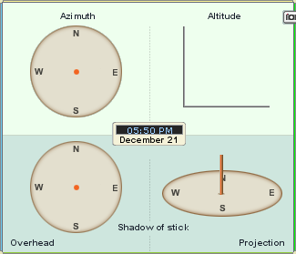 

1. Compare: Use the SHADOWS tab to compare the **Altitude** of the Sun on the summer and winter solstices. Draw the highest altitude the Sun reaches on each of those two dates in the graphs at right.

On which date does the Sun reach the highest altitude? _______________________

1. Collect data: Use the observations you have made to answer the following question: What do you think causes the changes in sunrise and sunset times over the course of the year?

_________________________________________________________________________

_________________________________________________________________________

1. Hypothesize: How do you think latitude affects sunrise and sunset times? ______________

_________________________________________________________________________

1. Collect data: Select the DESCRIPTION tab. Move the **Latitude** slider back and forth to see how it changes the red dot’s position in the SIMULATION pane.

Click **Reset**. Set the latitude to 89°. Then use the DAY GRAPH tab to fill in the table for January 1. Repeat for the other latitudes listed in the table.

|  |  |  |
| --- | --- | --- |
| **Latitude** | **Sunrise Time** | **Sunset Time** |
| 89° |  |  |
| 45° |  |  |
| 0° |  |  |
| -45° |  |  |
| -89° |  |  |

What causes the differences between the sunrise and sunset times at different latitudes?

_________________________________________________________________________

_________________________________________________________________________