Name: ______________________________________ Date: ________________________

Student Exploration: Seasons: Why do we have them?

Vocabulary: direct sunlight, Earth’s axis, equator, indirect sunlight, northern hemisphere, North Pole, season, solstice, southern hemisphere, South Pole, summer solstice, winter solstice

Prior Knowledge Questions (Do these BEFORE using the Gizmo.)

- At what time of day is sunlight strongest – in the early morning (when the Sun has just risen) or at noon (when the Sun reaches its highest point)? _______________________________

- At what time of year does the noon Sun rise highest in the sky? ______________________

- Based on your answers, why is it warmer in summer than in winter? ___________________ _________________________________________________________________________
_________________________________________________________________________

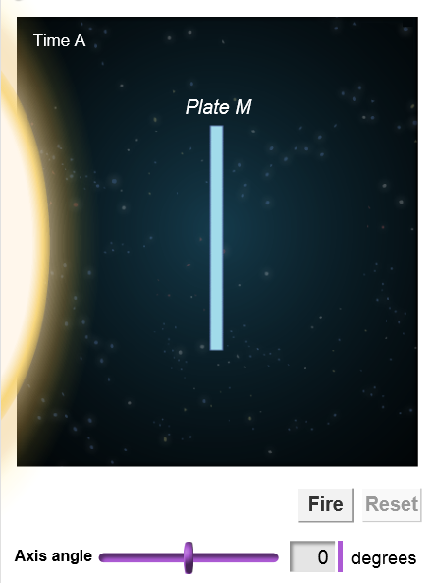
Gizmo Warm-up
The reasons for seasons have a lot to do with the angle at which the Sun’s rays hit Earth. To see why, select the PLATE tab on the Seasons: Why do we have them? Gizmo. The image shows a solar panel (Plate M) facing the Sun. Check that the Axis angle is set to 0˚.

- Click Fire to release 100 “rays” of sunlight. Look next to “Number of hits” below the plate.

How many of these rays hit Plate M? _____________

- Click Reset. Change the Axis angle to 40˚, and click Fire. How many rays hit Plate M now? _____________

- Which do you think will warm up the plate more quickly? (Circle one.)

      - Direct sunlight (sunlight that hits the plate at a 90° angle)

      - Indirect sunlight (sunlight that hits the plate at an angle of less than 90°)

Activity A:  Sunlight on a plate | Get the Gizmo ready:  - Click Reset. | 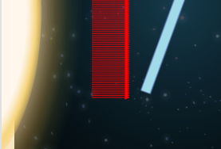

Question: How does the angle of sunlight affect the amount of energy that is absorbed?

- Form hypothesis: How do you think the angle of the plate will affect how much sunlight hits the plate? _________________________________________________________________

- Collect data: Set the Axis angle to -80° and click Fire. Record the Number of hits. Repeat for each angle and fill in the tables below. You can use the slider or type the number into the text field directly and click Enter on your keyboard. (Note that “0°” appears in both tables.)

Axis angle | Hits
-80°
-60°
-40°
-20°
0°

Axis angle | Hits
0°
20°
40°
60°
80°

- Analyze: What is the relationship between the axis angle and the number of solar rays that hit the plate? ______________________________________________________________

- Interpret: Select the GRAPH tab. What does the graph show? ________________________

_________________________________________________________________________

- Apply: At what angle will the plate get the hottest? _________

- Extend your thinking: The plate is a model for how sunlight hits Earth’s surface.

    - Which parts of Earth are most similar to the plate with an axis angle of 0°? Explain.

___________________________________________________________________

    - Which parts of Earth are most similar to the plate with an axis angle of 80°? _______

___________________________________________________________________

Activity B:  Sunlight on Earth | Get the Gizmo ready:  - Select the EARTH tab on the left and the DESCRIPTION tab on the right.  - Check that the Axis angle is set to 0 degrees. | 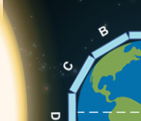

Question: What causes seasons on Earth?

- Predict: Look at the image of Earth (not to scale). Plate A is located at the North Pole, and plate G is located at the South Pole. Plates D and J are located at the equator.

    - Of the plates that are facing the Sun (plates A through G), which ones will receive the most solar energy? __________________________
    - Which of plates A through G will receive the least? __________________________

- Check: Click Fire. Select the TABLE tab to see how many rays hit each plate.

- Which plate got the most sunlight? ______________ The least? ______________

- Why is it colder at the poles than at the equator? ____________________________

___________________________________________________________________

- Set up Gizmo: Click Reset, and turn on Show axis. Earth’s axis is an imaginary line that connects the North Pole to the South Pole. Earth spins around its axis, which is tilted relative to Earth’s orbit. Click Earth axis angle to set the axis angle to a realistic 23°.

- Collect data: On the DESCRIPTION pane, check that Time A is selected. Click Fire. Select the TABLE pane to see the results, and fill in the left table below. Click Reset, and on the DESCRIPTION pane select Time A + 6 months. Click Fire and fill in the right table.

Time A Time A + 6 months

Plate | Angle | Hits
A
B
C
D
E
F
G

Plate | Angle | Hits
A
B
C
D
E
F
G

(Activity B continued on next page)
Activity B (continued from previous page)

- Analyze: Plates A, B, and C all lie in the northern hemisphere, the half of Earth north of the equator. Plates E, F, and G all lie in the southern hemisphere, south of the equator.

    - Which hemisphere gets more direct sunlight at Time A? ______________________

    - Which hemisphere gets more sunlight at Time A + 6 months? _________________

- Interpret: Plate B is a typical northern hemisphere location, and plate F is a typical southern hemisphere location. Circle the answer to each question below.

    - On plate B, which season is Time A? Start of summer Start of winter

    - On B, which season is Time A + 6 months? Start of summer Start of winter

    - On F, which season is Time A? Start of summer Start of winter

    - On F, which season is Time A + 6 months? Start of summer Start of winter

    - In general, how are seasons in the northern hemisphere related to seasons in the southern hemisphere? _________________________________________________

- Apply: December 21 and June 21 are important dates called solstices. The winter solstice is the shortest day of the year. The summer solstice is the longest day of the year.

    - Which date does Time A represent? June 21 December 21

This date is the winter solstice in the northern hemisphere, and the summer solstice in the southern hemisphere.

    - Which date does Time A + 6 months represent? June 21 December 21

This date is the summer solstice in the northern hemisphere, and the winter solstice in the southern hemisphere.

- Summarize: Based on what you have seen, what causes the seasons? ________________

_________________________________________________________________________

_________________________________________________________________________

_________________________________________________________________________

_________________________________________________________________________

_________________________________________________________________________

