Name: Date:

Student Exploration: Eyes & Vision 3 – Sensing Light

[Note to teachers and students: This Gizmo was designed as a follow-up to the Eyes and
Vision 2 – Focusing Light Gizmo. We recommend doing that activity before trying this one.]

Vocabulary: cone, fovea, nerve impulse, nocturnal, optic nerve, photoreceptor, retina, rod, ultraviolet light

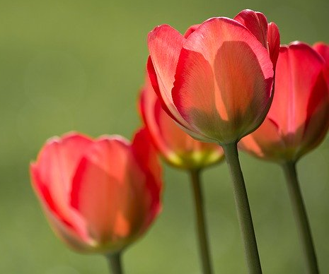
Prior Knowledge Questions (Do these BEFORE using the Gizmo.)

- Andrea takes a picture of flowers with a digital camera. What do you think is happening inside the camera?

- How is a digital camera similar to an eye?

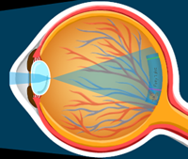
Gizmo Warm-up
Inside a digital camera, light is focused onto a small grid. When light hits a part of the grid, a tiny electric current is released. Your eye works in a similar way. In the Eyes and Vision 3 – Sensing Light lesson, you will learn how special cells in the eye sense light.

Select the RETINA tab of the Gizmo, and change the Percent cones to 50%. Notice where the book image appears on the back of the eye. Here, there is a thin sheet of cells called the retina. Turn on Show retina.

- What are the names of the two labeled cells?

- What happens when light (represented by the wiggly arrows) hits these cells?

Rods and cones are called photoreceptors. When light hits a photoreceptor, it sends out a nerve impulse (glowing dot). The nerve impulse goes through the optic nerve to the brain.
Activity A:  Rods and cones | Get the Gizmo ready:  - Check that the Fairy Tales book is selected.

Introduction: Rod and cone cells react to different colors of light. You will experiment with four types of cone cells: red, green, blue, and UV. Most of the photoreceptors in the retina are rods.

Question: What types of light are detected by rods and cones?

- Draw: Turn on Show retina. Set the Percent cones slider to 50%.
Cone
Rod

You are seeing a part of the retina called the fovea. The fovea is in the middle of the retina and is packed with photoreceptors.

Sketch a rod and a cone cell at right.

- Observe: Notice the different colors of light (represented by wiggly arrows) hitting the retina.

- What colors of light are entering the eye?
(Note: The purple arrows represent ultraviolet (UV) light, or light that is beyond the purple end of the spectrum. Humans can’t see UV light.)

- While the human retina as a whole has mostly rod cells, our fovea contains mostly cones. Set the Percent cones to 100%. Turn on Show what the eye “sees”.

Does the book appear in color?

- Observe: Set the Percent cones slider to 0%. Now there are only rods in the retina.
- Are the same colors of light entering the eye?

- Which colors of light stimulate the rod cells?

- What happened to the colors of the Fairy Tales book?

- Based on what you observed about the light and rod cells, why do you think this happens to the book?
Because there is only one type of rod, rods do not allow us to perceive different colors. Animals with only rods cannot see in color.

- Gradually increase the percentage of cone cells. What happens to the book image?

(Activity A continued on next page)
Activity A (continued from previous page)

- Experiment: Set the Percent cones to 100%. Use the Cone types check boxes to turn each cone type off and on. What do you notice about the book in What the eye “sees”?

- Experiment: Select the Frog Prince book. Turn off the Red and Blue check boxes so only the Green check box is selected.

- In the retina, what light color is hitting the photoreceptors?

- Are the green cones stimulated by this light?

- Turn off the Green cones. Then, one at a time, turn on the red then blue cones.

Are the red or blue cones stimulated by green light?

- What color is the book in the What the eye “sees” inset when only red or blue cones are selected?

- Experiment: Try different cone types with the Red Riding Hood and Blue Beard books. Fill in the table to indicate which color or colors of light stimulate each cell type. The first cell of the table has been filled in for you.

 | Green cones | Red cones | Blue cones | Rods
Stimulated by: | Green light

- Discuss: Summarize how the different cells in our eye allow us to see color.

- Investigate: Unlike humans, many animals have UV cones that can detect ultraviolet (UV) light. Select the Fairy Tales book. Compare the book with and without UV cones.

Which part of the book gives off UV light?

Bees are one animal that have UV cones. Some parts of flowers reflect UV light. In many cases, flowers that look quite plain to our eyes are very colorful to a bee because of the UV light the flowers reflect.
Activity B:  Color mixing | Get the Gizmo ready:  - Select The Little Mermaid.  - Turn on red, blue, and green cones.

Introduction: Humans only have red, green and blue cone cells. But we can see many other colors, including yellow, orange and purple.

Question: How can people see more than three colors?

- Hypothesize: If humans only have red, green and blue cones, how do you think we can see other colors?

- Investigate: The Little Mermaid book is cyan, a color made of blue and green.

- Which cones are stimulated by this book?

- Turn off the blue cones. What color does the book appear?

- Turn on the blue cones and turn off the green cones. What color does the book appear now?
- Explain why the book appears different when different cones are off.

When both blue and green cones are stimulated, the brain interprets the color of the object as cyan. If only one type of cone is present, the brain will only “see” that color.

- Test: Which cones will be stimulated by the light reflected from the books in the table below? Fill in the table, then use the Gizmo to check your answers.

Book | Color | Cones Stimulated
The Little Mermaid | Cyan | Blue and green
Goldilocks | Yellow
Three Little Pigs | Magenta
The Ugly Duckling | White

- Summarize: How do we see colors other than red, green and blue?

Activity C:  Seeing in the dark | Get the Gizmo ready:  - If necessary, turn off Show retina.  - Select the Fairy Tales book.  - Turn on all the cones except UV. | 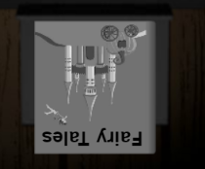

Introduction: Some animals have a lot of cones in their retina and others have very few. Believe it or not, there is an advantage to seeing in black and white!

Question: How do some animals see in the dark?

- Observe: Make sure What the eye “sees” is turned on and the Light intensity is set to Normal light. Slowly change the Percent cones from 100% to 0%.

- What happens to the color of the book?

- What happens to the brightness of the book?

- Compare: Set the Percent cones to 100%, Change the light intensity to Low light.

- What happens to the brightness of the book?

- Slowly reduce the percent cones to 0. What do you notice about the brightness of the book?
Although rods can’t distinguish colors, they are more sensitive to light than cones. So when the number of rods increases, the book looks brighter. Rods can help you see in the dark!

- Observe: Select Normal light. As you drag the Percent cones slider from 0% to 100%, observe the pupil of the eye at the right.

What happens to the pupil?

In normal light, the pupil controls how much light enters the eye. The eye with more cones needs more light, so the pupil diameter gets larger.

- Discuss: Nocturnal animals, such as owls, are active at night. Many nocturnal animals have poor color vision. Why do you think that is?

Besides having more rods, nocturnal animals have many adaptations to help them see in the dark. These include large eyes, wide pupils, and a reflective layer behind the retina.

