Vocabulary: Sight vs. Sound Reactions

Vocabulary

- Histogram – a graph that shows how many data points are in each category.
  - On a histogram, the x-axis is divided into equal categories.
  - The y-axis shows how many values are in each category.

- Mean – the sum of a set of numbers divided by the number of items in the set.
  - The mean of a set of numbers is also known as the set’s average.
  - The symbol for the mean is μ.
  - For example, the mean of 4, 4, 5, 7, and 10 is .
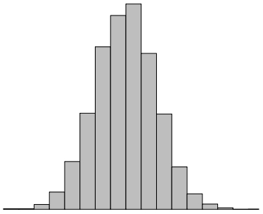

Normal distribution

- Normal distribution – a data distribution that has a “bell” shape when graphed as a histogram.
  - Many kinds of data will tend to have a normal distribution. For example:
    - Weight of adult men
    - Height of adult women
    - Distance that 10-year-old boys can throw a football

- Range – the difference between the greatest and least value in a data set.
  - For example, the range of 4, 4, 5, 7, and 10 is 10 – 4 = 6.

- Standard deviation – a statistic that describes how widely the points of a data set are distributed.
  - The symbol for standard deviation is σ.
  - If data points are very close, the standard deviation will be low.
  - If data points are spread out, the standard deviation will be high.
  - If the data set has a normal distribution, then about 68% of the data will be within one standard deviation of the mean (μ ± σ).

- Stimulus – something that causes an organism to respond.

