Vocabulary: Similar Figures

Vocabulary

- Image – a figure that has been transformed, compared to the original figure (the preimage).
  - Transformations include resizing, reflecting, rotating, or translating a figure.
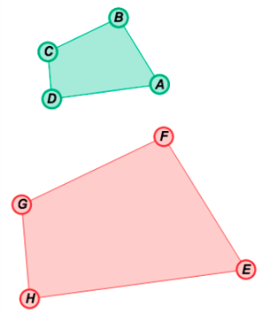
- Preimage – the original figure, before being transformed.

- Scale factor – the ratio of the lengths of the corresponding sides of two similar figures.
  - For example, the side lengths of quadrilateral EFGH are twice as long as the side lengths of quadrilateral ABCD, so the ratio of the lengths of each pair of corresponding sides is 2.

- Similar – having the same shape, but not necessarily the same size.
  - The symbol ~ means “is similar to.”
  - For example, quadrilaterals ABCD and EFGH above are the same shape, but not the same size, so ABCD ∼ EFGH.

