Name: Date:

**Student Exploration:** **Simplifying Radical Expressions**

**Vocabulary:** perfect square, radical expression, rationalize the denominator, square root

**Prior Knowledge Questions** (Do these BEFORE using the Gizmo.)

1. Write the prime factorization of each number. Use exponents as needed.
2. 20 =
3. 49 =
4. A **perfect square** is a number that is equal to an integer squared.
5. Which number above is a perfect square?
6. Which number is not a perfect square but has a perfect square factor?

**Gizmo Overview**

In the *Simplifying Radical Expressions* Gizmo, you will be given a **radical expression** (an expression that contains a root) to simplify.

Here’s how the Gizmo looks at first:

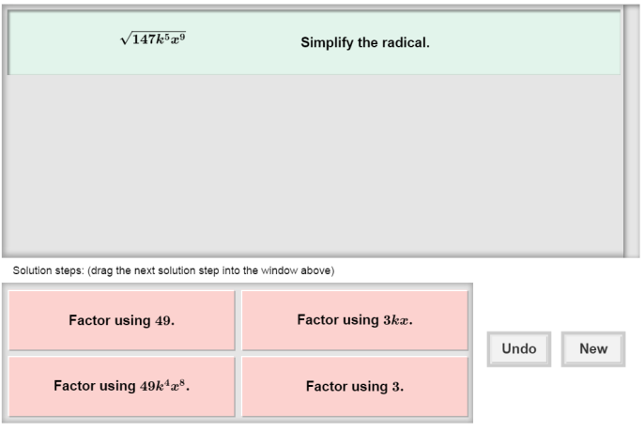

The radical expression for you to simplify is here.

The tiles give you four choices for the next step. Choose the one you think is correct and drag it into the white area above.

Click **Undo** to undo your last choice.

Click **New** to go to a different problem.

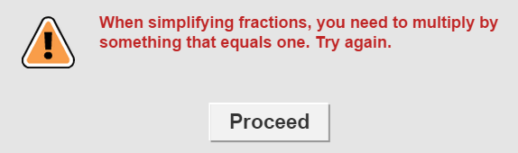Read your feedback in the Gizmo.

(No feedback is given for correct answers.)

Click **Proceed** to go to the next step.

Continue until the radical expression is simplified. Then click **New** for a new problem to work on.

|  |  |  |
| --- | --- | --- |
| **Activity:**  **Simplifying expressions** | Get the Gizmo ready:   * You should see the expression . If not, click **Refresh** in your browser. |  |

1. 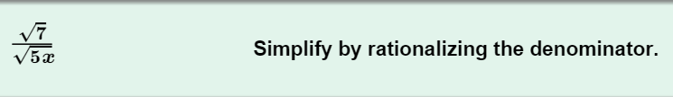When you begin, you should see the expression shown to the right at the top of the Gizmo.
2. To simplify, **rationalize the denominator**. This means multiplying the fraction by something equivalent to 1 that will leave no radical expression in the denominator.

What can you multiply  by to eliminate the radical expression?

1. If you multiply the denominator by something, what must you do to the numerator?

1. Choose the correct first step in the Gizmo. If your choice is incorrect, read the given feedback and try again. What is the product now (unsimplified)?
2. Choose the next correct step. What is the simplified product?

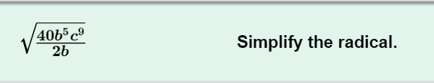

1. Click **New**. You should now see the expression shown to the right at the top of the Gizmo.
2. Can you simplify the fraction under the radical sign? Explain.

1. In the Gizmo, choose the correct first step. What is the new expression?
2. Taking the **square root** of all perfect square factors in the radicand helps simplify. What is the biggest perfect square factor in the radicand?
3. Take the square root of the perfect square. What is the final answer?
4. Click **New**. Work through more problems in the Gizmo. Be sure to read the feedback.

**(Activity continued on next page)**

**Activity (continued from previous page)**

1. Simplify each expression. Be sure to rationalize all denominators. Write all your steps in the space below each problem.
2. 
3. 
4. 
5. 
6. 
7. 