Name: Date:

**Student Exploration:** **Sine, Cosine, and Tangent Ratios**

**Vocabulary:** angle of elevation, cosine, hypotenuse, leg, right triangle, sine, tangent, trigonometric ratio

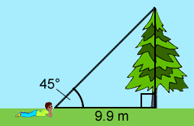

**Prior Knowledge Questions** (Do these BEFORE using the Gizmo.)

Joseph’s math teacher challenges him to estimate the height of a pine tree next to the school. Joseph walks 9.9 meters from the base of the trunk, lies on his belly, and measures a 45° **angle of elevation** to the top of the tree.

1. Do you think Joseph has enough information to estimate of the height of the tree?

Explain.

1. What is your estimate of the height of the tree?

**Gizmo Warm-up**

**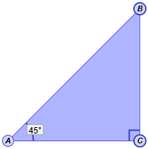**There are several ways Joseph could estimate the height of the tree. He could draw a **right triangle** (triangle with a 90° angle) with a side of 9.9 cm and an angle of 45°. Another way to solve the problem is to use **trigonometric ratios**. These ratios are the subject of the *Sine, Cosine, and Tangent Ratios* Gizmo.

You can use Δ*ABC* to model how Joseph could measure the tree. To begin, check that ***m*∠*A*** is set to 45°. (To quickly set a slider to a value, type the value in the box to the right of the slider and press **Enter**.)

1. The **legs** of a right triangle are the two sides that form the right angle, and . The **hypotenuse** is the side opposite the right angle, .
2. Which side of the triangle represents the height of the tree?
3. Which side represents the distance from Joseph to the base of the tree?
4. Which side represents the distance from Joseph to the top of the tree?
5. Turn on **Show side lengths**. Based on the lengths, what is the height of the tree?

|  |  |  |
| --- | --- | --- |
| **Activity A:**  **Sine** | Get the Gizmo ready:   * On the **SINE** tab, set ***m*∠*A*** to 30°. * Check that **Show side lengths** is turned on. * Drag point C as far as possible to the right. | 346SE_key6 |

1. In Δ*ABC*,  is the *opposite leg* because it is opposite **∠***A*.
2. What are the lengths of each side? *AC* = *BC* = *AB* =
3. When *m*∠*A* = 30°, what is the ratio of *BC* to *AB*?
4. Drag point *C* to the left. Notice that *m*∠*A* stays the same, so the new triangle is similar to the original. For two different positions of point *C*, record *BC*, *AB*, and .

**Position 1 Position 2**

*BC* *AB*  *BC* *AB* 

What do you notice?

1. Drag point *C* all the way to the right so that the length of the hypotenuse  is 14. Turn on **Show sine computation**. The **sine** of angle *A* (or “sin *A*”) is the ratio of the opposite leg to the hypotenuse: sin *A* = .
2. What is sin 30°?
3. Turn off **Show sine computation**. Set ***m*∠*A*** to 20°. What is sin 20°?

Check your work by turning on **Show sine computation**.

1. With **Show sine computation** turned on, set ***m*∠*A*** to 0°.
2. What is sin 0°?
3. How will the length of change as ***m*∠*A*** increases?
4. Slowly increase ***m*∠*A***. What happens to sin *A*?
5. Set ***m*∠*A*** to 90°. What is sin 90°?
6. Explain why the sine of an angle can never be greater than 1.

**(Activity A continued on next page)**

**Activity A (continued from previous page)**

1. Turn off **Show sine computation**. Set ***m*∠*A*** to each of the following angles, and use the side lengths and a calculator to find the sine of each angle. Use the Gizmo to check.

sin 15° = sin 45° = sin 60° = sin 75° =

1. In Δ*DEF*, ∠*F* is a right angle. Suppose *m*∠*D* = 12° and *EF* = 1.3. Follow the steps below to find the length of the hypotenuse, .
2. To solve this problem, first draw a sketch of Δ*DEF* in the space to the right.
3. You know that sin *D* = . In the space to the right, substitute the known values into this equation. Use *x* for the unknown, *DE*.
4. Use algebra to solve for *x*. Show your work to the right. Then, use the Gizmo to find the sine value you need. Finally, find *DE* with a calculator.

What is the length of ?

1. 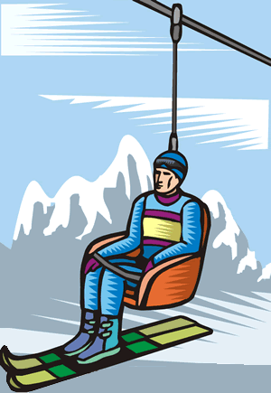Lars rides a chairlift to the top of a mountain. The chairlift rises at a constant angle of 37°. If the length of the chairlift ride is 1,392 m, what is the elevation gain from the base of the chairlift to the top?

Draw a right triangle to model this problem and use the Gizmo to find sin 37°. Show your work.

Elevation gain:

|  |  |  |
| --- | --- | --- |
| **Activity B:**  **Cosine** | Get the Gizmo ready:   * On the **COSINE** tab, set ***m*∠*A*** to 75°. * Turn on **Show side lengths**. * Drag point C as far as possible to the right. | 346SE3_ |

1. In Δ*ABC*,  is the *adjacent leg* because it is next to **∠***A*.
2. When *m*∠*A* = 75°, what is the ratio of *AC* to *AB*?
3. Drag point *C* to the left. For two positions of point *C*, record *AC*, *AB*, and .

**Position 1 Position 2**

*AC* *AB*  *AC* *AB* 

What do you notice?

1. Turn on **Show cosine computation**. The **cosine** of ∠*A* (or “cos *A*”) is the ratio of the adjacent leg to the hypotenuse: cos *A* = . What is cos 75°?
2. With **Show cosine computation** turned on, set ***m*∠*A*** to 0°.
3. What is cos 0°?
4. How do you think cos *A* will change as ***m*∠*A*** increases?

Explain.

1. Slowly increase ***m*∠*A***. What happens to cos *A*?
2. Set ***m*∠*A*** to 90°. What is cos 90°?
3. Turn off **Show cosine computation**. Set ***m*∠*A*** to each of the following angles, and use the side lengths and a calculator to find the cosine of each angle. Use the Gizmo to check.

cos 15° = cos 30° = cos 45° = cos 60° =

Compare cos 35° and sin 55°. In general, how does cos(*θ*) relate to sin(90 – *θ*)?

**(Activity B continued on next page)**

**Activity B (continued from previous page)**

1. In Δ*DEF*, ∠*F* is a right angle. Suppose *m*∠*D* = 39° and *DF* = 9.8. Follow the steps below to find the length of the hypotenuse, .
2. To solve this problem, first draw a sketch of Δ*DEF* in the space to the right.
3. You know that cos *D* = . In the space to the right, substitute the known values into this equation. Use *x* for the unknown, *DE*.
4. Use algebra to solve for *x*. Show your work to the right. Then, use the Gizmo to find the cosine value you need. Finally, find *DE* with a calculator.

What is the length of ?

1. 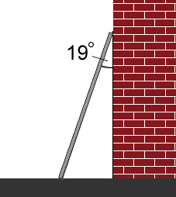A 12-foot ladder leans against a building. The top of the ladder forms an angle of 19° with the top of the building, as shown. How high is the top of the ladder?

To solve the problem, make a sketch, write an equation involving cosine, find the cosine value you need in the Gizmo, and solve for the unknown height. Show your work below.

Height of the top of the ladder:

|  |  |  |
| --- | --- | --- |
| **Activity C:**  **Tangent** | Get the Gizmo ready:   * On the **TANGENT** tab, set ***m*∠*A*** to 30°. * Turn on **Show side lengths**. * Drag point C as far as possible to the right. | 346SE4_ |

1. In Δ*ABC*, observe the opposite leg  and the adjacent leg .
2. When *m*∠*A*= 30°, what is the ratio of *BC* to *AC*?
3. Drag point *C* to the left. For two positions of point *C*, record *BC*, *AC*, and .

**Position 1 Position 2**

*BC* *AC*  *BC* *AC* 

What do you notice?

1. Turn on **Show tangent computation**. The **tangent** of ∠*A* (or “tan *A*”) is the ratio of the opposite leg to the adjacent leg: tan *A* = . What is tan 30°?
2. With **Show tangent computation** turned on, set ***m*∠*A*** to 0°.
3. What is tan 0°?
4. How do you think the tangent will change as ***m*∠*A*** increases?

Explain.

1. Slowly increase ***m*∠*A***. What happens to the tangent?
2. Set ***m*∠*A*** to 90°. What is tan 90°? Explain why this is true.

1. Turn off **Show tangent computation**. Set ***m*∠*A*** to each of the following angles, and use the side lengths and a calculator to find the tangent of each angle. Use the Gizmo to check.

tan 15° = tan 45° = tan 60° = tan 75° =

Why does tan 45° = 1?

**(Activity C continued on next page)**

**Activity C (continued from previous page)**

1. In Δ*DEF*, ∠*F* is a right angle. Suppose   
   *m*∠*D* = 57° and *EF* = 8.3. Follow the steps   
   below to find the length of the adjacent leg, .
2. To solve this problem, first draw a sketch of Δ*DEF* in the space to the right.
3. You know that tan *D* = . In the space to the right, substitute the known values into this equation. Use *x* for the unknown, *DF*.
4. Use algebra to solve for *x*. Show your work to the right. Then, use the Gizmo to find the tangent value you need. Finally, find *DF* with a calculator.

What is the length of ?

1. 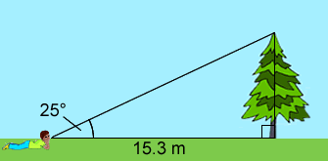Joseph is measuring another tree. He walks 15.3 m from the base of the tree, lies on his stomach, and measures a 25° angle of elevation. What is the height of the tree?

To solve the problem, write an equation using tangent, use the Gizmo to find the tangent value you need, and solve for the unknown height. Show your work below.

Height of the tree:

1. Challenge: Tangent may be defined as the ratio of the sine to the cosine: tan(*θ*) = . Use algebra to show that this is equivalent to tan(*θ*) = . Show your work.