Vocabulary: Sine, Cosine, and Tangent Ratios

dictionary2

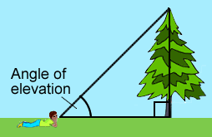**Vocabulary**

* Angle of elevation – the angle between the line of sight to an object and the horizon.
* 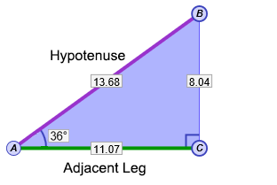Cosine – in a right triangle, the length of the leg adjacent to angle *θ* divided by the hypotenuse:   
  cos *θ* = .
  + The triangle to the right shows that:

cos 36° = , or ≈ 0.809.

* Hypotenuse – the side of a right triangle opposite the right angle.
* The hypotenuse is the longest side of a right triangle.
* Legs (of a right triangle) – the two sides of a right triangle that form the right angle.
* Right triangle – a triangle that contains one right angle.

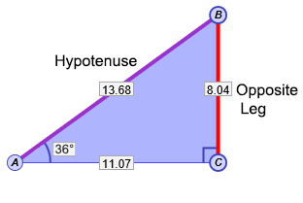

* Sine – in a right triangle, the length of the leg opposite to angle *θ* divided by the hypotenuse: sin *θ* = .
  + The triangle to the right shows that:

sin 36° = , or ≈ 0.588.

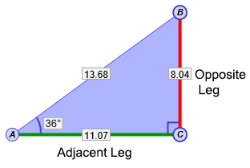

* Tangent – in a right triangle, the length of the leg opposite to angle *θ* divided by the length of the leg adjacent to angle *θ*: tan *θ* = .
  + The triangle to the right shows that:

tan 36° = , or ≈ 0.726.

* Trigonometric ratio – a ratio that relates the side lengths of a right triangle to its angles.
* The most commonly used trigonometric ratios are sine, cosine, and tangent. Others include *secant*, *cosecant*, and *cotangent*.