Vocabulary: Sine Function

Description: dictionary2

**Vocabulary**

* Odd function – a function whose graph is symmetric about the origin.
* If the point (*x*, *y*) lies on the graph of an odd function, then (–*x*, –*y*) also lies on the graph.
* 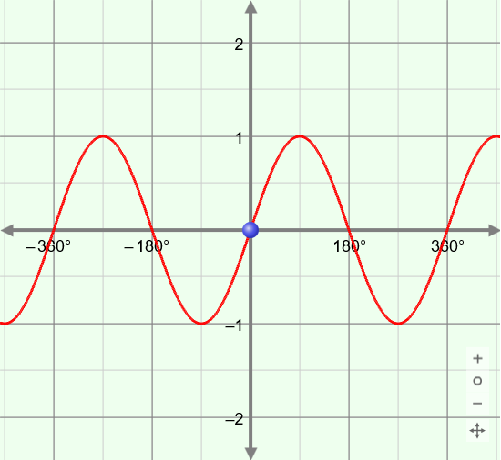Period – the length of the interval that repeats in a function.
* A function whose values repeat in regular intervals is *periodic*.
* For example, *y* = sin(*θ*) is periodic, with a period of 360°, or 2** radians.

* Radian – a unit of angle measure, such that one full rotation equals 2** radians.
* Because 1 rotation (360°) = 2** radians, it follows that ** radians = 180°, and   
  1 radian = , or about 57.3°.
  + If a central angle of a circle measures 1 radian, it intercepts an arc that is the same length as the radius of the circle.

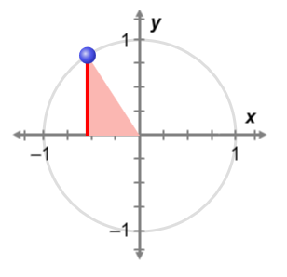

***θ***

**(cos(*θ*), sin(*θ*))**

***x***

***y***

**1**

* Reference triangle – a right triangle formed by a perpendicular segment drawn from the terminal ray of an angle *θ* in standard position to the *x*-axis.
* For example, the triangle to the right is the reference triangle for angle *θ*.
* Sine – in a right triangle, the length of the leg opposite angle *θ* divided by the hypotenuse: sin(*θ*) = .

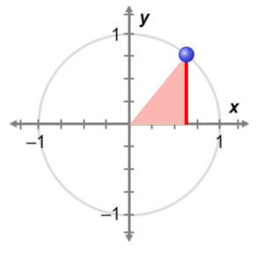

***θ***

**(cos(*θ*), sin(*θ*))**

***y***

***x***

**1**

* If *θ* is in *standard position*, with its vertex at the center of a unit circle, sin(*θ*) is the *y*-coordinate of the point where the angle intersects the circle.
* Trigonometric function – a function of an angle given as the ratio of the sides of a right triangle that contains the angle.
* Unit circle – a circle with a radius of 1.