Name: Date:

**Student Exploration:** **Slope-Intercept Form of a Line**

**Vocabulary:** slope, slope-intercept form, *y*-intercept

**Prior Knowledge Questions** (Do these BEFORE using the Gizmo.)

1. Your friend offers to pay you $10 plus $2 per day if you will watch his dog while he’s on vacation. Another friend offers you $15 plus $1 per day to watch her dog during the same time. You cannot do both jobs. Tell which job you would choose and explain why.

1. A third friend offers you a flat $20 to watch his dog during the same time. Tell whether you would choose this job over either of the other two and explain why.

**Gizmo Warm-up**

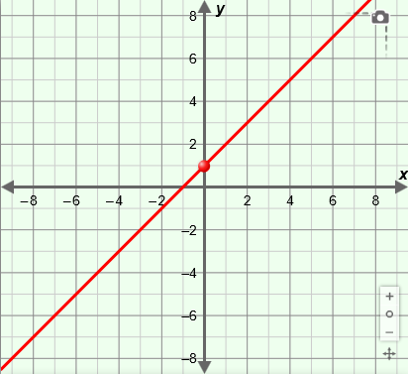In the *Slope-Intercept Form of a Line* Gizmo, you can graph a line and manipulate its equation in **slope-intercept form**   
(*y* = *mx* + *b*).

1. In the Gizmo, drag the point on the *y*-axis of the graph. Then, on the **CONTROLS** tab, drag the *b* slider. (You can also change *b* by clicking in the text field, typing a new value, and hitting **Enter**.) What changes about the line?

1. In the Gizmo, drag the line on the graph (not by the point). Then use the slider or the text field to change the value of *m*.
2. What changes about the line?
3. What stays the same about the line?

|  |  |  |
| --- | --- | --- |
| **Activity A:**  **The equation**  ***y* = *mx* + *b*** | Get the Gizmo ready:   * Be sure **Show triangle** is turned off. | 166SE2 |

1. Consider the line with the equation *y* = 2*x* + 1.
   1. Substitute the *x*-values shown in the table below into the equation to find several points on the line *y* = 2*x* + 1. Plot the points on the grid and draw the line. Then check your work by graphing the line in the Gizmo and clicking on the **TABLE** tab.

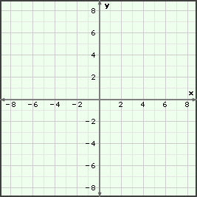

|  |  |
| --- | --- |
| ***x*** | ***y*** |
| –3 |  |
| –2 |  |
| –1 |  |
| 0 |  |
| 1 |  |
| 2 |  |
| 3 |  |

* 1. Where does your line cross the *y*-axis? This is the graph’s ***y*-intercept**.
  2. In general, the *y*-intercept of the line *y* = *mx* + *b* is *b*. Explain why that makes sense.

* 1. Study the table. By how much does *y* change as *x* increases by 1?

Where is this value in the equation *y* = 2*x* + 1?

* 1. On the **CONTROLS** tab, select **Show triangle** to see how the **slope** relates to the line. How can you graph the equation using just the slope and the *y*-intercept?

* 1. Use the method you described above to graph *y* = *x* – 4 to the right. Check in the Gizmo.

**(Activity A continued on next page)**

**Activity A (continued from previous page)**

1. Turn off **Show triangle**. In the Gizmo, set *b* to –5.
2. Vary the slope of the line in the Gizmo. Write the equations, in slope-intercept form, of three different lines with a *y*-intercept of –5.

1. If you know the *y*-intercept of a line, what else do you need to write its equation?



1. In the blanks below, write the equations, in slope-intercept form, of three different lines with a *y*-intercept of 1.5. Sketch the graphs of the lines on the grid to the right. Label each with its equation. Check your work in the Gizmo.

1. A line contains the points (–5, 0) and (0, –3).
2. What is the equation, in slope-intercept form, of the line that contains both of these points?
3. Explain how you found the equation above.

1. Graph this equation in the Gizmo. Explain how you can check if both (–5, 0) and   
   (0, –3) lie on this line.
2. Write the equation, in slope-intercept form, of each line described below. Then check your answers in the Gizmo.
3. *y*-intercept = 0, slope = –6
4. *y*-intercept = –1, slope = 

|  |  |  |
| --- | --- | --- |
| **Activity B:**  **Horizontal and vertical lines** | Get the Gizmo ready:   * Click on the **CONTROLS** tab. * Turn on **Show triangle**. | 166SE3 |

1. Drag the line in the Gizmo until it is horizontal.
   1. Write the slope, *y*-intercept, and equation of your line below.

slope = *y*-intercept = equation:

* 1. Click on the **TABLE** tab. What do you notice about the coordinates of the points?

* 1. Click on the **CONTROLS** tab. In the Gizmo, graph several other horizontal lines. Write the equations of three of your lines below.

* 1. What is the general equation of a horizontal line?
  2. Why does it make sense that the graph of an equation like that is a horizontal line?

1. Drag the line in the Gizmo until it is vertical.
2. Write the slope and equation of your line. slope = equation:
3. Click on the **TABLE** tab. When *x* = 0, what is *y*? Why do you think this is true?
4. Sketch several vertical lines on the grid to the right. Label each line with its equation. (Note: This Gizmo does not allow most vertical lines.)
5. What is the general equation of a vertical line?

1. Why does it make sense that the graph of an equation like that is a vertical line?

|  |  |  |
| --- | --- | --- |
| **Activity C:**  **Using *y* = *mx* + *b*** | Get the Gizmo ready:   * Click on the **CONTROLS** tab. * Turn off **Show triangle**. | 166SE4 |

Maggie is in charge of finding a company to print t-shirts for her softball team. She’s decided to go with T-Shirts & More. They charge a $25 set-up fee plus $8 per shirt.

1. You can write an equation in slope-intercept form (*y* = *mx* + *b*) to describe this situation.
   1. What is the value of *b*? Why?

* 1. What is the value of *m*? Why?

* 1. What is the equation in slope-intercept form for this situation?
  2. What do *x* and *y* represent? *x* = *y* =
  3. Graph your equation in the Gizmo. Click the zoom out button (**–**) until the *y*-intercept appears. Explain why part of this graph doesn’t apply to this situation.
  4. Click on the **TABLE** tab. Change the **MIN** and **MAX** values to show the cost for up to 25 shirts. What is the cost of 10 shirts?

1. Maggie decides to add the team logo to every shirt. This increases the cost by $2 per shirt.
2. What is the new equation in slope-intercept form?

Explain:

1. 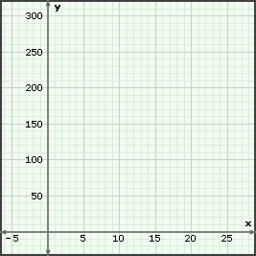Sketch this new line on the grid to the right.
2. What is the cost of 10 shirts?
3. Given your answer to the previous question, what point must be on the graph of this line?

Use the **TABLE** in the Gizmo to check your answer.