Name: ______________________________________ Date: ________________________

Student Exploration: Solar System Explorer

Vocabulary: astronomical unit, dwarf planet, eccentricity, ellipse, gas giant, Kepler’s laws, orbit, orbital radius, period, planet, solar system, terrestrial planet

Prior Knowledge Questions (Do these BEFORE using the Gizmo.)

- List all of the planets you can think of in our solar system. Try to list them in order from closest to farthest from the Sun.

_________________________________________________________________________

- Which planets are most like Earth? Which are most different from Earth? Explain.

_________________________________________________________________________

_________________________________________________________________________

_________________________________________________________________________

Gizmo Warm-up
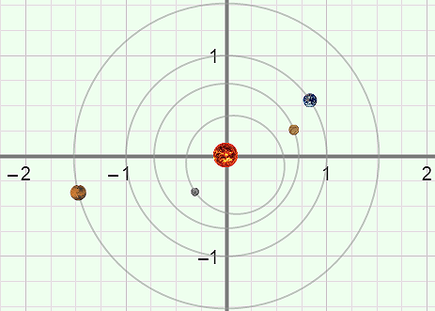
The Solar System Explorer Gizmo shows a model of the solar system. All of the distances, but not the sizes of the planets, are shown to scale. To begin, turn on Show orbital paths and click Play (). You are looking at the four inner planets.

- In which direction do planets go around the Sun, clockwise or counterclockwise? __________________________

- An orbit is the path of a body around another body. What is the shape of the planetary orbits around the Sun? ______________________________________________________

- Click Pause (). You can see the name of each planet by holding your cursor over the planet. What is the order of the eight planets, starting from the Sun? Click the “zoom out” button () to see the outer planets and Pluto, which is classified as a dwarf planet.

_________________________________________________________________________

_________________________________________________________________________

Activity A:  Classifying planets | Get the Gizmo ready:  - Click Reset (). | 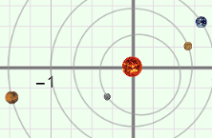

Question: How are planets classified?

- Think about it: How do you think astronomers group planets? ________________________

_________________________________________________________________________

- Gather data: Select Mercury from the Solar system menu at left. Turn on Additional data. In the table below, record Mercury’s Mass, Mean radius, and Density. Then repeat for each of the other planets as well as the dwarf planet Pluto. Include units.

Planet | Mass (×10²³ kg) | Mean radius (km) | Density (g/cm³)
Mercury
Venus
Earth
Mars
Jupiter
Saturn
Uranus
Neptune
Pluto (dwarf planet)

- Analyze: What patterns do you notice in your data table? ___________________________

_________________________________________________________________________

_________________________________________________________________________

- Analyze: Based on the data you have collected, how would you divide the planets into two groups? Explain your reasoning. (Note: Do not include Pluto in these groups.)

_________________________________________________________________________

_________________________________________________________________________

_________________________________________________________________________

(Activity A continued on next page)
Activity A (continued from previous page)

- Classify: Astronomers classify the eight planets in our solar system into two groups: terrestrial planets and gas giants. Terrestrial planets have rocky surfaces, while gas giants are composed mainly of gas. Based on your data, classify each planet as a terrestrial planet or a gas giant. (Hint: Look at the density of each planet.)

Mercury: ____________________

Venus: ____________________

Earth: ____________________

Mars: ____________________

Jupiter: ____________________

Saturn: ____________________

Uranus: ____________________

Neptune: ____________________

- Summarize: Compare the masses, radii, and densities of the terrestrial planets and the gas giants.

  - What do the terrestrial planets have in common? ____________________________

___________________________________________________________________

___________________________________________________________________

  - What do the gas giants have in common? __________________________________

___________________________________________________________________

___________________________________________________________________

- Extend your thinking: Why doesn’t Pluto fit into either the terrestrial planet group or the gas giant group? _______________________________________________________________
_________________________________________________________________________
_________________________________________________________________________

- Think and discuss: Why do you think the inner planets are small and dense, while the outer planets are gas giants? If possible, discuss your ideas with your classmates and teacher.

_________________________________________________________________________

_________________________________________________________________________

_________________________________________________________________________

_________________________________________________________________________

Activity B:  Planetary orbits | Get the Gizmo ready:  - Click Reset.  - Click the “zoom in” button () several times to zoom in as far as possible. | 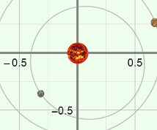

Introduction: Johannes Kepler (1571–1630) was a German astronomer who spent years poring over a vast store of planetary data compiled by his predecessor, Tycho Brahe. After many incorrect theories and other setbacks, Kepler at last determined the beautifully simple physical laws that govern orbiting bodies. These rules are now known as Kepler’s laws.

Question: What rules describe the size and shape of planetary orbits?

- Observe: Select Mercury from the Solar system menu. Look at Mercury’s orbit.

- What do you notice? __________________________________________________

- Is Mercury always the same distance from the Sun? _________________________

Kepler’s first law states that an orbit is in the shape of a slightly flattened circle, or ellipse. While a circle contains a single point at its center, an ellipse contains two critical points, called foci. The Sun is located at one focus of a planet’s orbit.

- Gather data: The eccentricity of an ellipse describes how “flattened” it is. A circle has an eccentricity of 0, and a flat line segment has an eccentricity of 1.

- Look at the data displayed at left. What is the eccentricity of Mercury’s orbit? ______
- Zoom out to look at the other orbits. Which object’s orbit is even more eccentric than the orbit of Mercury? __________________________________________________

- Observe: Zoom in all the way, and select Mercury again. Check that the simulation speed is Slow and click Play. Observe the speed of Mercury as it goes around the Sun.

What do you notice? ________________________________________________________

_________________________________________________________________________

Kepler’s second law states that a planet speeds up as it gets closer to the Sun, and slows down as it moves farther away.

- Confirm: Charge the speed to Fast and zoom out to observe Pluto. Does Pluto follow Kepler’s second law? Explain. _________________________________________________
_________________________________________________________________________

Activity C:  Planetary periods | Get the Gizmo ready:  - Click Reset.  - Zoom out as far as possible.  - Set the speed to Fast. | 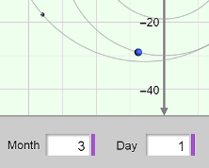

Introduction: Kepler’s third law describes the relationship between a planet’s orbital radius, or its mean distance from the Sun, and the planet’s period, or amount of time to complete an orbit.

Question: How does a planet’s orbital radius relate to its period?

- Predict: How do you think the period of a planet will change as its distance from the Sun increases? ________________________________________________________________
_________________________________________________________________________

- Observe: Click Play, and observe the orbits of all the planets. What is the relationship between the speed of planets and their distance from the Sun? _______________________
_________________________________________________________________________
_________________________________________________________________________

- Measure: Click Reset and zoom in as far as possible. Click Play, and then Pause when Earth is aligned with either the grid’s x-axis or y-axis. Note the starting time below.

Then click Play, and then click Pause again when Earth is in exactly the same position. Note the ending time below.

Starting time Month: _____ Day: _____ Year: _____

Ending time Month: _____ Day: _____ Year: _____

- Calculate: What is Earth’s period? _____________________________________________

Earth takes 12 months to complete an orbit, so Earth’s period is 12 months, or one year.

- Measure: The distance units shown are the grid are called astronomical units (AU). Look at Earth’s orbit. How far is Earth from the Sun in AU? ______________________________
As you can see, one astronomical unit is equal to the mean Earth-Sun distance, which is approximately 150,000,000 kilometers.

(Activity C continued on next page)
Activity C (continued from previous page)

- Gather data: Use the Additional data display to find the orbital radius and period of each planet. Record this data in the first two columns of the table below. Include units.

Planet | Mean orbital radius (AU) | Period  (Earth years) | R ³ | T ²
Mercury
Venus
Earth
Mars
Jupiter
Saturn
Uranus
Neptune

- Analyze: What happens to the period as the orbital radius increases? __________________

_________________________________________________________________________

- Calculate: Kepler discovered a very interesting relationship between the cube of each planet’s orbital radius and the square of its period. Use a calculator to find the cube of each planet’s orbital radius, and record these values in the “R ³” column of the table. Record the squares of the periods in the “T ²” column.

How do the numbers in the “R ³” and “T ²” columns compare? ________________________

_________________________________________________________________________

Kepler’s third law states that the cube of the orbital radius is proportional to the square of the period for any orbiting body. If the orbital radius is measured in astronomical units and the period is measured in Earth years, the numbers are nearly identical.

- Predict: Pluto has an orbital radius of 39.529 AU. Based on Kepler’s third law, what is the approximate period of Pluto’s orbit? ____________________________________________
(Hint: Find the cube of the orbital radius first, and then take the square root.)

- Confirm: Look up Pluto’s actual period in the Gizmo. What is it, and how does it compare to the calculated value? ________________________________________________________

