Name: Date:

Student Exploration: Solving Equations by
Graphing Each Side

Vocabulary: equation, expression, identity, solution

Prior Knowledge Questions (Do these BEFORE using the Gizmo.)

- Yan has four more apples than Xavier. If Xavier has x apples, use x, a number, and an operation to write an expression for how many apples Yan has.

- Yan also has three times as many apples as Xavier. Write a second expression for how many apples Yan has.

- How many apples does Xavier have? How many apples does Yan have?

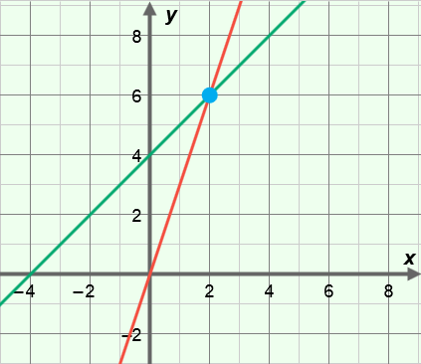
Gizmo Warm-up
One way to solve an equation like 3x = x + 4 is to graph each side. In the Solving Equations by Graphing Each Side Gizmo, you will use a graph to find the solution, or the value that makes an equation true.

To begin, check that ax + b = cx + d is selected. Set a to 3, b to 0, c to 1, and d to 4. Drag the sliders to vary the values of a, b, c, or, d. You can also change the values by clicking on the number in the text field, typing in a new value, and hitting Enter.

- What equations are graphed in the Gizmo? and

- Mouseover the blue point on the graph. What are its coordinates? ( , )

- How do the coordinates of the blue point relate to the solution of the equation 3x = x + 4?

Activity A:  Solving equations by graphing | Get the Gizmo ready:  - Be sure ax + b = cx + d is selected. | 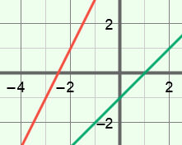

- Consider the equation 2x + 5 = x – 1.

  - What two equations can you graph to solve this equation?

Go ahead and graph these two equations in the Gizmo.

  - What does the blue point on the graph represent?

  - Mouseover the blue point on the graph. What are its coordinates? ( , )

  - Based on the coordinates above, what is the solution to 2x + 5 = x – 1?

Explain.

In the Gizmo, turn on Show solution on number line to check your answer.

  - Select the TABLE tab. How can you use the table to check the solution to the equation 2x + 5 = x – 1?
  - Suppose you substitute your solution for x into 2x + 5 = x – 1. What should be true of both sides of the equation once they are simplified?
Why?

  - Substitute the solution for x in the equation 2x + 5 = x – 1. Then simplify to check your answer from above. Show your work.

  - Use algebra to solve the equation 2x + 5 = x – 1. Show your work. In the Gizmo, select the SOLUTION tab to check your answer.

(Activity A continued on next page)
Activity A (continued from previous page)

- Select the CONTROLS tab and a(x + b) = cx + d. Turn off Show solution on number line. Consider the equation 4(x + 2) = 3x + 4.

- What two equations can you graph to solve this equation?

- Graph your equations in the Gizmo. What is the solution to 4(x + 2) = 3x + 4?

How do you know?

Turn on Show solution on number line to check your answer in the Gizmo.

- Select the TABLE tab. Can you use the table to check your answer?

If so, explain how you found the answer using the table.

- Solve the equation 4(x + 2) = 3x + 4 algebraically. Show your work. In the Gizmo, select the SOLUTION tab to check your answer.

- You’ve used both graphs and algebra to solve equations of the form ax + b = cx + d and
a(x + b) = cx + d. Which method do you find easier?
Explain.

- Use algebra to solve each equation. Then graph the equation in the Gizmo to check your solution. (If necessary, you can use the controls to the right of the graph to zoom in and out. You can also click on the graph and drag to pan it.)

- 5x – 2 = 3x + 22

- 3(x – 12) = –x + 4

Activity B:  Special types of solutions | Get the Gizmo ready:  - On the CONTROL tab, select a(x + b) = cx + d.  - Check that Show solution on number line is turned on. | 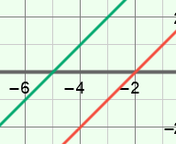

- Consider the equation 2(x + 4) = 2x + 8.

- Do you think this equation has a solution? Explain.

- In the Gizmo, graph the equation 2(x + 4) = 2x + 8. What is the solution to this equation? Why?
In general, an equation that is true for all values of the variable is an identity.

- Use algebra to solve the equation 2(x + 4) = 2x + 8. Show your work. In the Gizmo, select the SOLUTION tab to check your answer.

- Consider the equation 3(x + 4) = 3x + 10.

- Do you think this equation has a solution? Explain.

- Select the CONTROLS tab and graph the equation 3(x + 4) = 3x + 10. Is there a solution to this equation? Why?
- Use algebra to simplify the equation 3(x + 4) = 3x + 10. Show your work. In the Gizmo, select the SOLUTION tab to check your answer.

Activity C:  Using equations | Get the Gizmo ready:  - On the CONTROL tab, select ax + b = cx + d. | 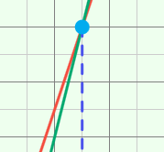

- Three times a number plus two is four less than four times the number.

- Write an equation that you can use to solve this problem.

- Use algebra to solve your equation and find the number. Show your work. Then check your answer in the Gizmo.

- Kari worked twice as many hours as Chris. She also worked ten less than three times as many hours as Mark. Chris and Mark worked the same number of hours.

- Let h be the number of hours Chris worked. How many hours did Mark work?

How do you know?

- Use h to write two different expressions for the number of hours Kari worked.

- Write an equation to describe this situation.

- Use algebra to solve your equation. Show your work. Then check your answer in the Gizmo.

- How many hours did Chris and Mark work?

- How many hours did Kari work?

