Name: Date:

Student Exploration: Solving Using Trend Lines

Vocabulary: correlation, scatter plot, trend line

Prior Knowledge Questions (Do these BEFORE using the Gizmo.)

- Anita is taller than Becca. How would you expect their shoe sizes to compare?

- Explain your answer to question 1.

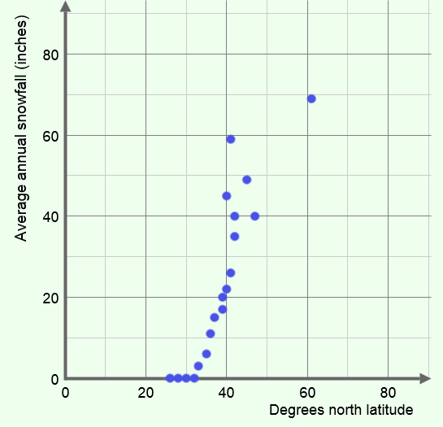
Gizmo Warm-up
In the Solving Using Trend Lines Gizmo, you will examine scatter plots, like the one shown to the right, related to weather at different latitudes. You will explore how the latitude of U.S. cities tends to be related to snowfall, temperature, and precipitation.

- In the Gizmo, on the CONTROLS tab, be sure Compare latitude and snowfall is selected.

- What variable is shown on the horizontal axis?

- What variable is shown on the vertical axis?

- Mouseover several points on the graph. You will see the coordinates of each point and the city that point represents.

- Give the coordinates of one of the points. ( , )

- Which city does your point represent?

- Fill in the blanks below to explain exactly what this point tells you.

is located at

and averages a year.

Activity A:  Trend lines | Get the Gizmo ready:  - Be sure Compare latitude and snowfall is selected on the CONTROLS tab. | 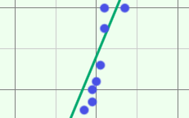

- The scatter plot in the Gizmo compares the latitude of a city to the average annual snowfall.

  - Look at the point closest to the upper right-hand corner. Give the coordinates of the point, and the city represented.
  - Now, find the point closest to the lower left-hand corner. Give the coordinates of the point, and the city represented.
  - Why are these cities the most extreme in this scatter plot?

  - A line that fits the points in a scatter plot well is called a trend line. Do you think the trend line for this data has a positive, negative, or near-zero slope?
Select Show least squares fit line to see the trend line.

  - The positive slope indicates a positive correlation. Fill in the blanks to explain this.

As degrees north , the average snowfall tends to

  - Click on the TABLE tab. Does this data agree with the statement above?

- Select the CONTROLS tab. Be sure Compare latitude and snowfall and Show least squares fit line are selected. Look at the equation of the trend line, given below y = mx + b.

- What do x and y represent?

- What is the slope (m) and y-intercept (b) of this line? m = b =

- In general, where are the data points located in relation to the line?

- Select Show probe. Drag the purple probe slowly across the graph. Place the probe at x = 45° north latitude. In the colorful table, what do y (line) and y (data) tell you?

(Activity A continued on next page)
Activity A (continued from previous page)

- On the CONTROLS tab, turn off Show probe and Show least squares fit line. Select Compare latitude and temperature.
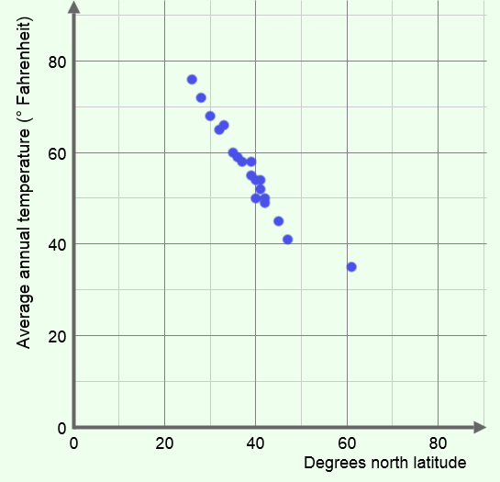
- What variables are represented in this scatter plot?

- On the scatter plot to the right, sketch a possible trend line for this scatter plot. Click on Show least squares fit line to check. Is the slope positive, negative, or near zero?

- Fill in the blanks to tell what the slope indicates about the relationship between the variables.

As degrees north , the average temperature tends to

The correlation between these variables is negative.

- On the CONTROLS tab, turn off Show least squares fit line. Select Compare latitude and precipitation.

- What two variables are being compared?

- Do you think this scatter plot shows a positive correlation, a negative correlation, or no correlation? Explain.
Click on Show least squares fit line to check your answer.
- You should have seen that there is essentially no correlation between latitude and precipitation. Explain why this makes sense.

Activity B:  Predicting trends | Get the Gizmo ready:  - Select Compare latitude and snowfall on the CONTROLS tab. | 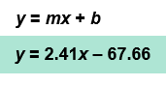

- Turn on Show least squares fit line. Look at the equation y = 2.41x – 67.66.

  - What do x and y represent?

  - Suppose you know the location of a United States city in degrees north latitude. How can you use this equation to predict the average annual snowfall of that city?

  - Columbia, South Carolina, is located at 34 degrees north latitude. Use the equation to estimate the average annual snowfall for Columbia. Show your work in the space to the right. Turn on Show probe and Show calculation to check your work.

  - What is the estimated average snowfall for a city at the Equator (0°)?

  - Is that a reasonable estimate? Explain.

- On the CONTROLS tab, select Compare latitude and temperature and Show least squares fit line. Turn off Show probe.

- Honolulu, Hawaii, sits at 21 degrees north latitude. Use the equation in the Gizmo to estimate the average annual temperature of Honolulu. Show your work in the space to the right. Turn on Show probe and Show calculation to check your work.

- Mobile, Alabama, is located at 31 degrees north latitude. Would you expect the average annual temperature for Mobile to be greater than or less than Honolulu?

Explain.

- What is the equation’s estimate for the average temperature in Mobile?

- How much cooler is that than the average temperature in Honolulu?

Explain why, based on the equation.

