Name: Date:

**Student Exploration:** **Solving Two-Step Equations**

**Vocabulary:** equation, expression, solution, solve

**Prior Knowledge Questions** (Do these BEFORE using the Gizmo.)

Bryan and his friends are playing a mental math game. Bryan asks each friend to pick a number, multiply it by 4, and then add 6 to the product. Luke says he ends up with 18.

1. What number did Luke start with? __________
2. How did you find Luke’s original number?

**Gizmo Overview**

In the *Solving Two-Step Equations* Gizmo, you will be given an **equation** (a mathematical sentence stating that two **expressions** are equal) with a variable in it. You will **solve** each equation (find the **solution**, or value that makes the equation true), step-by-step.

Here’s how the Gizmo looks at first:

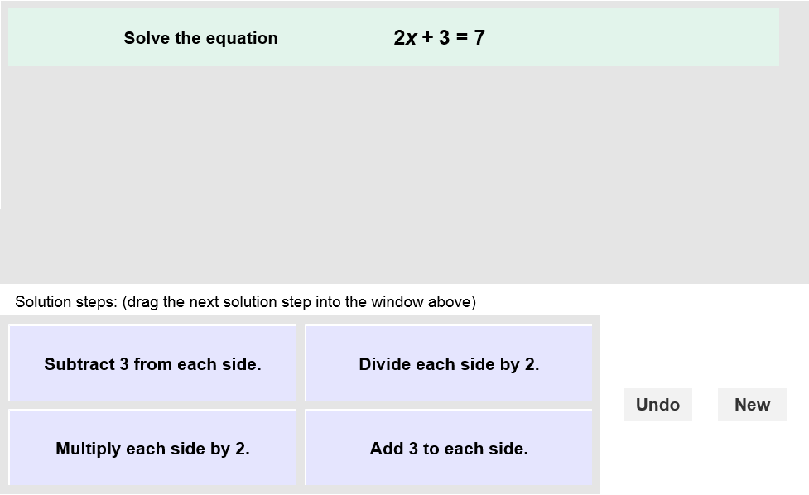

The equation for you to solve is here.

The tiles give you four choices for the next step. Choose the one you think is correct and drag it into the white area above.

Click **New** to go to a different problem.

Click **Undo** to undo your last choice.

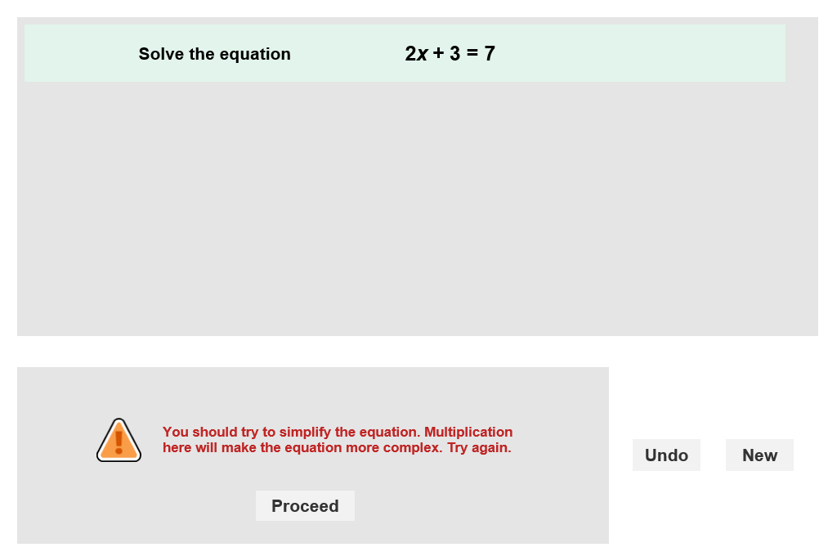

Read your feedback in the Gizmo. (No feedback is given for correct answers.)

Click **Proceed** to go to the next step.

Continue until you solve the equation. Then click **New** for a new problem to work on.

|  |  |  |
| --- | --- | --- |
| **Activity:**  **Finding the solution** | Get the Gizmo ready:   * You should see the equation 2*x* + 3 = 7. If not, click **Refresh** in your browser. | 274SE4 |

1. 274SE5When you begin, you should see the equation shown to the right at the top of the Gizmo.
2. This equation has multiplication and addition in it. To solve this equation, you need to get *x* by itself, which means you need to get 2*x* by itself first. How can you do this?

1. In the Gizmo, choose the correct first step. If your choice is incorrect, read the given feedback and try again. What is the first step?
2. Why is it important to subtract 3 from each side of the equation instead of just from the left side?
3. The equation shown should now be 2*x* = 4. Multiplication is the only operation left. How do you undo “multiply by 2?”
4. Choose the next correct step. What is the solution to 2*x* + 3 = 7?
5. Substitute your solution for *x* into 2*x* + 3 and evaluate. What do you get?
6. 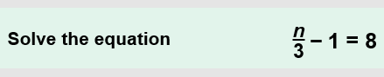Click **New**. You should now see the equation shown at the right in the Gizmo.
7. This equation has two operations, division and subtraction. Which operation should you undo first?
8. Choose the correct steps in the Gizmo. What is the solution to  – 1 = 8?
9. Substitute your solution into  – 1 and evaluate. What does the result tell you?

1. Click **New**. Work through more problems in the Gizmo.

**(Activity continued on next page)**

**Activity (continued from previous page)**

1. Solve each equation below. Write all your steps in the space below each problem.
2. 5*x* – 3 = 12
3.  + 4 = 7
4. 6*n* + 3 = –9
5.  – 5 = –8
6. –4*r* + 9 = –7
7.  – 8 = 2