Name: Date:

Student Exploration: Special Parallelograms

Vocabulary: parallelogram, rectangle, rhombus, square

Prior Knowledge Questions (Do these BEFORE using the Gizmo.)
Jerry is building a gate like the one shown to the right.

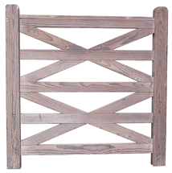
- Should the 4 diagonal boards (the X’s) be longer than, shorter than, or the same length as the 5 horizontal boards?

- Explain why the diagonal boards make this gate stronger.

Gizmo Warm-up
In the Special Parallelograms Gizmo, you can manipulate a dynamic parallelogram with various constraints. You can then name the figure, based on its side and angle measures.

- Be sure None is chosen under Condition. Drag the vertices around. What do the marks on the sides of the figure tell you is always true about the opposite sides of a parallelogram?

- Continue dragging the vertices to see more parallelograms.

- What seems to be true about the lengths of the opposite sides of the parallelograms?

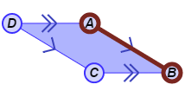
Use the Gizmo rulers to verify this. (Select Show ruler to open a Gizmo ruler. Then, attach the “donuts” to points, as shown to the right.)

- What seems to be true about the opposite angle measures of the parallelograms?

Use the Gizmo protractors to verify this. (Select Show angle measure tool to open a Gizmo protractor. Then, attach the “donuts” to points.)

Activity A:  Parallelograms with conditions | Get the Gizmo ready:  - Be sure Show shape name is turned off.  - Turn off any Gizmo rulers or protractors. | 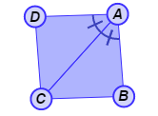

- Choose All four sides are congruent. Drag the vertices to see a variety of these shapes.

- What do you think a parallelogram with 4 congruent sides is called?

Select Show shape name to verify your answer.

- Sketch a couple of examples of a rhombus in the space to the right.

- Turn off Show shape name. Select All four angles are right angles from the Condition menu. Look at several of these shapes by dragging the vertices.

- What do you think the name of a parallelogram with 4 right angles is?

Check by selecting Show shape name.

- In the space to the right, sketch two examples of a rectangle.

- Can a figure be both a rhombus and a rectangle? Explain.

A parallelogram that is a rectangle and a rhombus is called a square.

- Select One angle is a right angle, and be sure Show name of shape is turned on. Experiment by dragging the vertices. Why must this parallelogram be a rectangle?

- Turn off Show name of shape. Select A diagonal bisects one angle. Drag the vertices.

  - What are these parallelograms – rhombuses, rectangles, or neither?

  - Which two sides can you measure to verify? Explain.

Use the Gizmo rulers to measure the sides. Select Show shape name to verify this.
(Activity A continued on next page)
Activity A (continued from previous page)

- Turn off Show shape name. Select A diagonal bisects two angles. Look at several of these shapes by dragging the vertices.

- Sketch an example of this parallelogram in the space to the right. Below, name the two pairs of congruent angles formed by the diagonal.

- Classify these parallelograms as rhombuses, rectangles, or neither.

Click Show shape name to check.

- Turn off Show shape name. Under Condition, select Diagonals are perpendicular. Drag the vertices to see a variety of parallelograms with perpendicular diagonals.

- Sketch an example of the figure to the right. Name the four right triangles formed by the diagonals.

- Are these four triangles congruent? Explain.

- How can you use the four congruent triangles to determine the type of parallelogram formed? Click Show shape name to check your answer.

- Turn off Show shape name. Choose Diagonals are congruent. Create several parallelograms with congruent diagonals by dragging the vertices.

- What appears to be true about the angles of this parallelogram?

Use the Gizmo protractors to check.

- Continue dragging the vertices. What does this shape appear to be?

Select Show shape name to check your answer.

- Do you think squares also have congruent diagonals? Explain:

Activity B:  Using parallelograms | Get the Gizmo ready:  - Turn off Show shape name. | 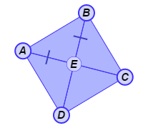

- Experiment with the Gizmo to help answer the questions below. Name the shape described, and explain your answers. Then check them by selecting Show shape name in the Gizmo.

- If a parallelogram has four congruent angles, then it is a

Explain.

- If a parallelogram has a diagonal that bisects one angle, and is also congruent to the other diagonal, then it is a
Explain.

- Solve each problem. Show all of your work.

- In parallelogram ABCD, ∠BAC and ∠DAC are congruent, and m∠ABC = 54°. What is m∠DAC?
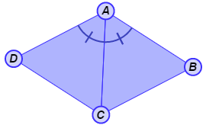
- In parallelogram ABCD, ≅ . If AC = 3x + 6 and BD = 5x – 8, what is the value of x?
