Vocabulary: Standard Form of a Line

dictionary2

**Vocabulary**

* Slope – a measure of the steepness of a line.
  + 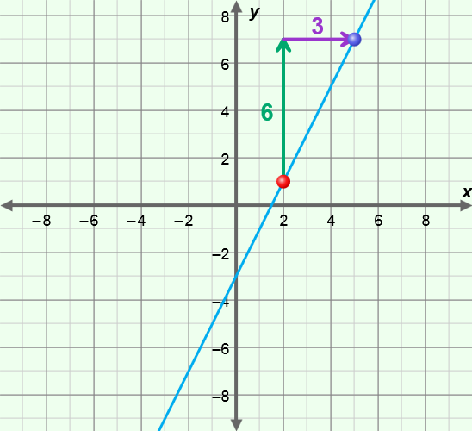For two points on a line, (*x*1, *y*1) and (*x*2, *y*2), slope is defined as:

slope =  =  = .

* + For example, the slope of the line through the points (2, 1) and (5, 7) as shown to the right is:

 =  = 2.

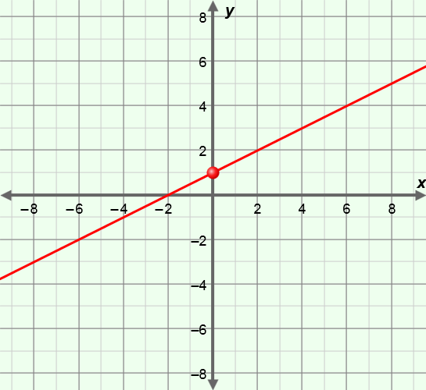

* Slope-intercept form – a linear equation of the form *y* = *mx* + *b*, where *m* is the slope and *b* is the *y*-intercept.
* For example, the line with the equation *y* = *x* + 1, shown to the right, has a slope of  and a *y*-intercept of 1.
* Standard form (of a linear equation) – a linear equation of the form *Ax* + *B*y = *C*, where *A*, *B*, and *C* are real numbers and *A* and *B* are not both zero.
* 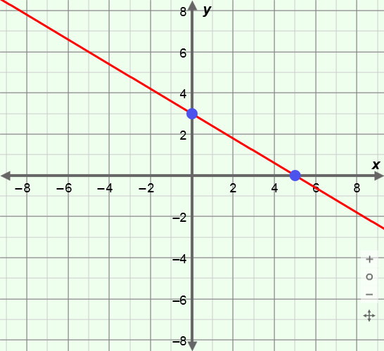*x*-intercept – the *x*-coordinate where a graph intersects the *x*-axis.
* The *x*-intercept of the line at the right is 5 because the line intersects the *x*-axis at the point (5, 0).
* *y*-intercept – the *y*-coordinate where a graph intersects the *y*-axis.
* The *y*-intercept of the line at the right is 3 because the line intersects the *y*-axis at the point (0, 3).