Name: ______________________________________ Date: ________________________

Student Exploration: Star Spectra

Vocabulary: absorption spectrum, binary star, blueshift, Cepheid variable, emission spectrum, giant star, nebula, redshift, spectrum, star

Prior Knowledge Questions (Do these BEFORE using the Gizmo.)

- What happens when light goes through a prism? __________________________________

This band of colors is called a spectrum.

- A rainbow is an example of a spectrum. What is the sequence of colors in a rainbow?

_________________________________________________________________________

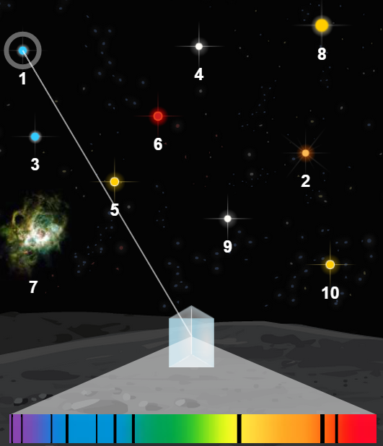
Gizmo Warm-up
The interior of a star produces a continuous spectrum of light, like a rainbow. Cooler gases in the outer layers of the star absorb certain wavelengths of light, causing dark lines to appear in the spectrum. The resulting absorption spectrum can tell astronomers a great deal about the star.

- On the Star Spectra Gizmo, turn on Show labels. Select star 1 to see its absorption spectrum.

How many lines do you see in the spectrum? ___________

- Drag the Hydrogen spectrum next to the Star spectrum so that the edges line up. Do some of the lines on the two spectra match up? ___________

- Drag the Helium spectrum next to the Star spectrum. Do some lines match? ___________

- Try out the other available spectra. Do any others have lines that match? ___________

- Which elements have contributed to the spectrum of star 1? _________________________

Note: The elements in a star’s spectrum do not necessarily reflect what the star is made of. The absorption spectrum is mostly determined by the surface temperature of the star.

Activity A:  Classifying stars | Get the Gizmo ready:  - Check that Show labels is on and Neutral spectra is selected. | 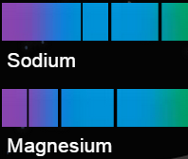

Question: How are stars classified?

Introduction: Late in the 19th century, Harvard astronomer Edward Pickering wanted to sort and catalog the thousands of star spectra that had been collected by the Harvard Observatory. He hired several women to do the work, paying them 25 cents a day. The most prominent of these women was Annie Jump Cannon, who devised a classification system still used today.

Harvard Classification Scheme
Class | Color | Prominent spectral lines | Surface Temp. (K)
O | Blue | Ionized helium, hydrogen | > 25,000
B | Blue-white | Neutral helium, hydrogen | 11,000 – 25,000
A | White | Hydrogen, ionized sodium, ionized calcium | 7,500 – 11,000
F | White | Hydrogen, ionized sodium and calcium; neutral sodium and calcium | 6,000 – 7,500
G | Yellow | Neutral sodium and calcium, ionized calcium, ionized iron, ionized magnesium | 5,000 – 6,000
K | Orange | Neutral calcium, neutral iron, neutral magnesium | 3,500 – 5,000
M | Red | Neutral iron, neutral magnesium, and neutral titanium oxide (not shown) | < 3,500

- Classify: Use the Gizmo to find the elements that are present in the spectra of stars 1 through 4. Remember to check both the Neutral spectra and the Ionic spectra. Then use the table above to classify each star and describe its surface temperature. (Note: A star spectrum may not display lines of all of the elements typical of its spectral class.)

Star | Color | Elements in spectrum | Class | Surface Temperature (K)
1
2
3
4

- On your own: Look up Annie Jump Cannon on the Internet or in a library and read her story. Share your discoveries with your classmates and teacher.

Activity B:  Unusual stars | Get the Gizmo ready:  - Select star 5. | 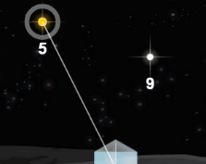

Question: What else can we learn from stellar spectra?

- Observe: Observe the spectra of stars 5 – 10. Identify the elements in each spectrum, and try to classify each star. If you notice unusual features in these spectra, describe them.

Star | Color | Elements in spectrum | Class | Unusual features
5
6
7
8
9
10

Match: Write the number of the star or object that matches each description. Then use this information to help you identify the elements and reclassify the stars in the table above.
____ High atmospheric pressures in a star cause spectral lines to be broadened, or “smeared out.” Giant stars, which have relatively low atmospheric pressures, are characterized by narrow spectral lines.
____ If a star is moving away from an observer, spectral lines are redshifted, or shifted toward the red end of the spectrum. An approaching star is blueshifted.
____ A star orbited by a large planet will move in a small circle. This will cause its spectrum to be slightly redshifted part of the time and blueshifted at other times.
____ Binary stars are pairs of stars that orbit one another. Their presence is indicated by two spectra that shift in opposite directions.
____ Cepheid variable stars change their brightness in a regular cycle. Gas pressure builds up, causing the stars to expand quickly. When the pressure is released, the star contracts, and the intensity of some spectral lines may decrease.
____ A nebula is an enormous cloud of gas and dust in which stars are born. Most nebulae produce an emission spectrum, which is characterized by bright lines of color against a dark background. The bright lines in an emission spectrum correspond to the dark lines in an absorption spectrum.

