Vocabulary: Stem-and-Leaf Plots

dictionary2

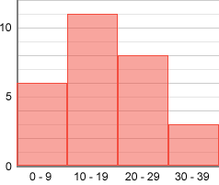**Vocabulary**

* Histogram – a graph that uses bars or rectangles to show how many data values are in each interval.
  + On a histogram, the *x*-axis is divided into equal-sized intervals.
  + The frequency of data values in each interval is shown by the height of the bars in the histogram.
* Mean – the sum of all the values in a data set divided by the number of values.
  + For example, the mean of the data set 2, 3, 5, 6 is  =  = 4.
* Median – the middle value in a set of numbers.
  + Before finding the median, all data should be in order from least to greatest.
  + If there is an odd number of values, the median is the middle number.
    - For example, the median of the data set 2, 3, 5, 6, 8 is 5.
  + If there is an even number of values, the median is the mean of the middle two values.
    - For example, the median of the data set 3, 5, 6, 8 is  =  = 5.5.
* Mode – the most common value in a data set.
  + For example, the mode of the data set 4, 4, 5, 7, 10 is 4 because 4 is the most common value.
* Range – the difference between the greatest and least value in a data set.
  + For example, the range of the data set 4, 4, 5, 7, 10 is 10 – 4 = 6.
* 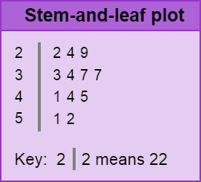Stem-and-leaf plot – a graph that displays each data value as a “leaf” (final digit) next to its “stem” (preceding digits).
  + The stems are written vertically, and the leaves are placed next to the stems.
  + The stem-and-leaf plot shown models the data set 22, 24, 29, 33, 34, 37, 37, 41, 44, 45, 51, 53.
    - For example, “51” is displayed as the leaf (1) next to its stem (5).