Name: ______________________________________ Date: ________________________

Student Exploration: Stoichiometry

Vocabulary: Avogadro’s number, balanced equation, cancel, coefficient, conversion factor, dimensional analysis, formula mass, molar mass, mole, molecular mass, stoichiometry

Prior Knowledge Questions (Do these BEFORE using the Gizmo.)

- A 250 mL glass of orange juice contains 22 grams of sugar. How much sugar is in a two-liter (2,000 mL) bottle of orange juice? ______________________________________________

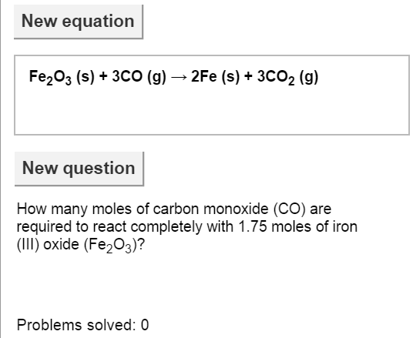
- It requires two sticks of butter to make a batch of 20 cookies. How much butter will it take to make 150 cookies? _________________________________________________________

Gizmo Warm-up
Just as a cook follows a recipe to decide how much of each ingredient to add, a chemist uses stoichiometry to determine the amounts of substances involved in chemical reactions. The Stoichiometry Gizmo allows you to try your hand at figuring out the amounts of reactants and products that take part in a chemical reaction.

To begin, check that this equation is shown:

Fe₂O₃ + 3CO 2Fe + 3CO₂

- Look at the coefficients (such as the “3” in 3CO) in front of each substance in the equation. The coefficients tell you how many molecules or atoms take part in a chemical reaction. In the spaces below, list the number of each molecule or atom in the equation:

Fe₂O₃ _____ CO _____ Fe _____ CO₂ _____

- In a balanced equation, the same number of each kind of atom is shown on each side of the equation. Calculate the number of iron (Fe), oxygen (O), and carbon atoms (C).

Reactants Iron: _____ Oxygen: _____ Carbon: _____

Products Iron: _____ Oxygen: _____ Carbon: _____

Based on these values, is the equation balanced? _________________________________

Activity A:  Moles | Get the Gizmo ready:  - Check that the equation is still:  Fe₂O₃ + 3CO 2Fe + 3CO₂  - If not, click New equation until it reappears.

Introduction: A mole is:
- A mammal known for digging up gardens.
- A small, dark spot on the skin.
- A spy embedded within an enemy government.
- 6.02 × 10²³ particles of a substance.
- All of the above.
The correct answer, of course, is E. In chemistry, the mole (mol) is defined as an amount of a substance that contains 6.022 × 10²³ particles of that substance. This number, called Avogadro’s number, is special because this number of particles has a mass in grams that is equal to the mass (in unified mass units) of a single particle of the substance.

Question: How do scientists find the formula mass and molar mass of a substance?

- Calculate: The formula mass of a compound is the sum of the masses of each atom in the chemical formula. The unit of formula mass is the unified mass unit (u). Formula mass is also called molecular mass if the compound is composed of molecules.

Iron’s atomic mass is 55.85 u, carbon’s mass is 12.01 u, and oxygen’s mass is 16.00 u.

- Calculate the formula mass of carbon monoxide (CO) by adding the atomic mass of carbon and the atomic mass of oxygen: _________________________________
- Calculate the formula mass of carbon dioxide (CO₂): _______________________
- Calculate the formula mass of iron (III) oxide (Fe₂O₃): _______________________

- Infer: A mole of a substance has a mass in grams that is equal to the formula mass. For example, a carbon atom has an average mass of 12.01 u. A mole of carbon has a mass of 12.01 g. Based on their formula masses, list the molar mass of each substance. The unit for molar mass is g/mol, or grams per mole.

Fe₂O₃ __________ CO __________ Fe __________ CO₂ __________

Check your answers on the Gizmo by inspecting the middle row of tiles on the right side of the Gizmo. These tiles show the units “1 mol” on top and “g” below.

- Practice: Hydrogen has an atomic mass of 1.01 u. What is the molar mass of these substances? (Remember to use the units g/mol.)

H₂O __________ CH₄ __________ H₂CO₃ __________ C₆H₁₂O₆ __________

Activity B:  Canceling units | Get the Gizmo ready:  - Check that the equation is still:  Fe₂O₃ + 3CO 2Fe + 3CO₂ | 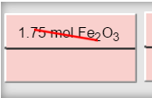

Introduction: While solving problems in stoichiometry, it is useful to pay attention to the units of the answer. The process of comparing units is called dimensional analysis. A common technique involves using conversion factors to convert from one unit to another. Units that appear in the numerator and denominator of a fraction can be canceled out. For example, converting 2 moles of carbon monoxide to grams involves multiplying by a conversion factor:

2 mol CO • 28.01 g CO = 56.02 g CO
1 mol CO

All conversion factors are equivalent to one. For example, the conversion factor given above is equivalent to one because the numerator (28.01 g CO) and denominator (1 mol CO) represent the same amount of CO. The “mol CO” unit is canceled, leaving an answer unit of grams.

Question: How do we solve problems in stoichiometry?

- Observe: The first question is: “How many moles of carbon monoxide (CO) are required to react completely with 1.75 moles of iron (III) oxide (Fe₂O₃)?” (If this is not the question you see, click New question until it appears.)

- What unit is given in the question? _______________________________________
- What quantity is asked for? _____________________________________________

- Find: Look for the conversion factor that contains the units “mol Fe₂O₃” on top and “mol CO” on the bottom. Drag the tile containing this factor down to the green strip at the bottom.

According to the tile, how many moles of CO react with one mole of Fe₂O₃? _____________

- Analyze: To get an answer in moles of CO, you need to cancel the moles of Fe₂O₃. Turn on Show units.

  - What units are given to the right of the equals sign? __________________________

  - If these aren’t the units you want, click Flip tile. What unit is given now? __________

- Calculate: If the units are correct, multiply or divide the numbers to solve the problem.

  - How many moles of CO will react with 1.75 moles of Fe₂O₃? ___________________

  - Turn on Show numerical result. Were you correct? _________________________

(Activity B continued on next page)
Activity B (continued from previous page)

- Practice: Turn off Show units and Show numerical result. Click New question, and use what you’ve learned to solve another stoichiometry problem. For each problem, list the units given, the units asked for, and the solution.

The problems in the Gizmo are given in random order, so you may have to click Next question several times to see a new problem. (Note: Each term in the equation is either a solid (s), liquid (l), gas (g), or an aqueous solution (aq).)

If you are stuck, try one of the following hints:
- If the given unit is grams (or liters or particles), convert from that unit to moles first. Then convert to moles of the answer substance.
- If the answer unit is grams, liters, or particles, find the number of moles of the answer substance first. Then convert the moles of answer substance to the desired unit.
- If you have a calculator, try to calculate the solution to each problem yourself before turning on the Show numerical solution checkbox.

Problems:

- What volume of carbon dioxide (CO₂) will be produced if 2.90 moles of iron (Fe) is produced? [Note: In the Gizmo, it is assumed that all gases are at standard temperature and pressure, or STP.]

Given unit: ____________ Answer unit: ____________ Solution: ____________

- What mass of iron (Fe) can be obtained from 3.80 g iron (III) oxide (Fe₂O₃) reacting with excess carbon monoxide (CO)?

Given unit: ____________ Answer unit: ____________ Solution: ____________

- How many moles of iron (Fe) will be produced from 6.20 moles of carbon monoxide (CO) reacting with excess iron (III) oxide (Fe₂O₃)?

Given unit: ____________ Answer unit: ____________ Solution: ____________

- How many molecules of carbon monoxide (CO) are needed to react with excess iron (III) oxide (Fe₂O₃) to produce 11.6 g of iron (Fe)?

Given unit: ____________ Answer unit: ____________ Solution: ____________

- On your own: Click New equation to try solving problems with a new chemical equation. There are five equations in all, and five problems per equation. The Gizmo will keep track of how many problems you solve. Good luck!

