Name: Date:

Student Exploration: Sums and Differences
with Decimals

Vocabulary: addend, decimal, decimal point, difference, hundredth, sum, tenth

Prior Knowledge Questions (Do these BEFORE using the Gizmo.)
Suppose there are 175 tickets available for a school play.

- If 98 tickets for the play have been sold, how many are left?

- After 24 more tickets are sold, how many have been sold, total?

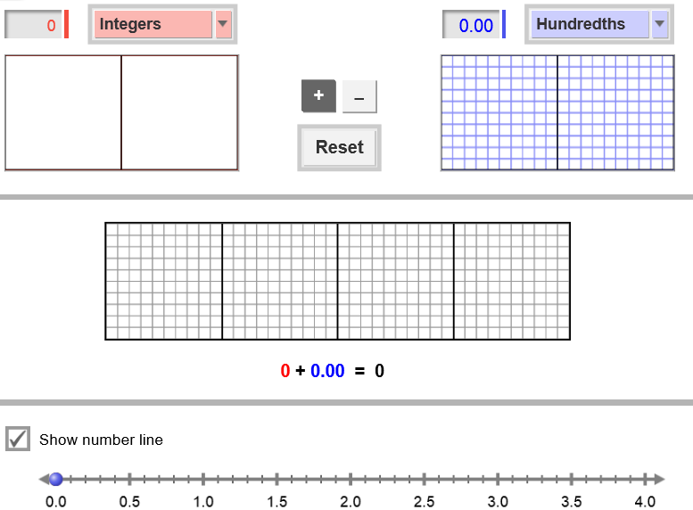
Gizmo Warm-up
In the Sum and Differences with Decimals Gizmo, you can add or subtract two numbers using area models or a number line. The two grids on top can model up to two wholes each. The model in the middle shows the sum or difference, up to four wholes.

Numbers are modeled by shading parts of a grid. There are two ways to do this. To enter a number, click in and highlight the text field showing the current number, type your new number, and hit Enter. To shade the grid directly, just click inside it.

- Set the red model to Integers and blue to Hundredths. Select Show number line.

- Show 2 on the red model. How many parts did you shade?

- Show 0.93 on the blue model. How many parts did you shade?

- To combine or show the sum of two numbers, called addends, select +.

What is 2 + 0.93?

- To take away or show the difference of two numbers, select –.

What is 2 – 0.93?

Activity A:  Combining and taking away | Get the Gizmo ready:  - Click Reset.  - Set the red and blue models to Hundredths. | 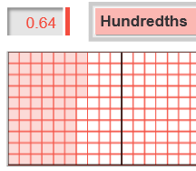

A decimal is a number written in a base-10 system. It usually has a decimal point separating the ones place from tenths, hundredths, etc. The tenths place is the position of the first digit after the decimal point. The hundredths place is the second digit after the decimal point.

- Type the decimal 0.06 in the text field of the red model and then hit Enter.

- Shade the grid to the right to show 0.06.

- How many parts are shown in each whole?

- How many parts are shaded to model 0.06?

- How would you say or write 0.06 in words?

- Show 0.04 on the blue model.

- Shade the grid to the right to show 0.04.

- How many parts are shaded to model 0.04?

- How would you say or write 0.04 in words?

- With 0.06 and 0.04 modeled in the Gizmo, select + to model the sum 0.06 + 0.04. Shade the grid to the right to represent the sum.

    - How many parts are shaded in the sum?

    - This sum is 10 hundredths. How many tenths does this look like?

    - Write sentences for the sum of 0.06 and 0.04 using numbers and then using words.

Numbers: _______ + _______ = _______

Words: ________ hundredths + ________ hundredths = ________ hundredths

________ hundredths + ________ hundredths = ________ tenth(s)

    - How many hundredths are in one tenth?

(Activity A continued on next page)
Activity A (continued from previous page)

- Now select – to find the difference of 0.06 and 0.04.

- Write a sentence for the difference using numbers. ________ – _______ = _______

- Write a sentence for the difference using words.

_____________________ – _____________________ = _____________________

- Click Reset. Change the red model to Integers and the blue model to Tenths. Show 1 in the red model and 0.8 in blue. Select –.

- How many tenths are in 1 whole?
- Write sentences for the difference of 1 and 0.8 using numbers and then using words.
Numbers: ________ – ________ = ________

Words: __________ whole – __________ tenths = __________ tenths

__________ tenths – __________ tenths = __________ tenths

- Click Reset. Change red to Hundredths. Show 1.23 on the red model and 0.9 on blue.

    - How many hundredths are in 0.9? __________ tenths = __________ hundredths

    - Select +. What is the sum of 1.23 and 0.9?

    - Select –. What is the difference of 1.23 and 0.9?

- Find each sum or difference. Then check your answers in the Gizmo. (Note: The last two cannot be modeled in the Gizmo.)

- 2 + 0.9 = __________ 2 – 0.9 = __________

- 1.32 + 1 = __________ 1.32 – 1 = __________

- 0.7 + 0.49 = __________ 0.7 – 0.49 = __________

- 1.04 + 0.77 = __________ 1.04 – 0.77 = __________

- 1.68 + 0.86 = __________ 1.68 – 0.86 = __________

- 9.5 + 5.9 = __________ 9.5 – 5.9 = __________

- 4.7 + 2.65 = __________ 4.7 – 2.65 = __________

Activity B:  Finding missing numbers | Get the Gizmo ready:  - Click Reset.  - Set the red and blue models to Hundredths.  - Click Show number line. | 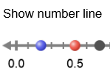
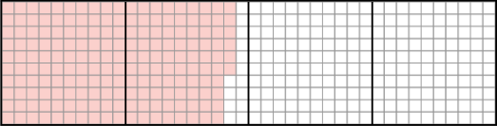
- Two numbers have a sum of 2. One of the addends is 1.86. Show 1.86 on the red model. The model in the middle (the sum) should now look like this:

  - Use a pencil to shade the model above to show 2 wholes.

What number did you shade with your pencil?

  - Select +. Drag the blue circle on the number line until the black dot (the sum) is on 2. Look at the blue model on the top. How does the number shown on the blue model compare with the number you shaded in part A?

  - What is the missing number in the equation 1.86 + ______ = 2?

  - How can you use 1.86 and 2 to find the missing number?

- Some number subtracted from 1.3 results in a difference of 0.85. Click Reset. Show 1.3 on the red model. The model (the difference) in the middle should now look like this:

- Use a pencil to shade over the red part in the model above until only 85 red squares are left. What number did you shade with your pencil?
- Select –. Drag the blue circle on the number line until the black dot (the difference) is on 0.85. Look at the blue model on the top. How does the number shown in the blue model compare with the number you shaded in part A?

- What is the missing number in the equation 1.3 – ______ = 0.85?

- How can you use 1.3 and 0.85 to find the missing number?
(Activity B continued on next page)
Activity B (continued from previous page)

- Suppose two positive numbers have a sum of 3.68.
- Do both numbers have to be less than 3.68? Explain.

- Click Reset. Select +. Drag the blue and red circles on the number line until you find a pair of numbers whose sum is 3.68. Record your numbers in the blanks below.

__________ + __________ = 3.68

- There are many other pairs of positive numbers whose sum is 3.68. Use the Gizmo to find two additional pairs.

__________ + __________ = 3.68 __________ + __________ = 3.68

- Suppose two positive numbers have a difference of 1.61.

- Do both numbers have to be less than 1.61? Explain.
- Click Reset. Select –. Drag the blue and red circles on the number line until you find two numbers whose difference is 1.61. Record your numbers in the blanks below.

__________ – __________ = 1.61

- There are many other pairs of positive numbers whose difference is 1.61. Use the Gizmo to find two additional pairs.

__________ – __________ = 1.61 __________ – __________ = 1.61

- Fill in the blanks below. Then check your answers in the Gizmo. (Note: The last one cannot be modeled in the Gizmo.)

- 1 + ________ = 1.56 1 + ________ = 2.8

- 2 – ________ = 1.3 2 – ________ = 0.96

- 1.34 + ________ = 1.85 1.34 + ________ = 2.7

- 0.87 – ________ = 0.66 0.87 – ________ = 0.09

- ________ + ________ = 0.16 ________ – ________ = 0.16

- 3.34 + ________ = 5.89 3.34 – = 1.12

