Name: Date:

**Student Exploration:** **Sum and Difference Identities for Sine and Cosine**

**Vocabulary:** identity

**Prior Knowledge Questions** (Do these BEFORE using the Gizmo.)



1

1

*B*

*A*

*C*

1. Use Δ*ABC* (a 45-45-90 triangle) to find the exact value of each expression:
2. sin 45° =
3. cos 45° =



1

2

*E*

*D*

*F*

1. Use Δ*DEF* (a 30-60-90 triangle) to find the exact value of each expression:
2. cos 30° =
3. sin 30° =
4. cos 60° =
5. sin 60° =

**Gizmo Overview**

In the *Sum and Difference Identities for Sine and Cosine* Gizmo, you will use trigonometric

**identities** (equations that are true for all values) to find the exact value of a given trigonometric expression.

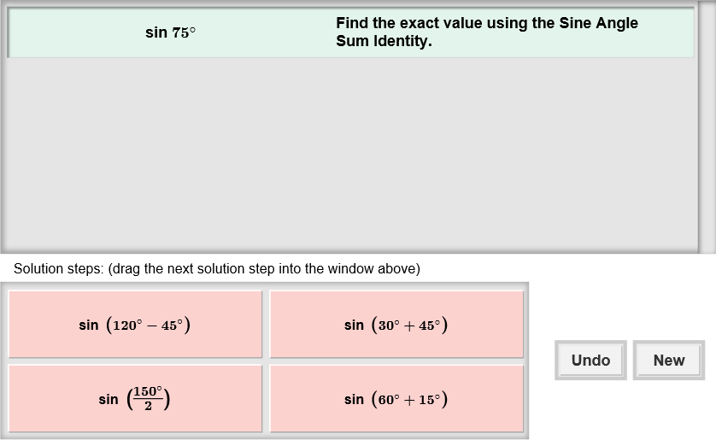Here’s how the Gizmo looks at first:

The expression for you to evaluate is here.

Click **Undo** to undo your last choice.

The tiles give you four choices for the next step. Choose the one you think is correct and drag it into the white area above.

Click **New** to go to a different problem.

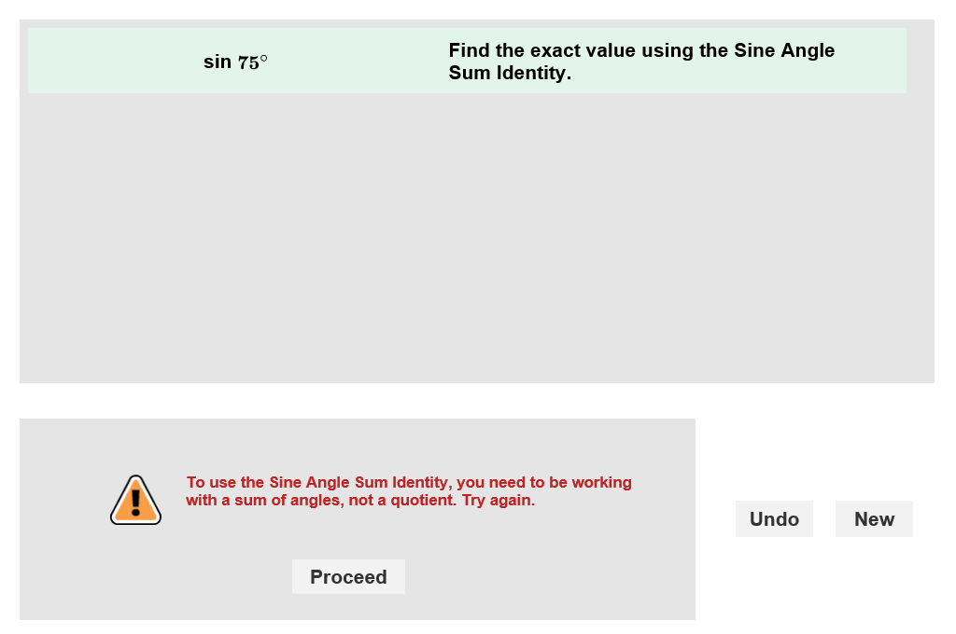

Read your feedback in the Gizmo.

(No feedback is given for correct answers.)

Click **Proceed** to go to the next step.

Continue until the expression is simplified. Then click **New** for a new problem to work on.

|  |  |  |
| --- | --- | --- |
| **Activity:**  **Finding exact values** | Get the Gizmo ready:   * You should see the expression sin 75°. If not, click **Refresh** in your browser. | 160SE3 |

The sum and difference identities you will use in this activity are given below:

|  |  |
| --- | --- |
| **Sine** | **Cosine** |
| sin (*α* + *β*) = sin *α* cos *β* + cos *α* sin*β* | cos (*α* + *β*) = cos *α* cos *β* – sin *α* sin *β* |
| sin (*α* – *β*) = sin *α* cos *β* – cos *α* sin *β* | cos (*α* – *β*) = cos *α* cos *β* + sin *α* sin *β* |

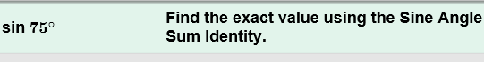

1. You should see the problem shown to the right at the top of the Gizmo.
2. You are asked to use the Sine Angle Sum Identity. The first thing you need to do is write an expression for 75°. What must be true about this expression?

1. Choose the correct first step in the Gizmo. If your choice is incorrect, read the given feedback and try again. How did you rewrite sin 75°?
2. Choose the tile that shows the Sine Angle Sum Identity. Are the sine and cosine of these angles positive or negative?
3. Choose the last two correct steps. What does sin 75° equal?
4. 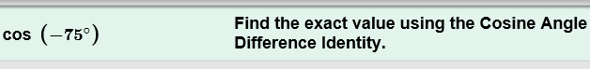Click **New**. You should now see the problem shown at the right in the Gizmo.
5. How can you rewrite –75° as a difference?
6. Choose the first two correct steps in the Gizmo. Are the sine and cosine of these angles positive or negative?
7. Choose the rest of the steps. What does cos (–75°) equal?
8. Click **New**. Work through more problems in the Gizmo. Be sure to read the feedback.

**(Activity continued on next page)**

**Activity (continued from previous page)**

1. Find the exact value of each function. Write all your steps in the space below each problem.
2. sin195°
3. cos 345°
4. cos (–285°)
5. sin 15°