Name: Date:

Student Exploration: Surface and Lateral Areas of Prisms and Cylinders

Vocabulary: cylinder, height (of a cylinder or prism), lateral area, net, prism, surface area

Prior Knowledge Questions (Do these BEFORE using the Gizmo.)

- Dustin is wrapping a present shaped like the one shown to the right. He has to find out how much wrapping paper he needs to cover all sides of the box.

- Four sides are rectangles. Each rectangle has length 7 in. and width 4 in. Find the total area of these sides.

Area of one rectangle = Total area =

- The top and bottom of the box are squares with sides of 4 in. Find the total area of the top and bottom.

Area of one square = Total area =

- How many square inches of wrapping paper does Dustin need?

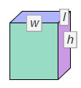
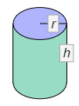
Gizmo Warm-up
Dustin’s present is a prism. A prism is a 3-dimensional figure with two parallel, congruent polygonal bases and sides that are parallelograms. Prisms with one base directly above the other are right prisms. A cylinder is similar to a prism, but with circular bases. You will explore the areas of right prisms and cylinders in the Surface and Lateral Areas of Prisms and Cylinders Gizmo.

- In the Gizmo, be sure Rectangle is selected. Drag the point at the top right corner of the rectangle down to change l (length of base), and to the left to change w (width of base). How does the 3-D View and the Unfolded View (net) of the prism change in each case?

Length:

Width:

- Drag the Height (h) slider to change the height. How do the figures change?

Activity A:  Rectangular prisms | Get the Gizmo ready:  - Be sure Rectangle is selected.  - Set the Width (w) to 8 and the Length (l) to 10.  - Set the Height (h) to 4.0 units by dragging the slider or entering a value to the right of the slider. | 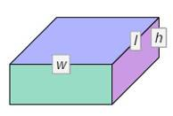
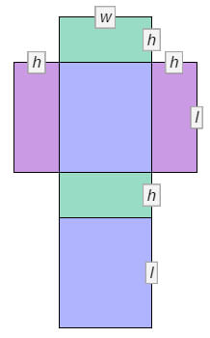
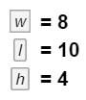
- The surface area of a prism can be found by adding the areas of all faces of the prism. Use the net view to find the area of each face of a right rectangular prism with width 8, length 10, and height 4.

- First, find the area of each face. Write each area on the net to the right.

- Then add the areas of all faces to find the surface area (S.A.) of the rectangular prism.

S.A. =

Select Compute lateral area and Compute surface area to check your answer.

- Turn off Compute surface area. Notice that some rectangles are still shaded. These are the lateral faces, or sides, of the rectangular prism.

- Add the areas of the lateral faces to find the lateral area (L.A.). L.A. =

Compare your answer to the Lateral area value given in the Gizmo.

- Turn off Compute lateral area. Because all of the lateral faces have the same height, they can be combined together into a single rectangle, as shown below.
h
w
l

What is the length of this rectangle, in terms of l and w?

- What is the perimeter of the base of the prism (using l and w)? P =

- How is the perimeter of the base related to the length of the lateral area rectangle?

- How can you find the lateral area using the perimeter of the base and the height?

(Activity A continued on next page)
Activity A (continued from previous page)

- Turn on Compute lateral area.

  - How is lateral area computed in the Gizmo?

  - Find the lateral area of a right rectangular prism with w = 3, l = 4, and h = 7. Show your work to the right and check in the Gizmo.

- Turn on Compute surface area. Look at the surface area formula (S.A. = L.A. + 2 • B).

- Why can you add twice the base area to the lateral area to find the surface area?

- Now use just w (width), l (length), and h (height) to write another formula for the surface area of a right rectangular prism. S.A. =
- What part of the formula you wrote above is the same as the L.A. part of the formula given in the Gizmo?
- What part of the formula you wrote is the same as the 2 • B part of the formula given in the Gizmo?

- A right rectangular prism has a square base with side lengths 4.5 in. and a height of 7 in. Find the lateral and surface areas of this prism. Show your work, and check in the Gizmo.

- Jessie is painting a 5-ft by 6-ft guest bathroom. The ceiling of the bathroom is 8 ft high.

- Find the total square footage of the four walls. Show your work.

- What is the surface area of the whole bathroom? Show your work.

Activity B:  Triangular prisms | Get the Gizmo ready:  - Turn off Compute lateral area.  - Select Triangle. | 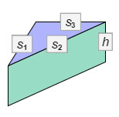
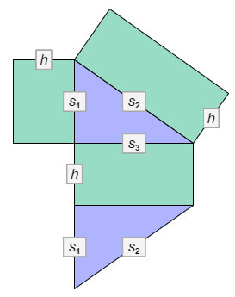
- Drag the points at the vertices of the triangle to create a right triangle with s₁ = 10 and s₃ = 15, as shown to the right. The length of s₂ should be 18.03. Set the Height (h) to 8.0.

- Find the area of each rectangular (lateral) face of this right triangular prism. Write these areas on the net.

- The area of each right triangular base with legs s₁ and s₃ is A = 0.5 • s₁ • s₃. Calculate the area of the base, and write the base areas on the net. Check your work in the Gizmo. (The base area is given under the triangle.)

- What is the surface area (S.A.) of the triangular prism?

S.A. =

Turn on Compute lateral area and Compute surface area to check.

- Turn off Compute surface area.

- Add the areas of the three lateral faces. What is the lateral area (L.A.) of the prism?

L.A. = Check your work in the Gizmo.

- What is the perimeter of the base?

- How can you use the perimeter of the base and the height to find the lateral area?

Use the Gizmo to check that this is true.

- Multiply the perimeter of the base times the height. Is this area the same as the lateral area you found above? Turn on Compute lateral area to check.

- In the Gizmo, create a triangular prism of your own with a height of 6.0. List the three side lengths of the base below. In the space to the right, find the lateral area of your prism. Check your work in the Gizmo.

s₁ = s₂ = s₃ =

(Activity B continued on next page)
Activity B (continued from previous page)

- Look back at question 1.

- How can you use the lateral area and the area of the base to find the surface area?

- Write two different formulas for finding the surface area of a right triangular prism. In the first, use lateral area (L.A.) and area of the base (B). In the second, use the perimeter of the base (P), height (h), and area of the base (B).

S.A. = S.A. =

Turn on Compute surface area to check your formulas.

- Write another formula for finding the surface area of a right triangular prism with a base that is a right triangle. Use s₁ and s₃ for the legs of the base and h for the height of the prism.

S.A. =

- Turn off Compute lateral area. Create a triangular prism of your own.

- List the dimensions of your prism.

s₁ = s₂ = s₃ = h =

- Use both of the formulas you wrote in part B above to find the surface area of your prism. (The base area is given in the Gizmo.) Show your work. Then turn on Compute lateral area and Compute surface area to check your work.

- A right triangular prism has a right triangular base with legs 3 ft and 4 ft, and hypotenuse
5 ft. If the height is 12 ft, find the surface area. Show your work.

Activity C:  Cylinders | Get the Gizmo ready:  - Turn off Compute lateral area.  - Select Circle. | 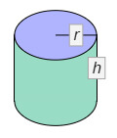

- A cylinder is like a prism with a circular base instead of a polygonal base. Two dimensions are used to describe a right cylinder: height (h) and radius (r). First, you will find the lateral area of a cylinder. The net of the cylinder below shows the lateral area as a single rectangle.
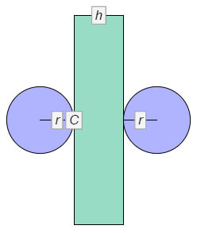
- What is the height of the rectangle?

- What is the length of the rectangle?

C is the circumference of (distance around) the circle.

- Drag the point on the circle to set the Radius (r) to 5. Set the Height (h) to 8.0.The formula for the circumference of a circle is C = 2πr. Use a calculator to find the circumference of the base of this cylinder to the nearest hundredth.

C ≈ Check in the Gizmo.

- What is the lateral area of this cylinder? L.A. ≈

- Write two different formulas for finding the lateral area of a right cylinder. In the first use circumference (C) and height (h). In the second, use radius (r), pi (π), and height (h). Then select Compute lateral area to check.

L.A. = L.A. =

- To find the surface area of a cylinder, you must first find the area of each circular base.

- The formula for the area of a circle is A = πr². What is the base area of the cylinder above to the nearest hundredth?
- Find the surface area to the nearest hundredth. S.A. ≈

- Write two different formulas for finding the surface area of a right cylinder. In the first, use the lateral area (L.A.) and area of the base (B). In the second, use the circumference of the base (C), height (h), and area of the base (B).

S.A. = S.A. =

Turn on Compute surface area to check your formulas and answer above.

(Activity C continued on next page)
Activity C (continued from previous page)

- Turn off Compute lateral area. Create a cylinder of your own.

- List the dimensions of your cylinder. h = r =

- Use the formulas you wrote on the previous page to find the lateral area and surface area of your cylinder to the nearest hundredth. Show your work. Then turn on Compute lateral area and Compute surface area to check your work.

- Find the surface area, to the nearest hundredth, of a right cylinder with radius 6.2 cm and height 10 cm. Show your work. Check your answer in the Gizmo.

- Challenge: You can also write a formula for the surface area of a right cylinder using just
pi (π), radius (r), and height (h). Write this formula below.

S.A. =

- How is the calculation of lateral area similar for right rectangular prisms, right triangular prisms, and right cylinders?

- How is the calculation of surface area similar for right rectangular prisms, right triangular prisms, and right cylinders?

