Name: Date:

**Student Exploration: Tangent Function**

**Vocabulary:** asymptote, odd function, period, radian, reference triangle, tangent,   
trigonometric function, unit circle

**Prior Knowledge Questions** (Do these BEFORE using the Gizmo.)

**5**

**4**

**3**

***θ***

tan(*θ*) = 

1. The **tangent** of angle *θ* of a right triangle is the length of the opposite leg divided by the adjacent leg.

The legs of the right triangle to the right have lengths of 3 units and 4 units, and the hypotenuse is 5 units.

***θ***

***x***

***y***

***r***

**(*x*, *y*)**

What is the tangent of angle *θ*? tan(*θ*) =

1. A right triangle is placed in a circle whose center is at the origin of a coordinate plane, as shown to the right.

What is tan(*θ*)? tan(*θ*) =

**Gizmo Warm-up**

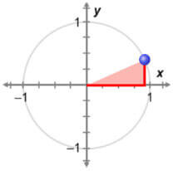

***θ***

The tangent function *y* = tan(*θ*) is a **trigonometric function**. When *θ* is in standard position, as shown to the right, tan(*θ*) is the ratio of the *y*-value of the point where *θ* intersects the circle to the *x*-value. So, tan(*θ*) = . In the *Tangent Function* Gizmo, you will explore the tangent function and its graph.

1. Turn on **Show reference triangle**. With **Degrees** selected, drag the blue point on the circle from 0° counterclockwise to 90°.

What is true about the *x*- and *y*-coordinates of all points in quadrant I?

1. Now, drag the slider from 0° to the right to 90°. Watch the value of tan(*θ*) as you do.
2. What is the sign of tan(*θ*)?
3. Explain why this makes sense, based on the unit circle.

|  |  |  |
| --- | --- | --- |
| **Activity A:**  **The basics of tangent** | Get the Gizmo ready:   * Be sure **Degrees** and **Show reference triangle** are selected. * Set ***θ*** to 0°. (To quickly set ***θ*** to a specific value, type the value in the text box, and hit **Enter**.) | 163SE2 |

The circle shown in the Gizmo has a radius of 1, so it is a **unit circle**. Angle *θ* is formed by the radius of the circle and the positive *x*-axis. The tangent of *θ* is the ratio of the *y*-value (sin(*θ*)) of the point on the unit circle to the *x*-value (cos(*θ*)). So, tan(*θ*) =  = .

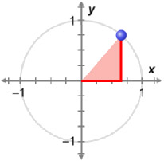

***θ***

**(cos(*θ*), sin(*θ*))**

***y***

***x***

**1**

The right triangle formed by the perpendicular segment from the terminal ray of *θ* to the *x*-axis is called the **reference triangle** for angle *θ*.

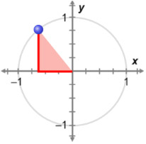

***θ***

**(cos(*θ*), sin(*θ*))**

***x***

***y***

**1**

1. Think about dragging the point around the circle, from 0° to 360°, in a counterclockwise direction.
2. For what angles *θ* do you think tan(*θ*) will have these key values? (Predict first, then check.)

tan(*θ*) = 0 when *θ* =

tan(*θ*) is undefined when *θ* =

tan(*θ*) = 1 when *θ* = tan(*θ*) = –1 when *θ* =

tan(*θ*) is positive in quadrants and negative in quadrants

Drag the point around the circle to check your predictions.

1. Explain why tan(*θ*) = 0 where it does, based on the unit circle.

1. Explain why tan(*θ*) = 1 where it does, based on the unit circle.

1. Drag the point around the circle a few times. How often do the tan(*θ*) values repeat?

You should have found that tan(*θ*) repeats every 180°. This interval is the **period** of the tangent function. A function that repeats in regular intervals like this is *periodic*.

**(Activity A continued on next page)**

**Activity A (continued from previous page)**

1. Set ***θ*** to 45°. Notice that tan(45°) = 1. Recall that tan(*θ*) repeats every 180°.
2. How can you find other angles *θ* with tan(*θ*) = 1?
3. In the Gizmo, check that this is also true for angles other than 45°. Then fill in the blank to generalize this relationship. tan(*θ*) = tan(*θ* ± ( *n*)°)
4. In this question, you will piece together your findings to sketch the graph of *y* = tan(*θ*). In your graph, be sure that *θ* is on the *x*-axis and tan(*θ*) is on the *y*-axis.
5. 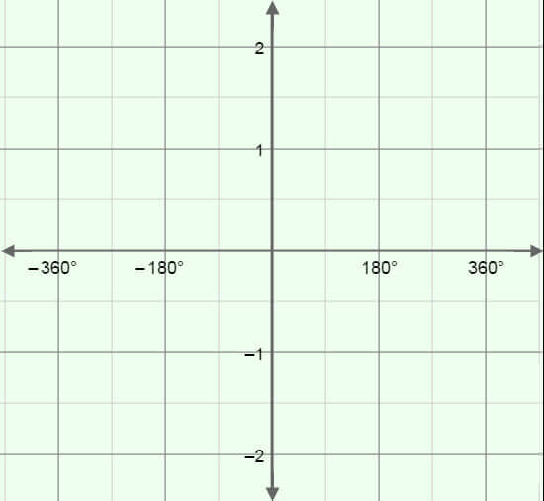At every *θ* where tan(*θ*) is undefined, the graph has a vertical dashed line called an **asymptote**. Sketch the asymptotes on the grid to the right.
6. Plot the points where tan(*θ*) = 0.
7. Then plot points where tan(*θ*) = 1 or –1.
8. What do you think happens to tan(*θ*) when *θ* is near the asymptotes? Explain why, based on the unit circle.

1. What do you think the rest of the graph of *y* = tan(*θ*) looks like? Sketch it above. After you are done, select **Show curve** in the Gizmo. Adjust your sketch as needed.
2. Angles can be measured in **radians** instead of degrees. A radian is a unit of angle measure, such that one full rotation (360°) equals 2** radians.
3. If 360° = 2**, what is the radian measure of a 180° angle?
4. A 30° angle is one-sixth of 180°. What does 30° equal in radians?
5. Fill in the table with the radian measure for each degree measure. Check in the Gizmo by setting the degree measure and then selecting **Radians**.

|  |  |  |  |  |  |
| --- | --- | --- | --- | --- | --- |
| **Degree measure** | 0° | 30° | 45° | 60° | 90° |
| **Radian measure** |  |  |  |  |  |

|  |  |  |
| --- | --- | --- |
| **Activity B:**  **The tangent function and identities** | Get the Gizmo ready:   * Be sure **Show curve** and **Show reference triangle** are turned on. * Select **Degrees** and **Common angles only**. | 163SE6 |

**1**

**45°**

**45°**

**1**

**60°**

**30°**

1. Label the legs of the 30-60-90 and 45-45-90 triangles to the right with their lengths. (Hint: If you don’t remember these values, use the Pythagorean Theorem. The short leg of the 30-60-90 triangle is exactly half of the hypotenuse.)
2. Start with ***θ*** at 0°, and drag the point on the circle counterclockwise from 0° to 180°.

|  |  |  |  |
| --- | --- | --- | --- |
| ***θ*** | 30° | 45° | 60° |
| **tan(*θ*)** |  |  |  |

1. Fill in the table to the right with the tangent values of 30°, 45°, and 60°.
2. What reference triangle (30-60-90 or 45-45-90) would you use for each angle below?

30° 45° 60°

|  |  |  |  |
| --- | --- | --- | --- |
| ***θ*** | 120° | 135° | 150° |
| **tan(*θ*)** |  |  |  |

1. Fill in the table to the right with the tangent values of 120°, 135°, and 150°.
2. What reference triangle (30-60-90 or 45-45-90) would you use for each angle below?

120° 135° 150°

1. For the angles above, what is true about tan(*θ*) for the same reference triangle?

1. Turn off **Common angles only**. Set ***θ*** to 0°. Drag the point around the circle.
2. In which quadrants is tangent positive? negative?
3. Explain why, using the unit circle.

1. Use what you know about reference triangles and quadrants to find the values.

tan(210°) = tan(315°) = tan(480°) =

**(Activity B continued on next page)**

**Activity B (continued from previous page)**

1. Set ***θ*** back to 0°. Drag the point around the circle. Examine pairs of angles whose measures add to 180°, or ** radians (for example, 60° and 120°, or 210° and –30°).
2. What do you notice about their tangent values?

1. Suppose two angles have measures that add to 180°. One angle is called *θ*. What expression represents the other angle?
2. Fill in the blanks below to show how the tangent values of angles that add to 180° relate to each other. (Write it once in degrees, and once in radians.)

tan(*θ*) = tan(*θ*) =

1. Set ***θ*** back to 0°. Drag the point around the circle. Examine pairs of angles whose measures add to 360°, or 2** radians (for example, 160° and 200°, or 380° and –20°).
2. What do you notice about their tangent values?

1. Suppose two angles have measures that add to 360°. One angle is called *θ*. What expression represents the other angle?
2. Fill in the blanks below to show how the tangent values of angles that add to 360° relate to each other. (Write it once in degrees, and once in radians.)

tan(*θ*) = tan(*θ*) =

1. Set ***θ*** back to 0°. Drag the point around the circle.
2. Examine pairs of opposite angles (for example, 30° and –30°). What is true about their tangent values?
3. Use what you noticed above to write an equation about the tangent values of opposite angles.

This makes tangent an **odd function**, and its graph is symmetric about the origin.

|  |  |  |
| --- | --- | --- |
| **Activity C:**  **Practice with the tangent function** | Get the Gizmo ready:   * Select **Degrees**. | 163TG1 |

1. Name an angle that has a very large, positive tangent value.

Why is this value large and positive?

Check your answer in the Gizmo.

1. The angle in the circle to the right measures 130°.



**130°**

**(–0.643, 0.766)**

1. What is tan(130°), as a fraction and as a decimal? (Use a calculator, and round to 2 decimal places.)

1. 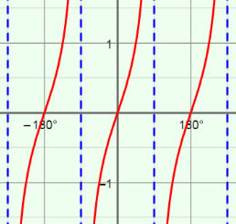The graph of *y* = tan(*θ*) is shown to the right. Plot and label the point that shows tan(130°) on this graph. Check in the Gizmo.
2. Plot 2 other points on the graph with a *y*-value (tangent) of –1.19. Write the coordinates below. Then check in the Gizmo.

1. Plot 3 points on the graph with a *y*-value of 1.19. Write the coordinates below. Check in the Gizmo.

1. Give the tangent value of each angle below. Then list four different angles (two positive and two negative) with the same tangent value. Check your answers in the Gizmo.
2. tan() = Angles with same tangent value:
3. tan() = Angles with same tangent value:
4. tan() = Angles with same tangent value: