Name: Date:

Student Exploration: Target Sum Card Game

Vocabulary: difference, digit, place value, sum

Prior Knowledge Questions (Do these BEFORE using the Gizmo.)

A football team has to go 35 yards or else they will lose the game.

- List two distances (numbers of yards) that the football team could go to move a total of 35 yards in 2 plays (tries). _________________ _________________

- The team went 8 yards on their first play, and 13 yards on their second play. How far would they have to go to get to 35 on their third play? _________________
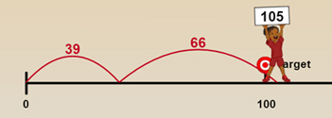
Gizmo Warm-up
In the Target Sum Card Game Gizmo, you will strategically arrange cards (digits) in a grid to try to get close to a target sum. The first target is 100. How close can you get?

- To play a game, click on Deal to get new cards. Drag the cards onto the jump grid. Your goal is for the numbers to add up to as close to 100 as possible. (It’s OK to go over.)

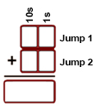
- What numbers are on your cards?

________ ________ ________ ________

- Click Jump. If you didn’t get as close to 100 as possible, rearrange your cards until you do. What is the best way to arrange the cards? (Fill in the grid on the right.)

- Click Play again and then Deal to get new cards. Ignoring the target, what are the smallest and largest sums you can make with these cards? Fill in your responses in the grids on the right.

Activity A:  1-player game | Get the Gizmo ready:  - Click on Play again. | 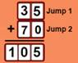

- To play different versions of the game, click Change game and select your options from the Game menu. When you’re ready, click Let’s play! to start the game.

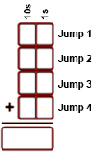
- Play one player games with targets 100, 150, and 200. Play each game a few times and record your best arrangement for each game below.

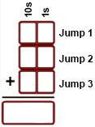
Target
Sum 150:
Target
Sum 200:
Target
Sum 100:

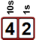
The place value of a digit is the value of that number based on its position. For example, in the number 42 there are 4 tens and 2 ones (42 = 40 + 2).

- Did you place your cards in the tens places or ones places first? Why?

___________________________________________________________________

___________________________________________________________________

- Arrange 1, 3, 6, and 7 in the Jump Grid to the right. Target sum is 100.

- How did you choose which numbers to put in the tens places?

___________________________________________________

___________________________________________________

- How much is added to the total sum if you place a 3 in the tens place? ________

- How much is added to the total sum if you place a 7 in the ones place? ________

- Click Change game. Select 1-player: Target 1000 from the Game menu. Play several times. How is your strategy for Target 1000 different from Target 100?

_________________________________________________________________________

_________________________________________________________________________

Activity B:  2-player game | Get the Gizmo ready:  - Click Change game, select 2-player: Target 100 from the Game menu, and click Let’s play! | 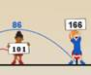

To complete this activity you need to work with a partner. Be sure to fill in your own sheet.

- Play three 2-player: Target 100 games with your partner. Describe your strategy for playing these games to your partner. How is your partner’s strategy different from yours?

_________________________________________________________________________

_________________________________________________________________________

- Click Change game, and choose 2-player: Target 150 from the Game menu. Under Digit cards, select Random draw and Both players get same cards. Click Let’s play! and play several games with your partner.
  - Record the sums for you and your partner in the grids to the right.

  - How did the winner get closest to the target?

_____________________________________

_____________________________________

- Choose 2-player: Target 100 from the Game menu, select Pick cards yourself, and play.

  - What cards did you pick? _______ _______ _______ _______

  - What cards did your partner pick? _______ _______ _______ _______

  - Explain why you chose your cards. ______________________________________

___________________________________________________________________

- Choose 2-player: Target 200 and select Pick cards yourself. Use cards 0, 1, 2, 3, 4, 5, 6, and 7 for both players. Ignoring the target, make two sums that are as far apart as possible.

  - Your sum: ________ Your partner’s sum: ________

  - How was the “small sum” strategy different from the “big sum” strategy?

___________________________________________________________________

___________________________________________________________________

