Name: ______________________________________ Date: ________________________

Student Exploration: Tides

Vocabulary: gravity, high tide, low tide, neap tide, spring tide, tidal bulge, tides

Prior Knowledge Question (Do this BEFORE using the Gizmo.)
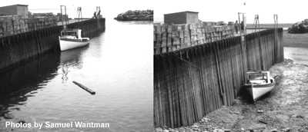

What is happening in these images?

______________________________

______________________________

______________________________

______________________________

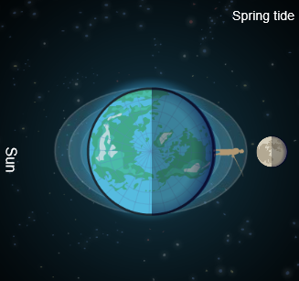

Gizmo Warm-up
The Tides Gizmo shows the relative positions of the Earth, Moon, and Sun. (None of the distances are to scale.) An observer stands on Earth.

- Set the Speed to Slow. Select the BAR CHART and press Play (). What do you notice?

__________________________________________

__________________________________________

The changing depth of water is due to tides.

- Click Pause () when the water is at its highest level. This is called high tide. What is the height of water during high tide? _______________________________________________

- Click Play, and then Pause when the water is at its lowest level, called low tide. What is the height of water during low tide? ________________________________________________

- Click Reset (). Click Play, and then click Pause after one day. Select the GRAPH tab.

How many high tides are there in a day? _______________ Low tides? _______________
Activity A:  The Moon and tides | Get the Gizmo ready:  - Click Reset.  - Select the BAR CHART tab. | 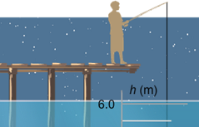

Question: What causes high and low tides?

- Observe: Click Play and watch the tides for a while on the BAR CHART and SIMULATION panes. Notice the oblong bands of water around Earth. These are tidal bulges.

- How many tidal bulges are there? ________________________________________

- What kind of tide does the observer experience as he passes through a tidal bulge?

___________________________________________________________________

- What kind of tide does the observer experience when he is between tidal bulges?

___________________________________________________________________

- In one day, how many times does the observer pass through a tidal bulge? _______

- Form hypothesis: What do you think causes the tidal bulges to form? __________________

_________________________________________________________________________

- Observe: Set the Speed to Fast and click Play. What do you notice about the tidal bulges and the position of the Moon? _________________________________________________
_________________________________________________________________________

- Draw conclusions: How does the Moon influence the tides? _________________________

_________________________________________________________________________

_________________________________________________________________________

- Extend your thinking: The Moon’s gravity pulls on Earth.

    - How does the Moon’s gravity affect the oceans nearest to the Moon? _______________

______________________________________________________________________

    - What happens on the side of Earth opposite the Moon? __________________________

______________________________________________________________________

Activity B:  The Sun and tides | Get the Gizmo ready:  - Click Reset.  - Select the GRAPH tab. | 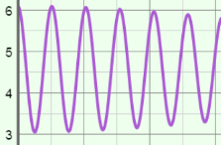

Question: How does the Sun influence tides?

- Observe: Set the Speed to Fast and click Play. Observe the shape of the tidal bands over time. After 15 days or so, click Pause. How do the tidal bands change over time?

_________________________________________________________________________

_________________________________________________________________________

- Analyze: On the GRAPH tab, click the “–” button twice to zoom out.

- What do you notice? __________________________________________________

- When the high tide is very high, and the low tide is very low, it is a spring tide. On which days did the observer experience a spring tide? ________________________
- When there is a smaller difference between high and low tide, it is a neap tide. On which day did the observer experience a neap tide? __________________________

- Sketch: As the Moon orbits Earth, there are two periods of spring tides and two periods of neap tides. Sketch the positions of the Earth, Moon, and Sun for each spring and neap tide.

Spring tide | Neap tide
Spring tide | Neap tide

(Activity B continued on next page)
Activity B (continued from previous page)

- Analyze: List the type of tide (spring or neap) that occurs in each situation:

    - The gravity of the Sun and Moon pull Earth’s surface in the same direction: _______

    - The gravity of the Sun and Moon pull Earth’s surface in opposite directions: _______

    - The gravity of the Sun and Moon pull Earth’s surface at right angles: _______

- Draw conclusions: How does the Sun’s gravity influence tides? _______________________

_________________________________________________________________________

_________________________________________________________________________

_________________________________________________________________________

_________________________________________________________________________

_________________________________________________________________________

_________________________________________________________________________

- Extend your thinking: Think about how the Moon would look for the observer on Earth.

    - What kind of tides (spring or neap) would you expect during a full Moon? _________

    - What kind of tides would you expect during a new Moon? _____________________

    - What kind of tides would you expect during a half Moon? ______________________

