Name: Date:

**Student Exploration: Translating and Scaling Functions**

**Vocabulary:** amplitude, parent function, periodic function, scale (a function),   
transform (a function), translate (a function)

**Prior Knowledge Questions** (Do these BEFORE using the Gizmo.)

Shown to the right are the graphs of two functions, *y* = *f*(*x*) and *y* = *g*(*x*).

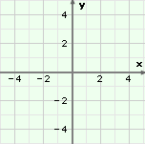

**(–4, –4)**

**(–1, 1)**

**(3, –2)**

***y* = *f*(*x*)**



***y* = *g*(*x*)**

**(–4, –1)**

**(–1, 4)**

**(3, 1)**

1. How would you have to “move” the graph of *y* = *f*(*x*) so that it would match the graph of *y* = *g*(*x*)?

1. Based on your answer above, if the point (*x*, *y*) lies on the graph of *y* = *f*(*x*), what point must lie on the graph of *y* = *g*(*x*)?

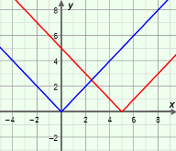**Gizmo Warm-up**

In the *Translating and Scaling Functions* Gizmo, you can graph both the function *y* = *f*(*x*) and also the general function, *y* = *af*(*b*(*x* – *h*)) + *k*. Students can vary the values of *a*, *b*, *h*, and *k* to see how they alter, or **transform**, the graph. You can choose from four parent functions – absolute value, parabola, cube root and sine wave. The **parent function** is the basic form of a function in a family of functions.

You can vary the values of *a, b, h*,and *k* in the Gizmo by dragging the sliders.

1. With **Show parent function** selected, vary ***h***with the slider. What happens to the graph?

1. Drag the ***k***slider back and forth. How does the graph change as you vary *k*?

|  |  |  |
| --- | --- | --- |
| **Activity A:**  **Effects of *h* and *k* on the graph** | Get the Gizmo ready:   * Be sure the **TRANSLATION** tab, **abs. value** function, and **Show parent function** are selected. * Set ***h***to 0 and ***k*** to 0 so that *f*(*x*) = |*x*| is graphed. |  |

1. Keeping ***h*** = 0, set ***k*** to 3 to graph *y* = *f*(*x*) + 3, shown in red. (To set a slider to a specific value, click on the number in the text field, type the new value and hit **Enter**.)
2. How does the graph change?
3. On the blue parent function graph, the coordinates of the vertex are (0, 0). What is the vertex of the red **translated** (shifted) graph?
4. The ordered pair (2, 2) lies on the graph of the parent function. What point must lie on the graph of *y* = *f*(*x*) + 3? Explain.
5. Use the sliders to vary the values of *h* and *k*. Watch the graph as you do. In general, how do the values of *h* and *k* relate to the vertex of the graph?

1. If the parent function *y* = *f*(*x*) were translated down 5 units, what is the new function? (Use *f*(*x*) notation.) *y* = Check your answer in the Gizmo.
2. With **abs. value** selected, set ***h*** to 2 and ***k*** to 0 to graph *y* = *f*(*x* – 2), shown in red.
3. What is the vertex of the original (parent) graph in blue?
4. What is the vertex of the new graph?
5. How was the graph translated?
6. What value of *x* makes *f*(*x* – 2) equal *f*(0)?
7. If the point (3, 3) lies on the graph of *y* = *f*(*x*), what point lies on *y* = *f*(*x* – 2)?

Explain.

1. How do you think the graph of *y* = *f*(*x* – *h*) relates to the graph of *y* = *f*(*x*)?

**(Activity A continued on next page)**

**Activity A (continued from previous page)**

1. Select **parabola** so that *f*(*x*) = *x*2 is the parent function. Set ***h*** to –5 to graph *y* = *f*(*x* + 5).
2. How has the graph been translated?

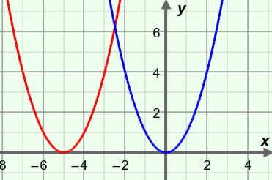

***y* = *f*(*x*)**

1. What value of *x* makes *f*(*x* + 5) equal *f*(0)?
2. Explain why the graph of *y* = *f*(*x* + 5) was translated to the left, not to the right.

1. If (2, 4) lies on the graph of *y* = *f*(*x*), what point must lie on *y* = *f*(*x* + 5)?

Explain.

1. If (*x*, *y*) lies on the graph of *y* = *f*(*x*), what point must lie on *y* = *f*(*x* + *h*)?

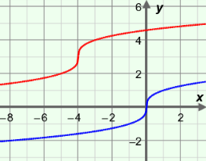

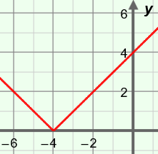

1. The graph of an absolute value function is shown to the right.
2. What is the vertex?
3. If *f*(*x*) = |*x*|, what function is graphed here? *y* =

Check your answers using the Gizmo.

1. The parent graph *g*(*x*) = is shown below, along with the translated graph *y* = *g*(*x* – *h*) + *k*.
2. How was the parent graph translated?



***y* = *g*(*x*)**

***y* = *g*(*x*** – ***h*) + *k***

Explain how you can tell.

1. What is the value of *h* for the translated graph? What is *k*?
2. In *y* = *g*(*x*) notation, what function is graphed? *y* =

Use the Gizmo to check your answers.

|  |  |  |
| --- | --- | --- |
| **Activity B:**  **Effects of *a* and *b* on the graph** | Get the Gizmo ready:   * Select the **SCALING** tab. * Set ***a*** and ***b*** both to 1. * Unselect **Show parent function**. |  |

1. In the Gizmo, select **sine wave** so the parent function is *f*(*x*) = sin (*x*).

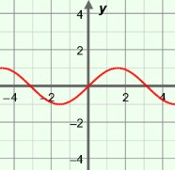

***f*(*x*) = sin (*x*)**

1. The sine wave is a **periodic function**, meaning its *y*-values repeat at constant intervals. (The *period* is the length of the interval before the values repeat again.)

Approximately what is the period of the sine curve?

1. Drag the ***a*** slider. What happens to the graph as *a* changes?

**Amplitude** is half the distance between the maximum and minimum *y*-values of a periodic curve, such as the sine wave function.

1. How does the value of *a* relate to the amplitude?

1. What happens to the graph when *a* is negative?

1. Now select **Show parent function** and click on **parabola** so the parent function is *f*(*x*)= *x*2.
2. Vary the ***a*** slider. What happens to the graph as you do so?

1. Set ***a***to 2 to graph *y* = 2*f*(*x*). The point (–2, 4) lies on the graph of the parent function *y* = *f*(*x*). What point must lie on the graph of *y* = 2*f*(*x*)?
2. The point (10, 100) lies on the graph of the parent function *y* = *f*(*x*). What point must lie on the graph of *y* = 3*f*(*x*)?
3. Why do you think the graph opens down when *a* is negative?

The value of *a* **scales** (stretches or shrinks) the graph vertically.

**(Activity B continued on next page)**

**Activity B (continued from previous page)**

1. Select the **sine wave** so the parent function is *f*(*x*) = sin (*x*). Start with ***a***and ***b*** both set to 1.
2. Drag the ***b***slider. What happens to the graph as the value of *b* is greater than 1?

1. Drag the ***b***slider. What happens to the graph as the value of *b* is between 0 and 1?

1. When *b* is negative, what do you notice about the graph?

1. In general, how does the value of *b* affect the graph?

1. Select the **cube root** so the parent function is *f*(*x*)= . Set ***a*** and ***b*** both to 1.
2. Using the graph, what is the value of *f*(*x*)at *x* = 8?
3. Set ***b*** to 4 to graph *y* = *f*(4*x*). For what *x*-value will *f*(4*x*)= 2?
4. Set ***b***to 0.5 to graph *y* = *f*(0.5*x*). For what *x*-value will *f*(0.5*x*)= 2?

You may need to zoom out (**–**) or click and drag the grid to see more of the graph.

1. What happens to the graph as *b* increases?

Why?

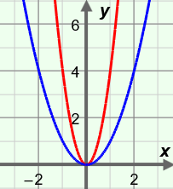

**(1, 4)**

**(2, 4)**

1. The point (2, 4) lies on the parent function, *f*(*x*) = *x*2, shown to the right. The point (1, 4) lies on the steeper (narrower) graph.
   1. What are TWO different possible equations of the steeper graph? (Use *f*(*x*) notation.)

*y* = *y* =

* 1. Explain your answers.

|  |  |  |
| --- | --- | --- |
| **Activity C:**  **Practice scaling and translating functions** | Get the Gizmo ready:   * Select the **BOTH** tab. * Unselect **Show parent function**. |  |

1. Before using the Gizmo, consider the graph of the absolute value function graphed below.
2. 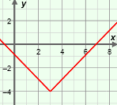How has the parent function (*f*(*x*)= |*x*|) been transformed to create the graph shown?

1. What is the value of *h*? Of *k*?
2. In *y* = *f*(*x*) notation, write the function graphed above. *y* =

Using the Gizmo, check your answers.

1. A transformed sine curve is shown below. (The parent function is *f*(*x*) = sin (*x*).)

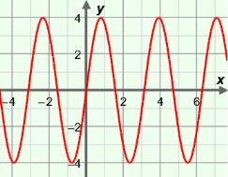

1. What is the amplitude, *a*, of the graph?
2. Approximately how long is the period of the function?

1. What is the value of *b*?
2. In *y* = *f*(*x*) notation, write the function graphed above. *y* =

Use the Gizmo to verify your answers.

1. The point (–4, 4) lies on the graph of *f*(*x*) = |*x*|.
2. What is the corresponding point on the graph of *y* = *f*(*x* – 2)?

Explain.

1. What is the corresponding point on the graph of *y* = *f*(*x*) – 5?

Explain.

Using the Gizmo, check your answers.

**(Activity C continued on next page)**

**Activity C (continued from previous page)**

1. 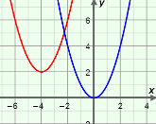A parent function (*g*(*x*) = *x*2) and a transformed graph are shown to the right.
2. Describe how the graph was transformed.

1. What are the values of *h* and *k*?
2. In *y* = *g*(*x*) notation, write the function graphed above. *y* =

In the Gizmo, select **parabola** and check your answers.

1. The point (–8, –2) lies on the graph of the parent function *f*(*x*)= .
2. What is the corresponding point on the graph of *y* = –*f*(*x*)?
3. What is the corresponding point on the graph of *y* = –2*f*(*x*)?
4. What is the corresponding point on the graph of *y* = *f*(–*x*)?
5. What is the corresponding point on the graph of *y* = *f*(2*x*)?
6. What is the corresponding point on the graph of *y* = *f*(2*x*) + 3?

Use the Gizmo to check your answers.

1. The point (4, 16) lies on the graph of the parent function *f*(*x*) = *x*2.
2. If the point (1, 16) lies on the graph of *y* = *f*(*bx*), what is the value of *b*?

Explain.

1. What point on the graph of *y* = 0.5*f*(*x*) corresponds to (4, 16)?

Explain.

Check your answers in the Gizmo.

1. Explain why the graphs of the functions *y* = *f*(*x*) and *y* = *f*(–*x*) are identical when *f*(*x*) = *x*2.