Vocabulary: Translating and Scaling   
Sine and Cosine Functions

Description: dictionary2

**Vocabulary**

* Amplitude – the vertical distance between the midline and the maximum of the graph of a sine or cosine function.

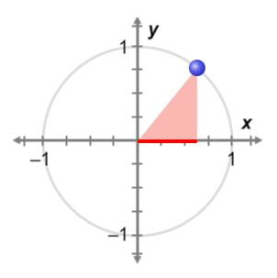

***θ***

**(cos(*θ*), sin(*θ*))**

***y***

***x***

**1**

* Cosine – in a right triangle, the length of the leg adjacent to angle *θ* divided by the hypotenuse: cos(*θ*) = .
  + If *θ* has its vertex at the center of a unit circle, cos(*θ*) is the *x*-coordinate of the point where the angle intersects the circle.

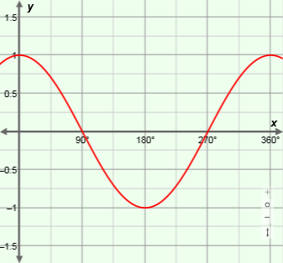

**amplitude = 1**

**period = 360°**

***y* = cos(*x*)**

**midline**

***y* = 0**

* Midline – the line halfway between the maximum and minimum points of the graph of a sine or cosine function.
* Period – the length of the interval that repeats in a function.
* A function whose values repeat in regular intervals is *periodic*.

**midline**

***y* = 0**

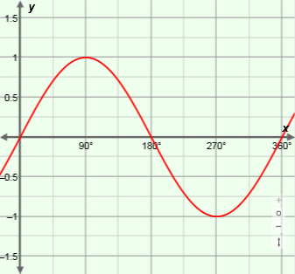

**period = 360°**

**amplitude = 1**

***y* = sin(*x*)**

* Radian – a unit of angle measure, such that one full rotation equals 2** radians.
* Because 1 rotation (360°) = 2** radians, it follows that ** radians = 180°, and   
  1 radian = , or about 57.3°.
* If a central angle of a circle measures 1 radian, it intercepts an arc that is the same length as the radius of the circle.
* Sine – in a right triangle, the length of the leg opposite angle *θ* divided by the hypotenuse: sin(*θ*) = .

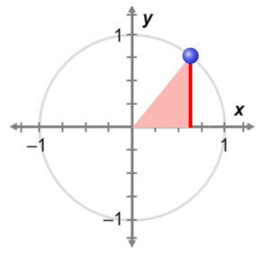

***θ***

**(cos(*θ*), sin(*θ*))**

***y***

***x***

**1**

* + If *θ* has its vertex at the center of a unit circle, sin(*θ*) is the *y*-coordinate of the point where the angle intersects the circle.