Vocabulary: Translations

Vocabulary

- Image – a figure that has been transformed, compared to the original figure (the preimage).
  - Transformations include resizing, reflecting, rotating, or translating a figure.

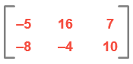
- Matrix – a rectangular array of numbers and/or variables.
  - The matrix shown to the right has 2 rows and 3 columns, so it is a 2 × 3 matrix.
  - Each number or variable in a matrix is called an element.

- Preimage – the original figure, before being transformed.
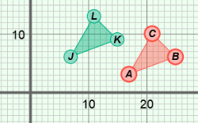
- Translation – a movement of a figure from one place to another.
  - In the figure shown to the right, the preimage, ΔABC, has been translated 10 units to the left and 3 units up to get the image, ΔJKL.

