Name: Date:

**Student Exploration:** **Triangle Angle Sum**

**Vocabulary:** exterior angle, interior angle, triangle

**Prior Knowledge Questions** (Do these BEFORE using the Gizmo.)

In the figure below, lines *a* and *b* are parallel, and are cut by transversal *c*, as shown.

**1**

**2**

**3**

**4**

**5**

**6**

**7**

**8**

***a***

***b***

***c***

1. Is ∠2 ≅ ∠6? Why?

1. What other pairs of angles in this figure are congruent for the same reason?
2. Now suppose lines *a* and *b* are *not* parallel.
3. Name a pair of angles that would still be congruent.
4. Name a pair of angles that would no longer be congruent.

**Gizmo Warm-up**

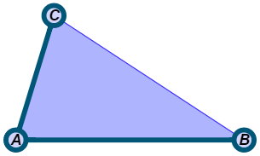In the *Triangle Angle Sum* Gizmo, you can manipulate a **triangle** (a 3-sided polygon), and explore its angle measures.

1. In the Gizmo, drag the vertices of Δ*ABC* to form any triangle you like. Select **Show angle measure tool** to open a Gizmo “protractor.” (To measure an angle, attach the “donuts” to it, as shown to the right.)

Find the measures of the three **interior angles** of the triangle, and record them below.

*m*∠*A* = *m*∠*B* = *m*∠*C* =

Select **Show angle measures** to check your answers.

1. Turn off **Show angle measures**. Drag the vertices of the triangle. Do you think an interior angle of a triangle can measure 180°? Why or why not?

|  |  |  |
| --- | --- | --- |
| **Activity A:**  **Angle measure sums** | Get the Gizmo ready:   * Turn off **Show angle measures**. * Turn on the Gizmo protractors. | 202SE2 |

1. In the Gizmo, drag points *A*, *B*, and *C* to explore a variety of triangles.
   1. Use the Gizmo protractors to find the interior angle measures of three different triangles. Record the angle measures and their sum in the table below. Then select **Show angle measures** to check.

|  |  |  |  |  |
| --- | --- | --- | --- | --- |
| **Triangle** | ***m*∠*A*** | ***m*∠*B*** | ***m*∠*C*** | ***m*∠*A* + *m*∠*B* + *m*∠*C*** |
| 1 |  |  |  |  |
| 2 |  |  |  |  |
| 3 |  |  |  |  |

* 1. What seems to be true of the sum of the interior angle measures?

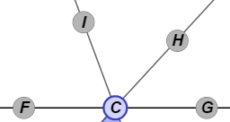

1. Select **Show reference lines**.
2. What is *m*∠*FCI* + *m*∠*ICH* + *m*∠*HCG*?

How do you know?

1. Use the fact that ||  to fill in the blanks below. (Note: The missing angles below are interior angles of Δ*ABC*.)

∠*FCI* ≅ because they are

∠*ICH* ≅ because they are

∠*HCG* ≅ because they are

1. Turn on **Show angle measures**. Use the markings in the diagram to verify your answers above. Explain how this helps prove that the sum of the interior angle measures of a triangle is 180°.

**(Activity A continued on next page)**

**Activity A (continued from previous page)**

1. Turn **Show reference lines** off. Then drag the vertices of Δ*ABC* to form any triangle.
   1. Sketch your triangle in the space to the right. Label each interior angle with its measure. Then extend  to the left, and add point *D* to that new segment,to form ∠*CAD*. This new angle, formed by extending one side of the triangle, is an **exterior angle** of Δ*ABC*.
   2. What is *m*∠*CAB* + *m*∠*CAD*? How do you know?

* 1. What is *m*∠*CAB* + *m*∠*B* + *m*∠*C*?
  2. Fill in the blank below with =, >, or < to show how these two sums are related. Then, in the space below, simplify, if possible.

*m*∠*CAB* + *m*∠*CAD* *m*∠*CAB* + *m*∠*B* + *m*∠*C*

Turn on **Show reference lines**. Use the Gizmo protractors to check your answers.

* 1. Other exterior angles shown in the Gizmo are ∠*CBE*, ∠*HCB*, and ∠*ICA*. Draw those angles on the triangle you sketched above, in part A. Fill in the blanks below to show the relationship between each exterior angle and two of the interior angles.

*m*∠*CBE* = *m*∠ + *m*∠

*m*∠*HCB* = *m*∠ + *m*∠

*m*∠*ICA* = *m*∠ + *m*∠

Use the Gizmo protractors check your answers.

* 1. Experiment with other triangles to see if this relationship is always true. In general, how can you summarize this finding? (Complete the sentence below.)

The measure of an of a triangle is equal to the sum of

This is called the *Exterior Angle Theorem*.

|  |  |  |
| --- | --- | --- |
| **Activity B:**  **Applying angle sums** | Get the Gizmo ready:   * Turn off **Show reference lines**. * Select **Show angle measures** if you like. | 202SE4 |

Solve each problem. Show all of your work in the space below each. Then, if possible, check your answers in the Gizmo.



**140°**

**98°**

1. In Δ*ABC*, if *m*∠*A* = 45° and *m*∠*B* = 55°, what is *m*∠*C*?
2. What are the interior angle measures in the triangle shown below?

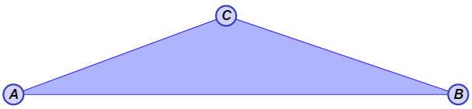

***x*°**

***x°***

**7*x°***

1. In the figure to the right, *m*∠*CBE* = 140° and *m*∠*CAB* = 98°. Find *m*∠*CBA* and *m*∠*ACB*.
2. What are the values of *x* and *y* in the triangle shown below?

***x*°**

**75°**

***y*°**

***y*°**

**75°**